Class – Help Document


CREATING NEW COURSES

Problem

I have created a new Tuition Master Price List but when adding a course in an enrolment it is not available in the Booking Section.

Solution

This is the process to create a new course.

- Admissions
- Courses (within Processes)
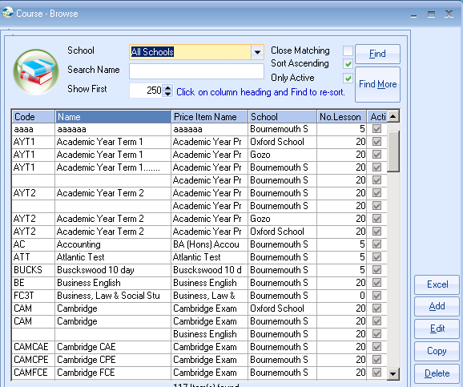
Select Add

Complete the screen similar to the example below.

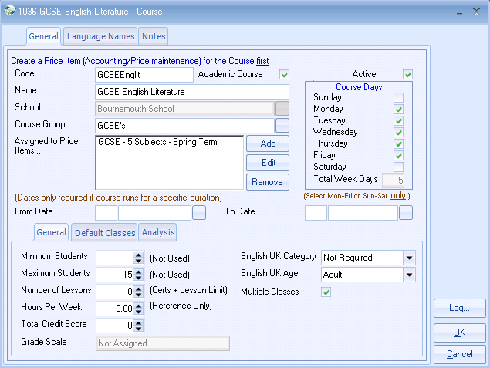

Note: If you want Auto-Coursing don’t forget to amend the price item in the Master Price List. See below for example:
