Class – Help Document

Price Lists

How do I add a new item to the Price List?

Select: Maintenance/Settings > Maintenance.
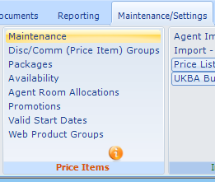

Price List Name
The MASTER PRICE list is the “Gross Price.”

Price Items
A Master Price List item is required for every element in the price list.

Every item will have a “From” date, which indicates the price start date.
E.g. 01/Jan/14 (Winter prices)
The price item remains valid up to the “From” date of the next start date e.g. 29/Jun/14 (Summer prices)

Values entered are used for Direct Student invoicing and the basis for
Discount/Commission.
E.g. an Agent receiving 10% discount/commission will have it applied to the MASTER Price List item.

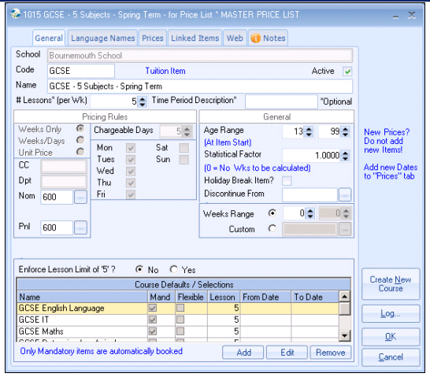

School Name Select school
Code Mandatory
Name Up to 50 Characters (prints on the invoice)
Lessons (per wk) Enter number of lessons (if applicable)
Units Date based (system will use dates to calculate the price)
e.g weekly/daily rates.
Leave blank if prices are unit based, eg transfers, exam fees.

Calculate Duration as Nights? (Accommodation)
If “nights” (default) then Sunday to Saturday = 6 nights (student does not stay Saturday night)
If “days”, then Sunday to Saturday = 7 days (a week is charged/paid).

Large units (No. Days/Units) - Examples:
Tuition typically 5 day week
Accommodation typically 7 day week
Items sold in units (Transfers/one to one lessons/Exam fees/enrolment fees) =1

Use of “Unit” prices for Tuition items.
Avoid Unit prices (except for “individual lesson” prices).

Example 1
Course 10, 11 or 12 weeks long, but same price applies for any number of weeks, up to 12 i.e. a minimum price of 12 weeks applies.
Eg £1500 for up to 12 weeks, thereafter an extra £100 per week.

Price set all units, from 1 to 12 = £1500
Additional Large Unit charge = £100

Example 2
A Mon-Fri course sold in 4 week blocks only (£400 per 4 weeks)
Large unit:
1 = £400
2 = £400
3 = £400
4 = £400
5 = £800
6 = £800
7 = £800
8 = £800

Part units - If the Large unit is date based the Part unit means “Days” (if set).

For Information: All prices can be manually overridden when the invoice is calculated.

Course Defaults - Select the course(s) relating to the Price Item.

Mand (Mandatory) - Tick this box, this will allow the course(s) to be automatically set when the price item is selected, during enrolment entry.

If the course has not yet been created then click on the “Create New Course” button.

Cost Centre/Department/Nominal Codes.

Enter codes if accounting analysis is required.

On Accommodation the system will force the entry of Nominal ledger codes for Sales and Payment accounts, to ensure valid codes are set, even if not used.

Language Names
Enables the invoice be produced with the price item name printed in the relevant language.
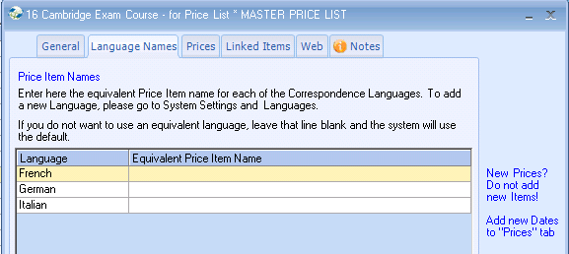

Prices
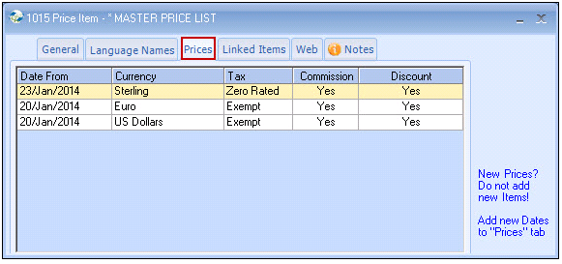
Enter the weekly value in the Calculator and use the ‘Tab’ button on the keyboard to automatically calculate the weekly rates from week 1 to week 53.

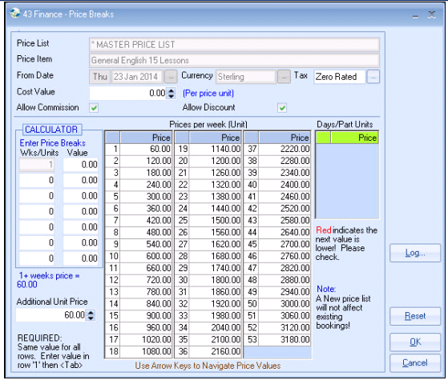

From Date Commencing date of the price.

Ensure the date represents a normal starting day for the item e.g. Course = Monday whilst Accommodation = Saturday.

Having prices starting mid week may create undesirable price breaks.

Currency A price is required for each currency.

Allow Discount Select if Discount is allowed

Allow Commission Select if Commission is allowed

Calculator If the weekly price changes after a certain number of weeks studied, enter the prices breaks for the required weeks.
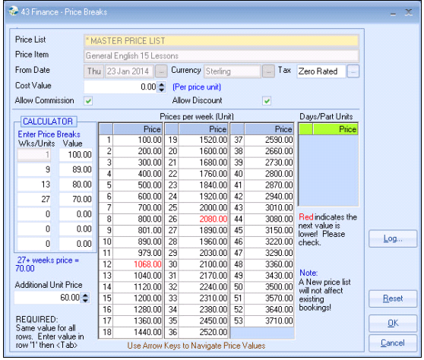

Part Units
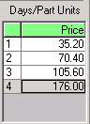
Used for charging or paying “Days” for Courses or Accommodation.
Prices should be entered for each of the days.
Courses - 4 part unit days
Accommodation - 6 part unit days

These values can be manually amended.

Transfer Records
Chargeable Days = 1 (one off payment)
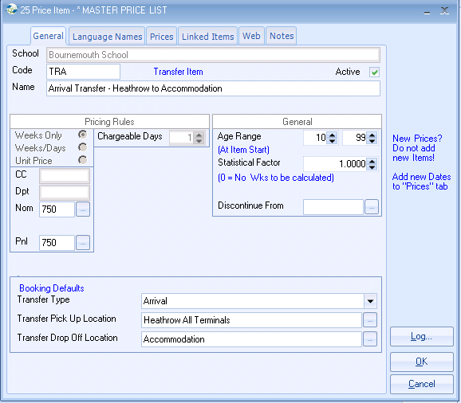

Note: Default values should be set for the “Booking Defaults”.

Prices
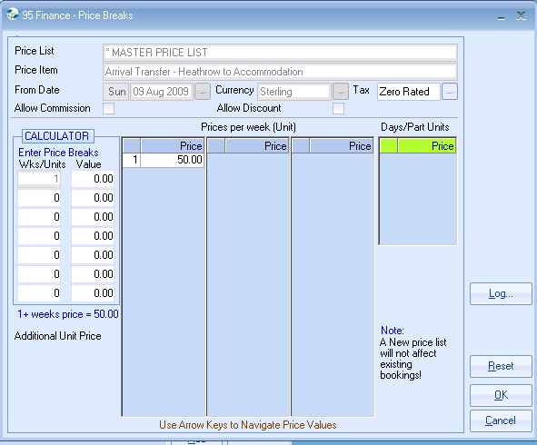
Sundry Records

Enrolment Fee - one off payment so Chargeable Days = 1
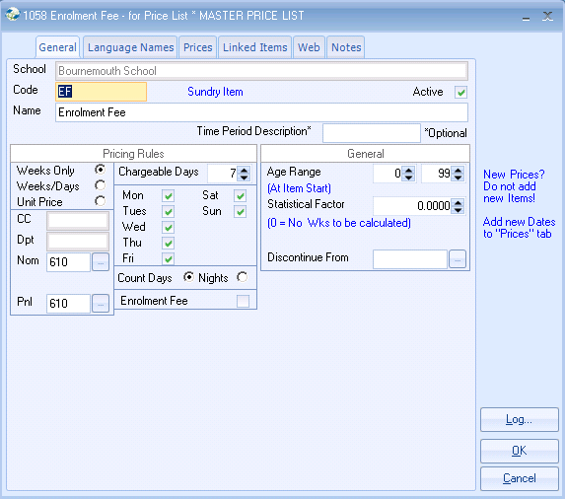

Enter the price in week one. Click the ‘Tab’ button on keyboard.
Select YES to set all week prices to the same value.
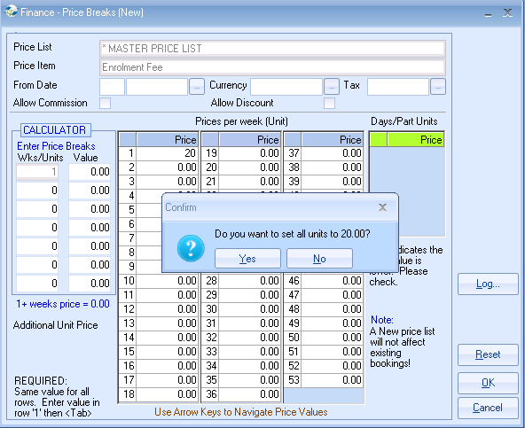

Price Item Notes
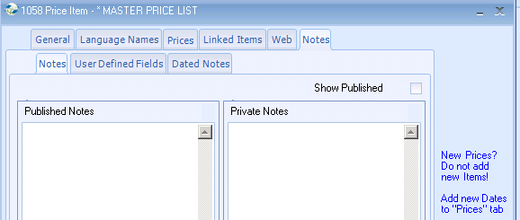
Linked Items
If whenever using a particular price item within an enrolment another item should automatically be included e.g. a student booking the Cambridge Course should also be charged for the Exam Fee, set up Linked Price item.

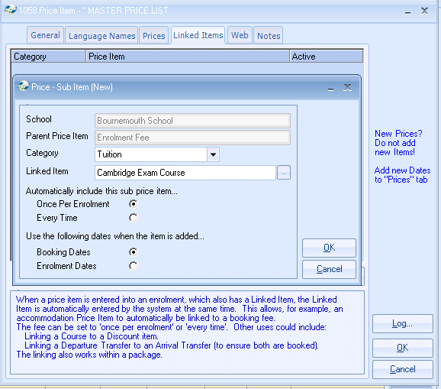

Web
If an interface with your web page is in use then the “Web” tab should be completed.
Contact the Support Desk for more detailed information.
