Class – Help Document


QUICK REPORTS

Problem

I need to be able to produce a list of students with their current Accommodation Provider.

Solution
Create an Enrolment Accommodation Booking type report (Accomm - Booking)
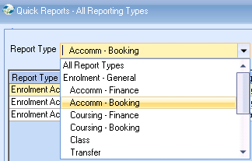

Date Filter = Present. Enter the required date range.
Use ‘Add Item’ to insert the required fields in to the report.
Example:
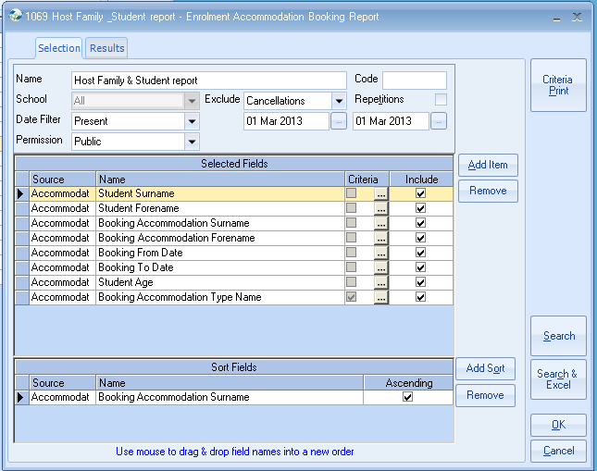

Sort the report by Booking Accommodation surname / forename.

Criteria:

To include only those students booked in homestay accommodation enter the following field and criteria:

Field:

Criteria:

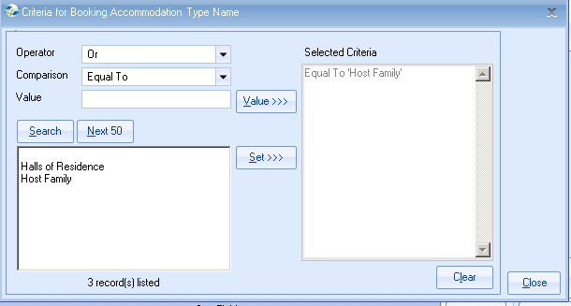

Click on Search or Search & Excel to see the result of your report.

OR select Send Document to produce a document for each of the listed students.

