Class – Help Document


AGENT COMMISSION PAYMENTS/STATEMENTS

Problem

How do I get a list of Agents Commission?

Solution
Select: Accounting/Ledger > Agent Commission Payments

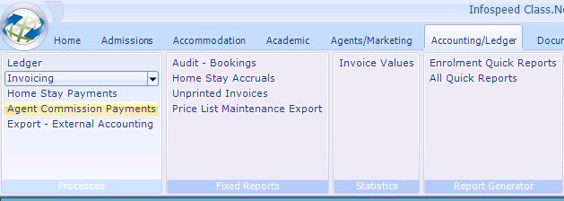

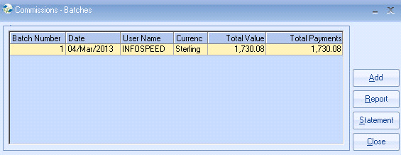

Click on Add

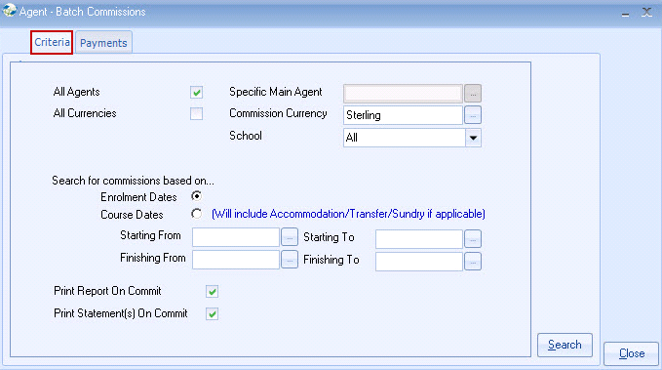

- Agents can be selected individually or altogether, covering any range of starting dates. This allows the system to limit Commissions only to say, those students who have arrived.
- Click on Search.
Or PRINT to send the list to Excel.

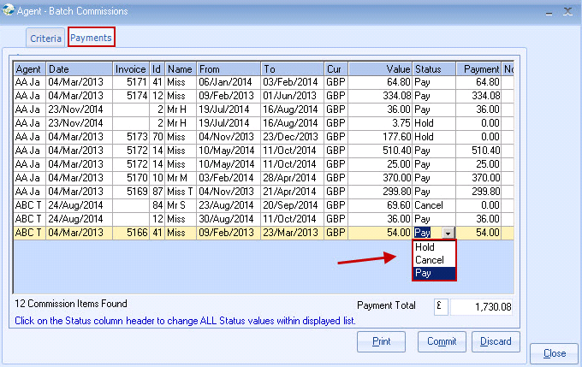

All commissions listed have a status of “Hold”.
Amend status to “Pay” for any that needs paying.
The Payment value can be amended manually.
Manually type a Note in the last column if required.

After making any changes, select the Commit button.
The complete process can be cancelled by selecting Close.

The default is to print a report of commissions paid and also a Statement for each Agent.

Details are shown on the agents Commission Record:

The commission payments have no direct link to the accounting.
If the agents account is to be credited then a Receipt entry will need to be made in the Class Ledger. (If in use).

Reprinting previous selection:
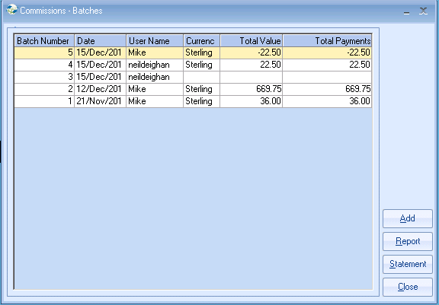

Select the batch and click on Report or Statement.

The agents commission will be updated for viewing within the agents record, commissions tab.

