Class – Help Document


CANCELLING A STUDENT

Problem
How do I cancel a student?

Solution
To cancel an ‘enrolment’ entirely you should click on Cancel Enrolment this will then show the items as cancelled. The Enrolment cannot actually be deleted only cancelled, as this needs to be held on the system for statistical and security purposes.

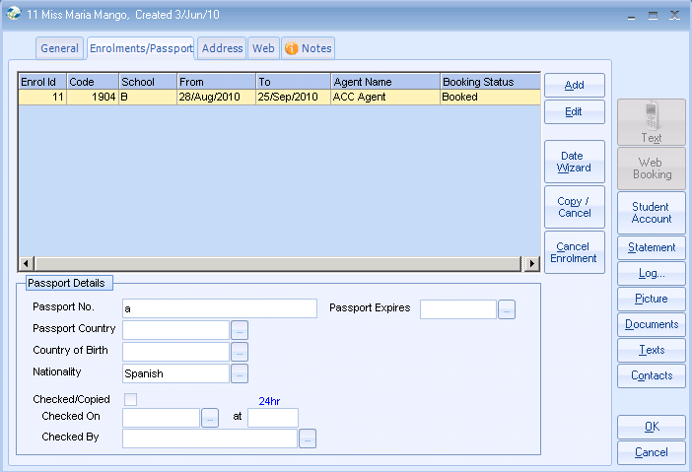

Click on Cancel Enrolment.

If a ‘Student’ has an enrolment attached the student record can not be cancelled or deleted. We would suggest changing the student’s family name by entering a Z at the beginning of the surname so it is moved to the end of the search screen, and users will know not to update it.

