Class – Help Document


HOST FAMILY MAILING

Problem

I need to produce a list of Host Families to mailshot or Email.
(see help sheet SQL004 to produce Host Family labels)

PLEASE NOTE: these instructions are for a general mail shot to families and can not be used to merge details about student bookings.

You would need to create an ‘Enrolment’ Document and ‘Enrolment-General’ Quick report in order to send a mail shot with student details merged, i.e. confirmation letter.

Solution.

Step 1.

Within Class create a new “Accommodation” type Document.

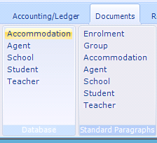

In this document insert the required merge fields and text.
Example document:
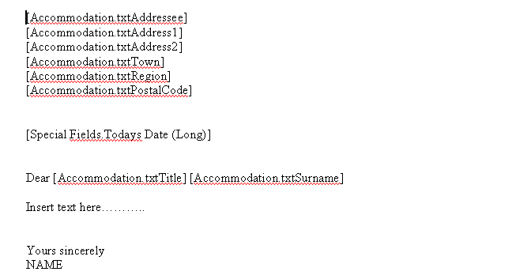

Select “Save” from the Word Edit box to save & close the document.

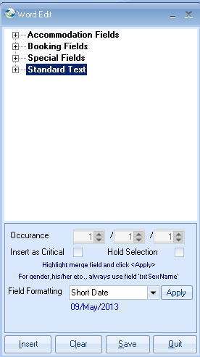

Step 2.

Go to Quick Reports and create a new report.

Ensure the report type is set correctly as Accommodation.

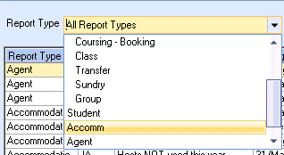

Add fields and criteria to the report that will select the required records that are to be included in the mailing (similar to the following).

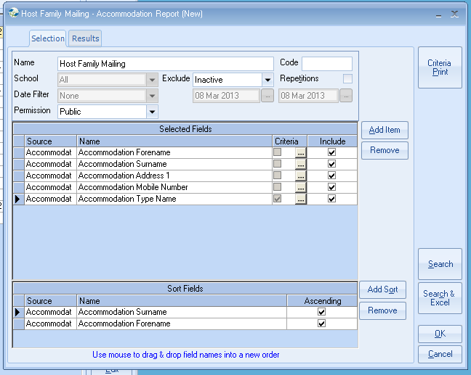

The above selection will include all ‘Active’ Accommodation items including host families, residence, hotels, etc.

To include just host families, add the following field and criteria:

Field: Accommodation Type - Name
Criteria: Equal To ‘Host Family’
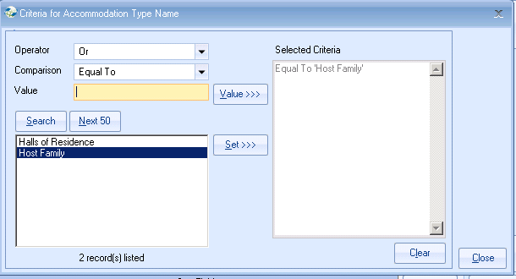
Select Close
Click on ‘Search’ to display all Host Families that match the selected criteria.
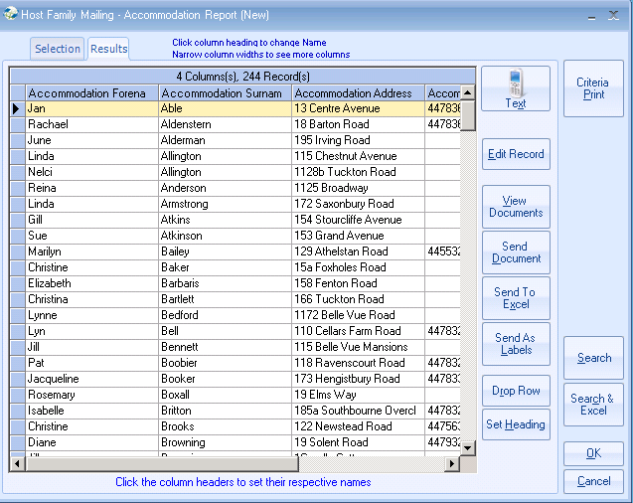

Click on “Send Document”

To Send a Document
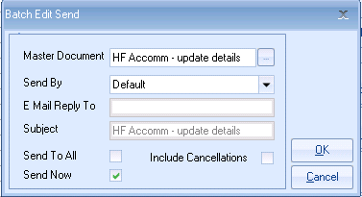

Master Document – search and select the document to be mailed to the selected families by using the “Find” button.

Send By -
Default: This will look at the host’s record and if set to Printer the document will print and if the family is set to Email the document will be emailed to the address set with the host record.
Printer: This will override the host’s ‘send by’ settings and print all the documents in the list.

Send To All – unticked box will only produce a letter for the first family in the list. Ticked box will produce a letter for all families in the list.

Send Now – ensure this box is ticked to print the letters immediately.

Select OK to start the merge.

Tip: If your mailing is to be emailed, include the host family email address in the report.
You can then scroll down the list to ensure all families have an email address set up.

To export data to a new Excel Worksheet –

Click on Send to Excel.

