Class – Help Document


GROUPS

Adding Groups

Go to: Admissions / Groups.
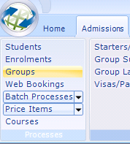
Select: ADD

General Tab:
Complete the details on the General tab, as required.

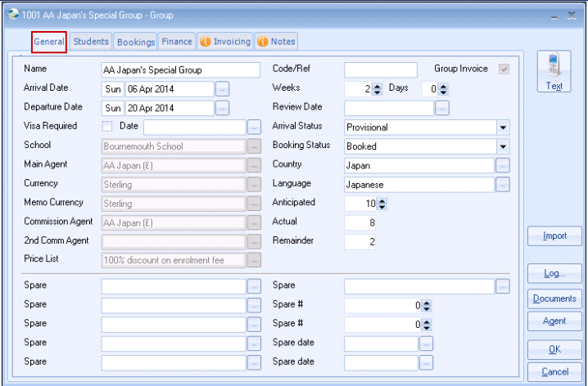

Group Invoice (top right corner)
This setting is taken from the Main Agent’s record. (top right corner of agents’ General screen)
Ticked: will produce a Gross invoice for the group, plus memo invoices if set within the agent record.

Unticked: if individual (gross) invoices are required for each student with no group invoice for the agent.

Students Tab:

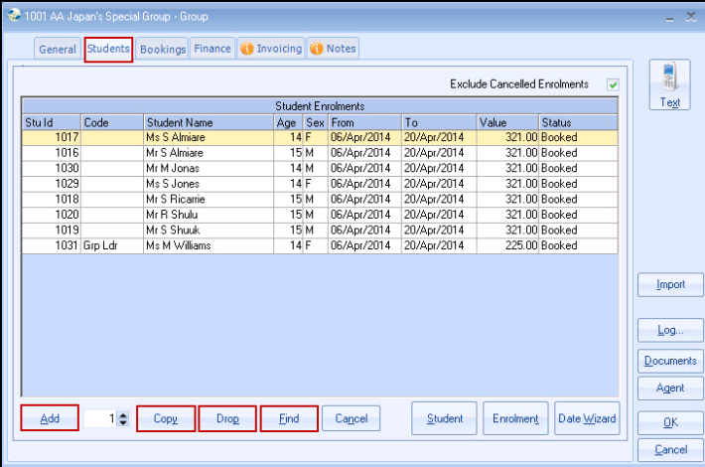
Add Student + Enrolment details (some defaults will already be completed).

Copy –Copies an existing Student/Enrolment, making entry for similar or identical enrolments quick and easy. (set number of copies required).
Highlight the Student you wish to copy, check all the details are correct including the addition or cancellation of any enrolment fees, select the number, then Copy. If in doubt, copy 1 first and check before proceeding.
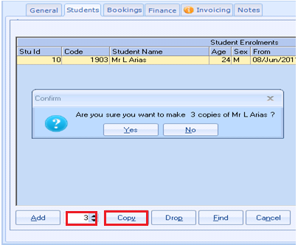

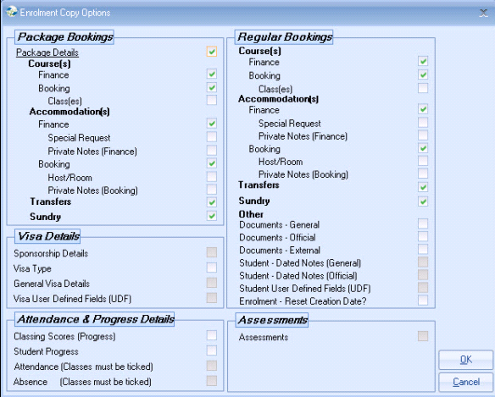
After the copy, use Student to edit the name, address, age, etc.

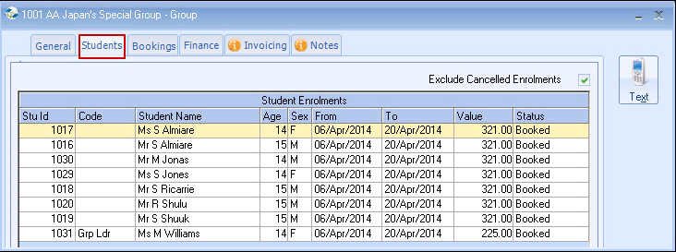

Copying Rules:
All details are copied (including the name) except:
Accommodation booking (i.e. the actual Family)

Find – Allows an existing student to be found in the database and added to the Group.
If student has been entered as a normal enrolment and later found that he/she is part of a Group, then cancel the enrolment and add to Group via “Find” option.
(See page 7 for instructions)

Bookings
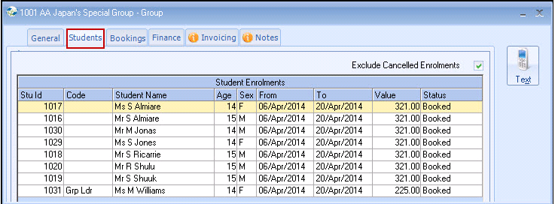

Bookings may be edited just like a normal enrolment. Double click on the Student name to edit.
Bookings Tab:

This lists the enrolment bookings together with the Quantity of students booked per item.
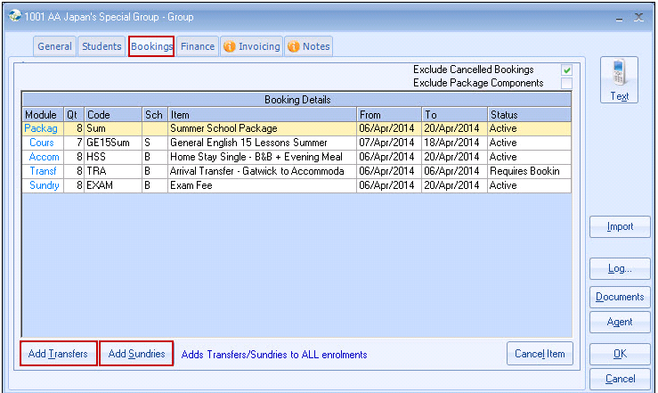

Transfers and Sundry items can be added from this screen.

Any amendments to the courses/accommodation, i.e. dates, can be amended within ‘Batch Processes’ though the Admissions menu.

NOTE: new Courses and/or Accommodation can not be added using the batch update and must be added manually to each student in the group.
Items can not be cancelled or deleted using the batch update process.

Refer to help sheet SQL026 for detailed information on Group Batch Processes

Finance Tab:

This screen is similar to an individual finance screen but lists the total price per item for all students in the group.

To make manual amendments to a line, highlight and select Edit.
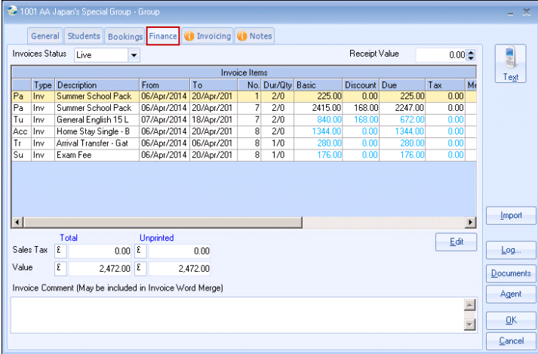

Invoicing Tab:

Print/Post the group invoices and credits from here.

How to add an existing student to a group:

A normal student enrolment can be added to a Group.
A student can be dropped from one Group and added to another Group.

Using the FIND button:
Allows an existing student to be found in the database and added to the Group.

- Go in to the Group that you wish to add the first student to and go to the "Students" tab
- Select the FIND button
- Input the students surname in to the Search Surname field
- Highlight the student from the list and choose EDIT
- Once in to the students General screen showing the address details, select the "Enrolments" tab.
- Select ADD to create a new enrolment (the original individual enrolment or enrolment from a previous group can not be used)
- This will automatically create the General tab for the enrolment with all the details (dates/school/agent etc) for the new group - check details.
- Click on the "Bookings" tab and add the course/accommodation/transfers etc as required.
- The Finance will automatically be calculated for the Group.
- Once complete select OK, and OK again. This will take you back to the Groups "Students" tab.
- Now select FIND again and follow the instructions to add the next student to the Group, and so on.

