Class – Help Document


Problem

I need to not only see a list of students present in the school in any one week, but also the numbers of starters and leavers.

Solution

There is a Starters/Leavers report that will give this information.

- Admissions
- Select Starters/Leavers Report

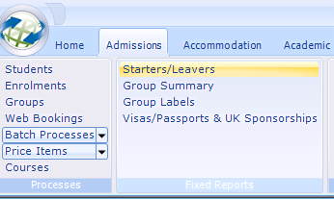

The following selection screen will be displayed.

Make your selection.
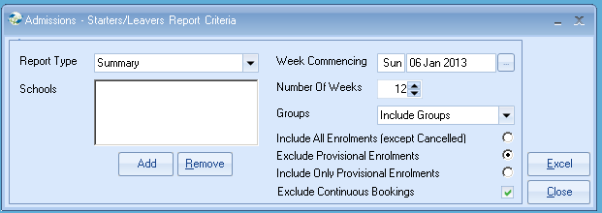
Example of Summary report -

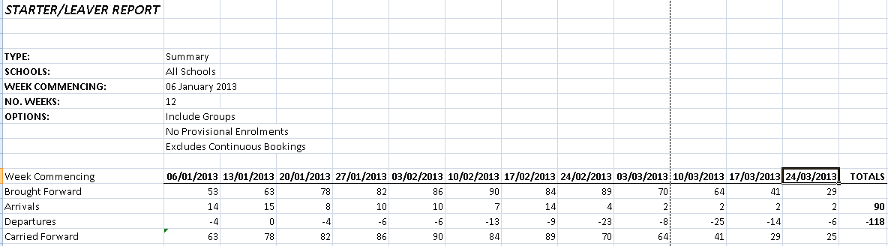

Example of a Detailed report -

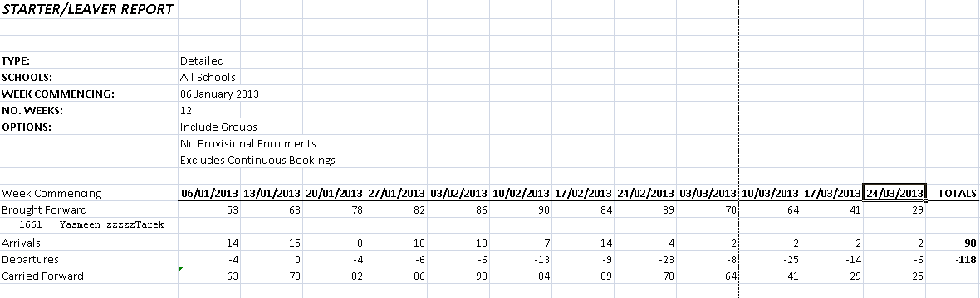

This will list the present student names as at 06.01.13
Then the arrivals and departures are listed with the carried forward figure.

