Class – Help Document


Value By Agent From Class

You have 2 Options.

Option 1:

- Click on Reporting
- Reporting Module
- Reporting
- Invoicing Statistics.
- Click on Add
- enter the information you require, for example see below.

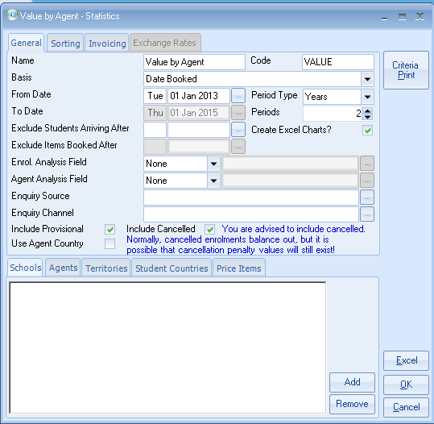

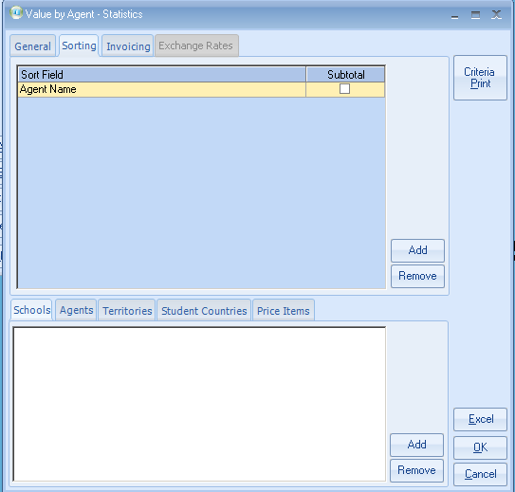

‘Value Used’ has several options
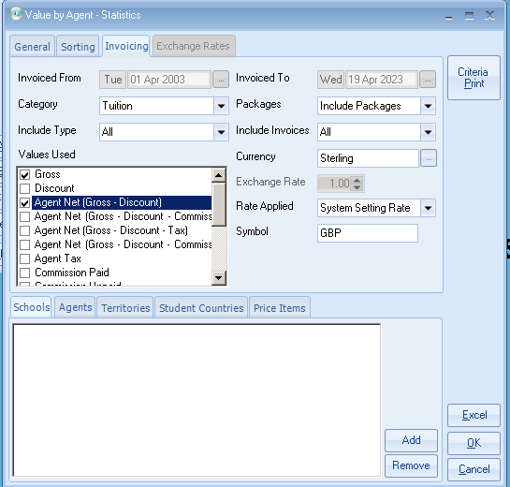
Then click on Excel.

This will now be merged into Excel. (See examples below).

Example

‘Value Used’ = Agent Net (Gross-Discount)
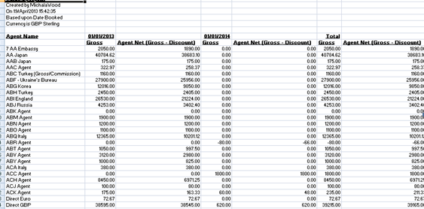

Value Used

This can be set to Student Weeks or Count

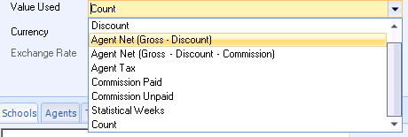
Option 2:

This option allows you to select by an individual agent.
- Go into the Agents list and select the agent.
- Click on the Statistics tab
- Select the type of report you require – Booking based or Production based.
- Then click on Refresh

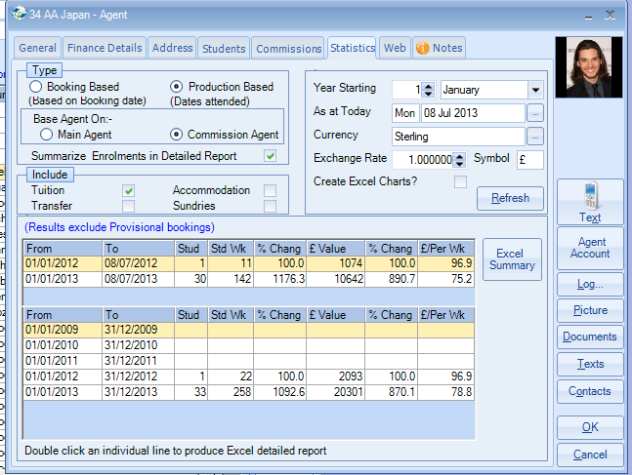

This report can be sent to Excel as a Summary by clicking on the “Excel Summary” tab.

If you require detailed information to be sent to Excel, you can double click on an individual line.

Example:

Summary

