Class – Help Document


Amending Label Format
e.g. Student Cards

Problem
I need to produce labels (student cards) but would like to have our logo on them and headings.

Solution (Based on the example of Student Cards)

- Reporting/Quick Reports

- Create a new report

- Report Type: Enrolment - General
- Create a selection similar to the following:
- (Ensure you input the Selected Fields in the order you want them printed on the label.)
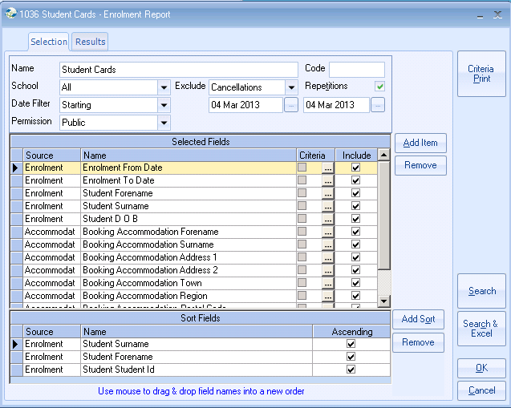

Click on “Search”

Click on “Send as Labels”

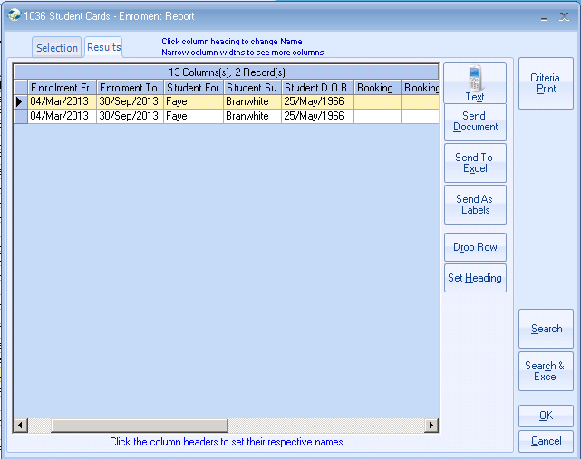

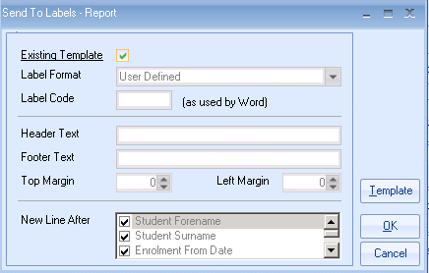
Remove the tick from Existing template to amend it.

Click on “Yes”.

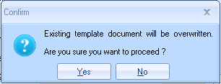

Amend the “New Line After” to reflect which lines you want the information to appear on.

Click on OK.
This will produce the labels.

(If you get a message to say that “this report contains multiple lines….” click on Yes.)

If you wish to edit the template label, exit the Word and Excel screens that this process has opened.

Re-run the labels but this time click on Template.
This will load a Word document displaying the Label format. Amend it as necessary.

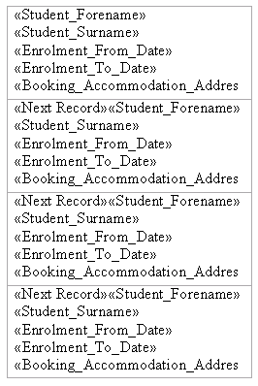

Click on “File”
Click on “Close”
Save document and exit Word

Now run your labels.

