Class – Help Document


Host Family Statistics Schedule

Problem
I want to produce an Excel Spreadsheet of families with the students they have booked in.

Solution

Go to: Reporting
Start Reporting Module
Reporting
Select Accommodation Bookings Statistics (House Icon).

General tab-
Create a selection similar to the following:

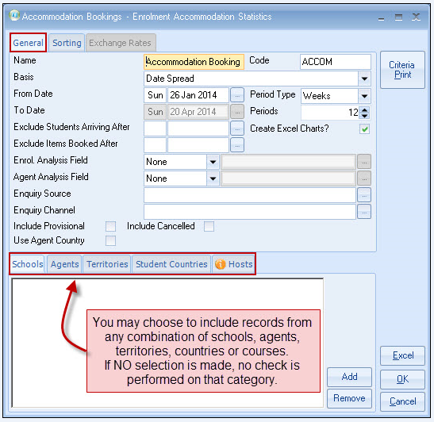

Sorting tab-
Add the sort fields as shown in the example below

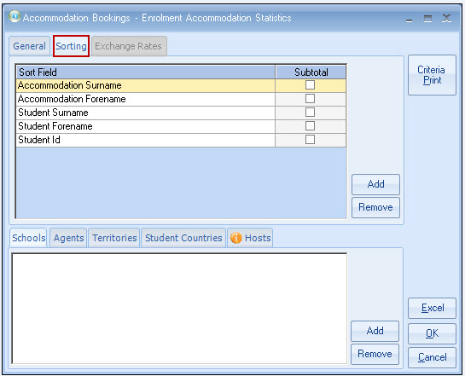

Click on “Excel”

The result will be similar to the following example:

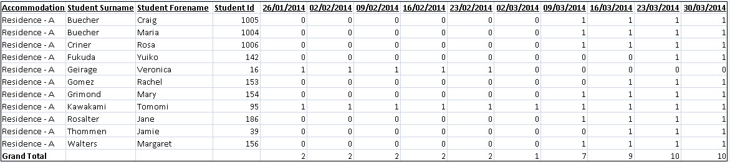

This will give a list of students attached to the family within the date period that was selected from the General tab of the stats report.

If there is a number one (1) against each of the weekly dates it means the student has stayed with the family in that week.

If a month is displayed with a zero (0) then the student is not staying with the family within that particular week.

