Class – Help Document


Cancelling a Group

Problem
I need to cancel a group and charge a cancellation fee.

Solution

Highlight the group and select CANCEL GROUP

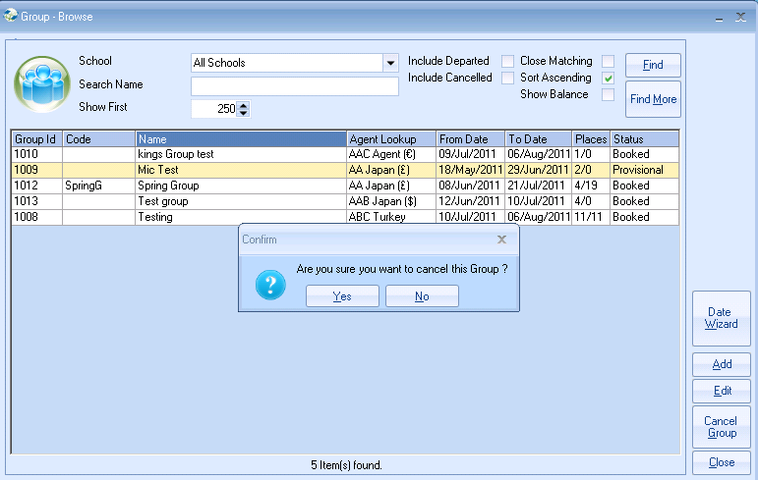
- Answer YES

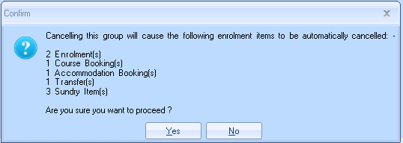
- Answer YES


- Select OK

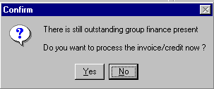
- Select YES to print the Credit note now
or
- NO to print later

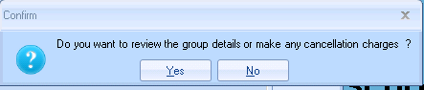

- Select YES to make your cancellation charges

- This will take you to the Group Bookings tab and as all items have been cancelled this will be blank.

- Go to the ‘Students’ tab and untick the box – ‘Exclude Cancelled Enrolments’ to list the students in the group.

- Then edit one of the student records and ADD a new ‘Sundry’ Price Item for the Cancellation Fee.

- Exit out of the students record and in to the Group Finance to see the new unprinted cancellation fee. You may wish to edit this item to change the value.

- If you have selected NO to ‘Do you want to process the invoice/credit now?’ then you will also see all other outstanding finance items.

- These are now ready to print.

Support@infospeed.co.uk

