Class – Help Document


Adding Multiple Price Items to a Course

Problem:

I want to be able to have more than one Price Item attached to a course but how do I do it?

Solution:
Create your Price Items (see Help Sheet SQL034).

This is the Booking Defaults section where a default course is set by clicking on Add.

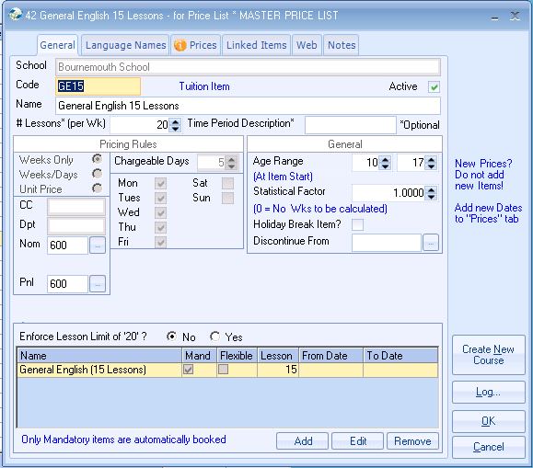
Go into Courses – Admissions, Courses

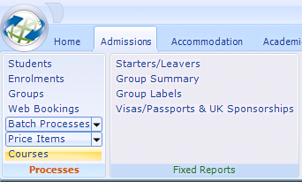

Click on Price Item.

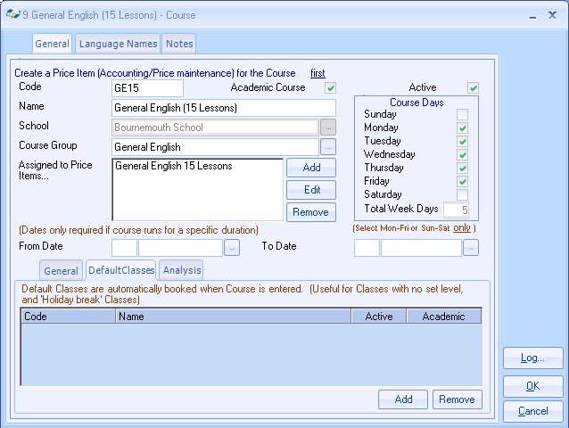

Select your Price Item and then you must click on OK

Go back into the Course and select your next Price Item and click OK.

It is important that after each Price Item that you select that you click on OK and then go back into the Course to select the next Price Item.

