Class – Help Document


“Students Starting A Course” List

Problem

I need to create my own Starters List

Solution

Select: Quick Reports

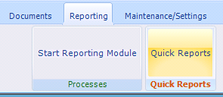

Select Report Type of “Enrolment Coursing Booking”

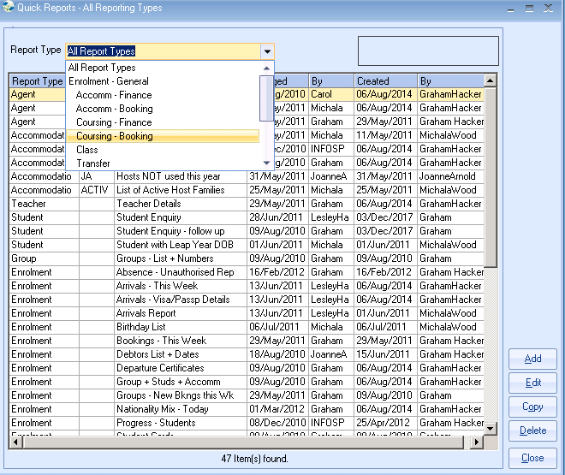

Click on Add

Date Filter could be “Starting” if you require a list of all starters or “Present” if you want to see all students currently on a course or “Finishing” if you want to see all students finishing a course.

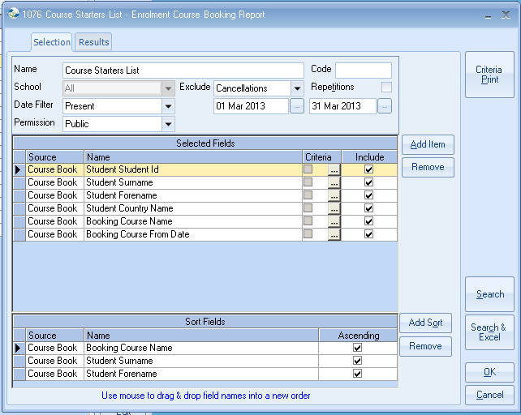

Complete the selection screen similar to the above.

Criteria – allows you to select by field e.g. all students from a particular country.

Include – if the “tick” is removed then although the field is available for selection it will not be displayed/printed.

Sort Fields – Add the fields that you would like the list displayed in. The example above will list the students by sex and then surname and forename.

Click on “Search”

Once the Result is displayed it can then be “Sent to Excel”. (Alternatively you could have clicked on “Search/Excel” from the previous screen).

