Class – Help Document


Question: How do I get a list of all students who made an enquiry within a particular date range.

Solution: Produce a Quick Report

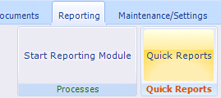

Select the “Report Type” of “Student” and then click on “Add”.

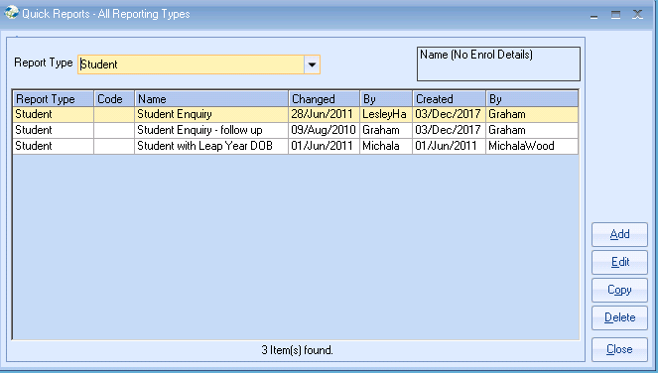

Give the report a name and then add the relevant fields (similar to the following)

You will need to add some selection criteria to both the “Student Creation Date” and “Student Status Name”. See the following two screens:

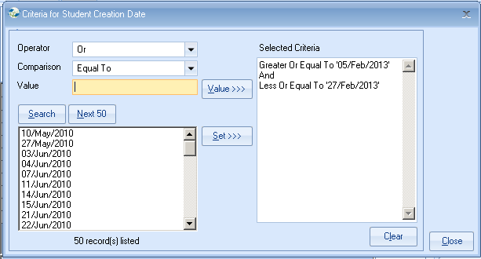

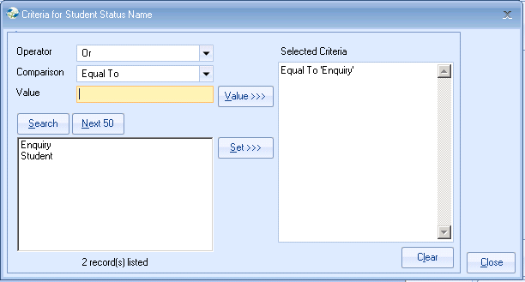

Then click on “Search”

The result will be similar to the following:

To merge the report with a document click on “Send Document” and select the correct document.

