Class – Help Document


Problem: How do I get a list of agent weeks by country

There are 2 Options

Option 1 - Produce an Invoice Statistics report by Student Weeks

- Reporting
- Reporting Module
- Reporting
- Statistics Generator
- Invoicing
- Click on “Add”

Complete the screen similar to the following:

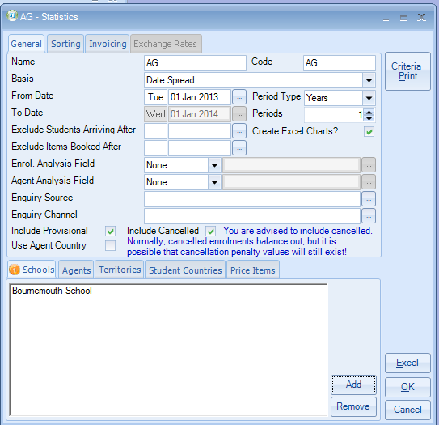

Basis – you have the option of Date Booked, Date Spread and Date Arrival.

- Click on the “Sorting” tab
- Add the items that you wish to be included by clicking on the “Add” button.

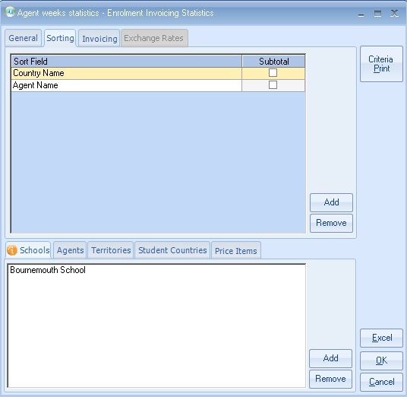

Click on the “Invoicing” tab and complete similar to the following:

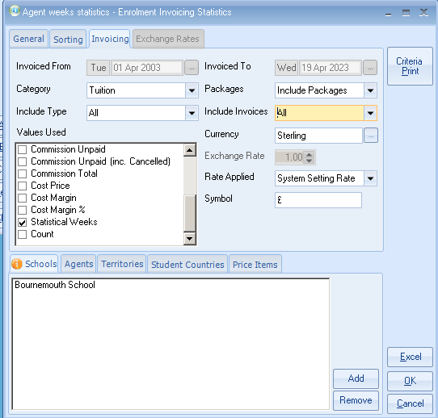

Click on Excel and the result will be as follows:

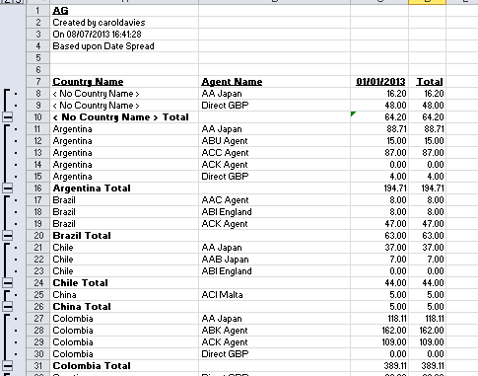

Option 2 - Booking and Production Stats.

- Go onto Reporting
- Reporting Module
- Reporting
- Marketing Statistics
- Booking and Production.

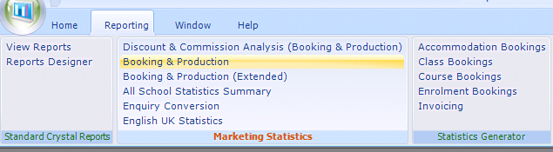

Statistics will be calculated to whatever date you have in the “As at Today” field

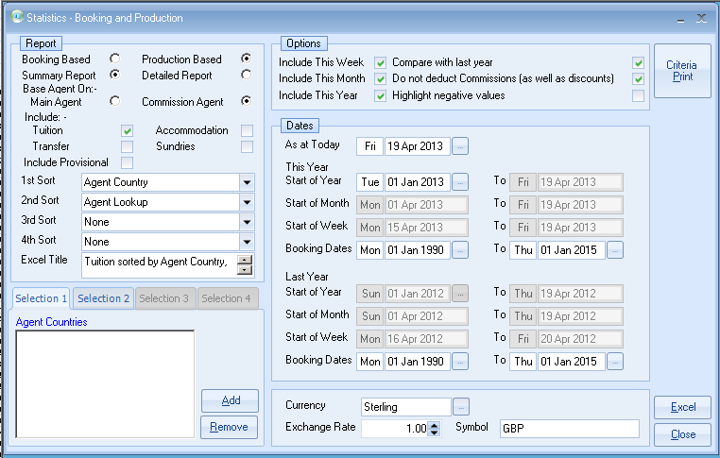

Examples

Weekly Statistics

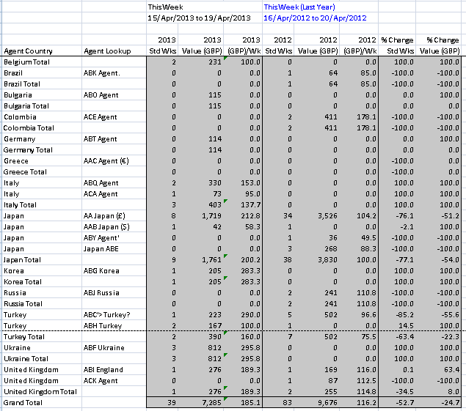

This Month
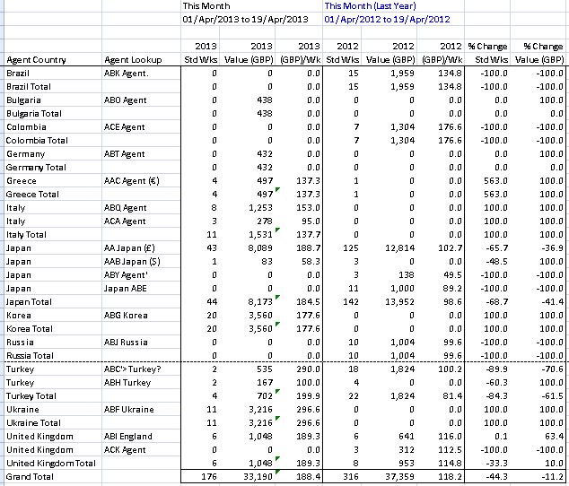

This year

