Class – Help Document


Problem
I need to produce a report for the British Council Inspection showing a list of host family names and addresses that hosted students within a specific date range together with payments values.

Solution
Create a Quick Report

Create an “Accommodation” type report similar to the example below:

This report will select each family that has hosted a student within the date range selected. Each family will be selected just once.

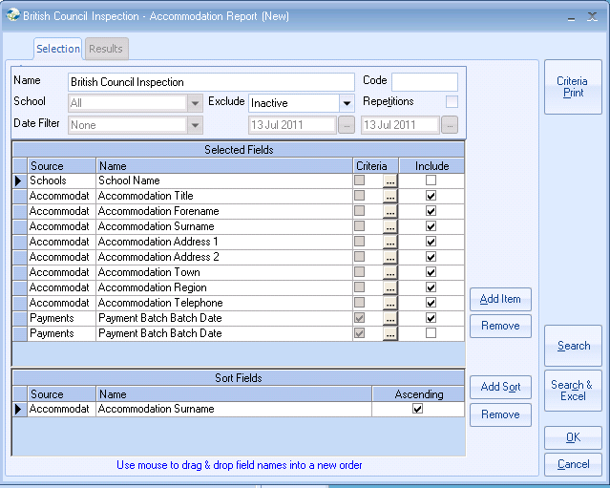

SCHOOL:
If multiple schools are in use and you only wish to select families attached to a specific school, then add the School Name with Criteria to select the required school.
Un-tick the “Include” box so that the school name does not printed for every family.

Add the fields for the hosts Name, Address and Telephone Number.
Plus add any other fields that have been requested.

DATE RANGE:
To select the date range to include only families that have hosted students between specific dates, add the “Payment Batch Date” field to the report twice. One to select the From date range and one to select the To date range.
Un-tick the “Include” box so that these dates are not printed in your report.

Criteria for ‘Payment Batch Date’

1) To select the first date range – (EXAMPLE BELOW March 2003):

Comparison = Greater Or Equal

Search the list of dates to find the earliest date in March 2003 and highlight this date.
Click SET>>>

Ensure the Selected Criteria is set correctly and select CLOSE
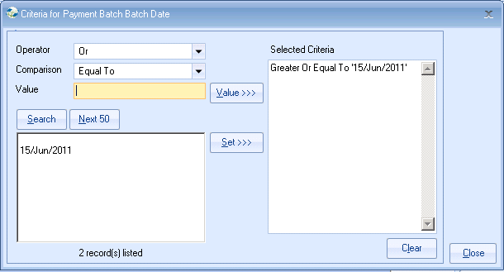

2) To select the second date range

Comparison = Less Or Equal

Search the list of dates to find the end date for your search and highlight this date. Click SET>>>

Ensure the Selected Criteria is set correctly and select CLOSE
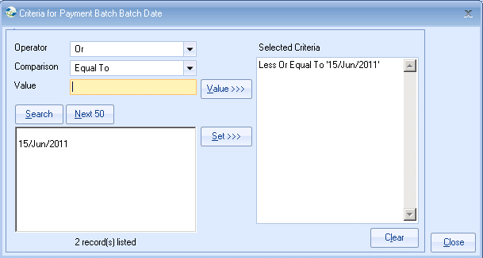

Example of report sent to Excel:
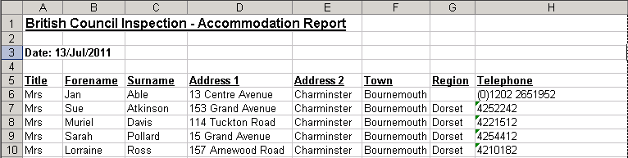

Note:
If the list you have been asked to produce is different to the above, please contact the support desk. support@infospeed.co.uk

