Class – Help Document


Problem: Host Family – Keeping a record of Students from other Schools

Solution:

This is the method to be considered for the above where “Matching” is in use:

- Create say 1 student with a popular nationality:
  - Name: Z-Other Schools (Fre)
Set the corresponding Country, Country of Birth and Language
- Add a Direct enrolment with arrival/depart well in the past e.g. 1/1/2000 – 7/1/2000
  - Set arrival status to “No show” (This stops family being paid)
  - Add an accomm (Finance) booking for same period with zero value.
  - Cancel the accomm (Booking) booking, as it is not required

- Copy the enrolment “n” times, changing the “name of the student (+Country etc) to other popular nationalities e.g.
  - Z-Other Schools (GER)
  - Z-Other Schools (CHI)
  - Z-Other Schools (ITA)
  - Z-Other Schools (SPA)
  - Z-Other Schools (JAP)
  - Z-Other Schools (OTHER)
Remember to amend the Country, Country of Birth and Language

- You may repeat the process for “Male/Female” students if sex requires identification.

- When a family notifies that they have a French Male student from XYZ school, just add the accommodation booking to the relevant Z-Other Schools… enrolment, with the correct dates.
The system will warn that the dates are “outside” the range, but the record can still be accepted.
Remember to ‘Include Departed’ when searching for the enrolment.

What has been achieved?

- A student for each nationality (or group of nationalities) with an accommodation “booking” (single zero value finance) for every family hosting other schools students.
- The accommodation booking could literally have hundreds of bookings, this is not a problem for the system.
- Host Family Payments – As arrival status is “No Show” no payment will be made.

Sample Screens:

Student:
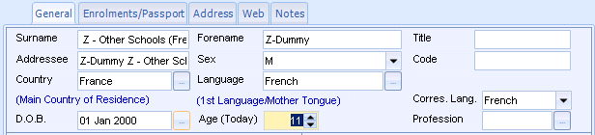

Enrolment:
Note – pop up note + No Show arrival status
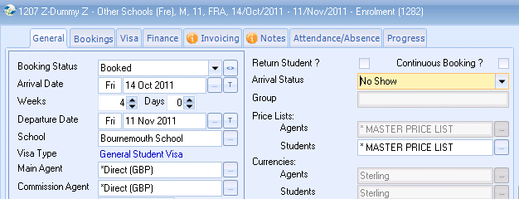
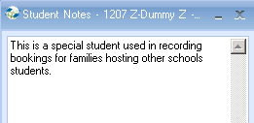

Booking:

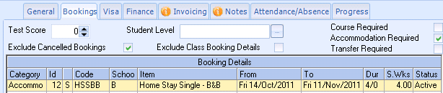

Accomm Bookings:
Note: Finance dates are historical but booking dates are current.

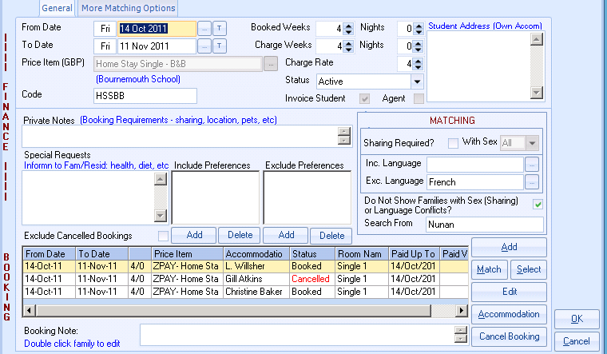

Single Accommodation Booking:

