Class – Help Document


Group Labels

Problem
I need to produce labels for all students within a Group to put onto Welcome Packs.
(see help sheet SQL037 for merging reports with mailing letters to send as a printed document/e-mail)

Solution
- Click on Reporting/Reporting Module
- Report Type = Group
- Click “Add” to create a new report.
- Use “Add Item” to add the fields needed to produce the labels.
- See example below:
Note: as long as the report type is set to Agent the system will automatically exclude agents whose status is Inactive.

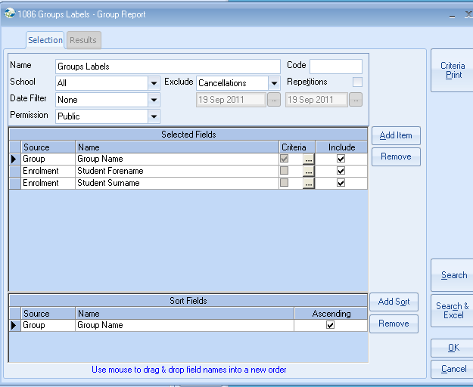

To produce labels:

Click

Select the required Label Format that matches the size of your label stationery.

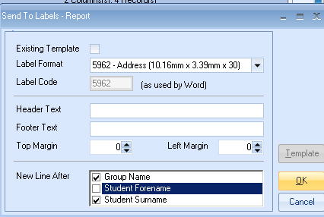

Select OK.

This will go through a process of creating an Excel Spreadsheet listing the selected records and then create a Word label document with the merged names and addresses ready for printing.

