Class – Help Document


How to create/amend the layout of a Master Invoice

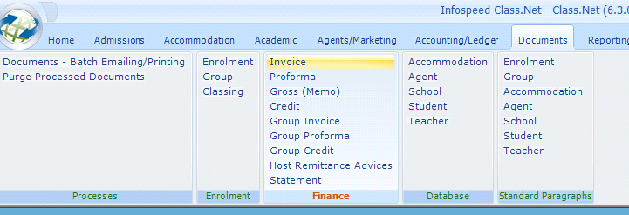
All master documents work in the same way. Each master document consists of a Word document with a Class header record that identifies and controls its use in the system.
As enrolments are the most commonly used, these are explained in detail in the Enrolment Master Documents help notes.

Master Document Selection

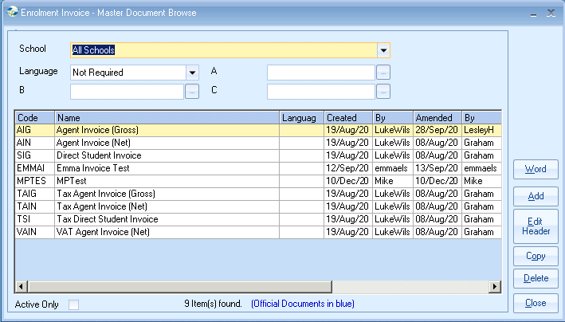

Class Header Details

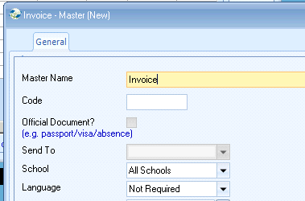

Field Categories
The following may be inserted into the document.
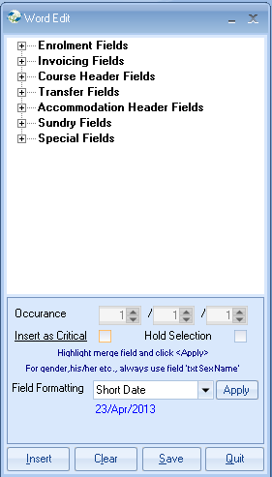
Note: standard paragraphs may not be inserted into Enrolment Invoice Master Documents. This is because financial documents are built automatically by the system. This means that the user cannot be prompted for which standard paragraph is to be printed against each student.

