Class – Help Document


Problem
I need to produce a list of host families with available rooms for a given period.

Solution
Select Accommodation (top of screen) / Matching,,,

Input the required date range plus any other matching criteria.

“Search Name” – remove the surname from this field so the report is produced alphabetically from the beginning of the alphabet.

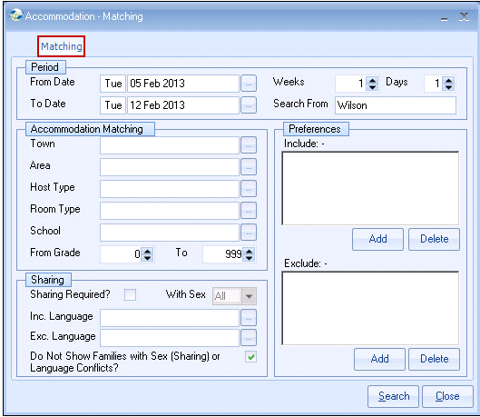

Select Search.

This report will list alphabetically the families together with a list of their available rooms for the period selected.

The bottom of the screen shows all rooms for the highlighted family. This includes the occupied rooms showing the students details and dates booked.

Click on the “FIND MORE” button until all the available families are listed A-Z.

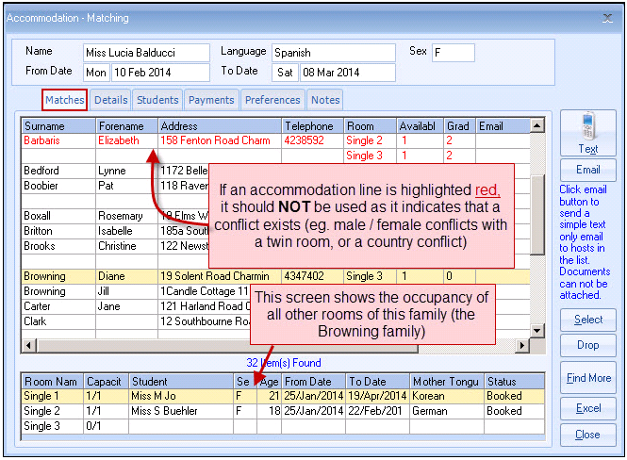

Now click on EXCEL to export the list of families together with their available room names to a spreadsheet.

NOTE: if you do not click FIND MORE to list ALL families first, then only the ones listed will be sent to Excel.
Example of Excel report:

Only the available beds are listed in the report.

