Class – Help Document


Problem: Need to produce a listing of host families that have hosted a student within a certain period.

The family should only be listed once if multiple students have been hosted. (Useful for the production of labels for Christmas Cards)

(Note: This report will only work if Class is used for producing host payments)

Solution:

Create a Quick Report:
Report Type – select ‘Accommodation’

Add the fields similar to the example below:

Ensure to include the ‘Payment Created Date’ field.
Untick the Include box to stop the each host being reported multiple times.
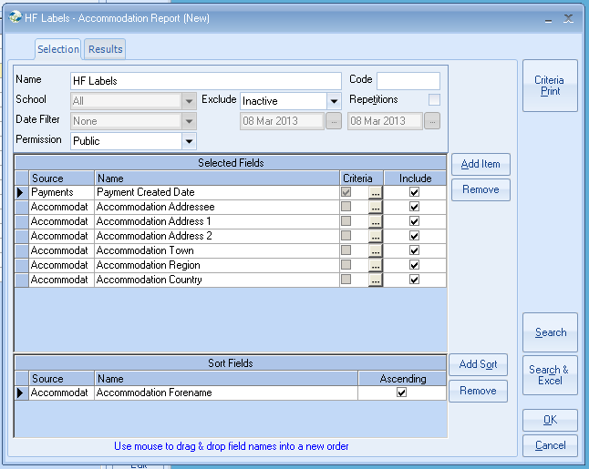
Click on the “Criteria” button alongside ‘Payment Created Date’

First amend the Comparison to ‘Greater Or Equal’
Search down the list of available dates for the first required date range,
i.e. 30/Jan/2013
Highlight this date
Select SET.

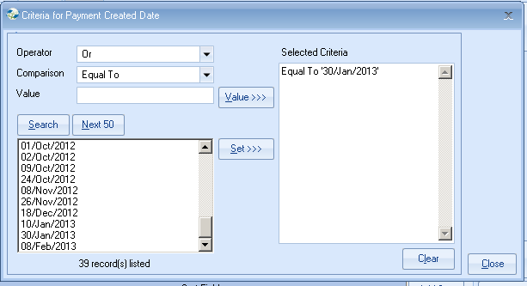

Now amend Operator to ‘AND’
Amend the Comparison to ’Less Or Equal’
Search down the list of available dates for the last required date in the range,
i.e. 08/Feb/2013 (Note: you may need to select Next 50)
Highlight this date.
Select SET.

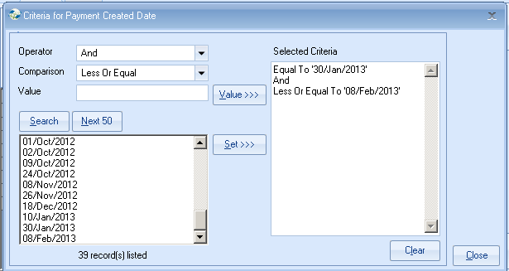

Ensure the ‘Selected Criteria’ shows your correct date range and the details are the same as my example.
Click on “Close”
Click on “Search”

This will display a list of families who have received a payment between the selected date ranges.

Please note:
Families that have not yet received any payments, but have students booked in the future will not be included in this list.

Send As Labels

Select the correct Label Format.
Select OK to merge the addresses in to Word where they can be printed out.

OR

Use “Send As Document” if you wish to merge this list with a master document that you have already created within Class.

