Class – Help Document


Popular Merge Codes

MASTER DOCUMENT – Showing popular codes
Updated 28/2/06

 | Table/Heading | Merged Field – Copy this Field | Comment

STUDENT
Student ID | Enrolment/Student | [Student.intStudentId]
Title | “ | [Student.txtTitle]
Forename | “ | [Student.txtForename]
Surname | “ | [Student.txtSurname]
DOB | “ | [Student.dteDOB]
Sex | “ | [Student.txtSexName]
Age | “ | [Student.intStudentAge]
Picture | “ | [Student.picStudentPicture]
Country/Birth | “ | [Student.CountryOfBirthName]
Country Name | “ | [Student.txtCountryName]
Nationality | “ | [Student.txtLanguageName]
Stud Schedule Hours | “ | [Attendance.decScheduledHours] | If Attendance in use
Stud Actual Hours | “ | [Attendance.decActualHours] | If Attendance in use
Percentage Attend. | “ | [Attendance.decPercentage] | If Attendance in use
Student Balance | “ | [Student Account.curAccountBalance] | If Ledger in use
Student A/c Curr Symbol |  | [Student Account.txtPaymentCurrencySymbol] | If Ledger in use
Last Payment Value | “ | [Student Account.curLastPaymentValue] | If Ledger in use
Last Payment Date | “ | [Student Account.dteLastPaymentDate] | If Ledger in use
ENROLMENT
From Date (Arrival) | Enrolment/Enrolment | [Enrolment.dteFromDate]
To Date (Departure) | “ | [Enrolment.dteToDate]
Enrolled Date | “ | [Enrolment.dteEnrolledDate]
Duration – Wks (rounded) | “ | [Enrolment.intDurationWeeksRounded]
Duration - Wks | “ | [Enrolment.intDurationWeeks]
Duration -days | “ | [Enrolment.intDurationDays]
GROUP
Group Name | Enrolment/Group | [Group.txtName]
Group Code | “ | [Group.txtCode]
From Date | “ | [Group.dteFromDate]
To Date | “ | [Group.dteToDate]
SCHOOL
School Name | Enrolment\School | [School.txtName]
School Code | “ | [School.txtCode]

AGENT
Agent Name | Main Agent | [Main Agent.txtName] | Use Commission Agent, not Main Agent
Commn Agent | Commn Agent | [Commission Agent.txtName] | Commission Agent –Use instead of Main Agent. This will additionally show the “Commn Agent” on a Direct Booking.
C/Agent Lookup Name | “ | [Commission Agent.txtLookupName] | Internal Reports – use Lookup name
C/Agent – Main contact - Title | “ | [Commission Agent.txtTitle]
C/Agent – Main contact - First Name | “ | [Commission Agent.txtForename]
C/Agent – Main contact - Surname | “ | [Commission Agent.txtSurname]
C/Agent Add1 | “ | [Commission Agent.txtAddress1]
C/Agent Add2 | “ | [Commission Agent.txtAddress2]
C/Agent Add3 | “ | [Commission Agent.txtTown]
C/Agent Add4 | “ | [Commission Agent.txtCountry]
C/Agent PTC/Zip | “ | [Commission Agent.txtPostalCode]
C/Agent Tel | “ | [Commission Agent.txtTelephone]
Agent Balance | “ | [Main Agent Account.curAccountBalance] | If Ledger in use
Agent Curr Symbol |  | [Main Agent Account.txtAccountCurrencySymbol] | If Ledger in use
Last Payment Value | “ | [Main Agent Account.curLastPaymentValue] | If Ledger in use
Last Payment Date | “ | [Main Agent Account.dteLastPaymentDate] | If Ledger in use

Course Header Course Booking

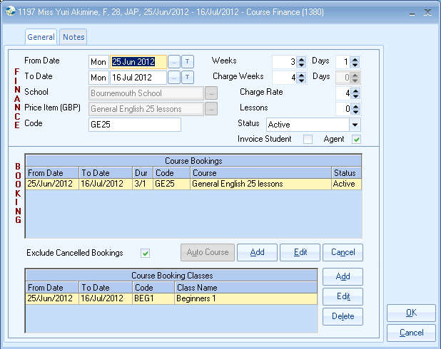
COURSE Header | FINANCE (Price Item) | EXTERNAL Documents  Used for Confirmations
Name 1 | CourseHeader\Course Header | [Course-Header.txtPriceItemName/1] | Price Item Name (Course) This refers to the “Top” part of the Course entry screen, ie the FINANCE item. Normally used in confirmation documents to Agent/Student
Code 1 |  | [Course-Header.txtPriceItemCode/1]
Start Date 1 |  | [Course-Header.dteFromDate/1] | Start date of Course 1
End Date 1 |  | [Course-Header.dteToDate/1] | End date of Course 1
 |  | Note: To show second/third price item etc. Repeat above only use suffix 2 (for second course), Suffix 3 (for third course) etc etc.
COURSE Booking 1 | BOOKING (Course Item) | INTERNAL docs e.g. Classing | This refers to the “Bottom” part of the Course entry screen, ie the booking.
Name 1 | CourseHeader\Course-Header-Booking | [Course-Header-Booking.txtCourseName/1/1] | Course Name. Only used in internal documents. This refers to the “Bottom” part of the Course entry screen, ie the BOOKING item.
Code 1 |  | [Course-Header.txtCode/1]
Start Date 1 |  | [Course-Header-Booking.dteFromDate/1/1] | Start date of Course 1
End date 1 |  | [Course-Header-Booking.dteToDate/1/1] | End date of Course 1
COURSE Booking 2 | Second Course |  | Course 2 is achieved by copying Course 1 and changing the numbers, as highlighted below
Name 2 | CourseHeader\Course-Header | [Course-Header-Booking.txtCourseName/2/1]
Code 2 |  | [Course-Header.txtCode/2]
Start Date 2 |  | [Course-Header-Booking.dteFromDate/2/1]
End date 2 |  | [Course-Header-Booking.dteToDate/2/1]

Special Course Booking Fields
First Course Name | First Course/First Course Booking | [First-Course-Booking.txtCourseName]
First Course From date |  | [First-Course-Booking.dteFromDate] | Used in Certificates to provide a date range for “All” Courses
First Course To Date |  | [First-Course-Booking.dteToDate] | Used in Certificates to provide a date range for “All” Courses
Current Course |  | [Current-Course-Booking.txtCourseName]
Current Course From date |  | [Current-Course-Booking.dteFromDate]
Current Course To Date |  | [Current-Course-Booking.dteToDate]
Last Course |  | [Last-Course-Booking.txtCourseName]
Last Course From date |  | [Last-Course-Booking.dteFromDate] | Used in Certificates to provide a date range for “All” Courses
Last Course To Date |  | [Last-Course-Booking.dteToDate] | Used in Certificates to provide a date range for “All” Courses

Special Class Fields
Last Class Name |  | [Last-Class.txtName]
Last Class Level Name |  | [Last-Class-Level.txtName] | Used in Certificates to provide the level the student attained. This value is taken from the “level” field in the Class record
Accommodation Header Accommodation Booking
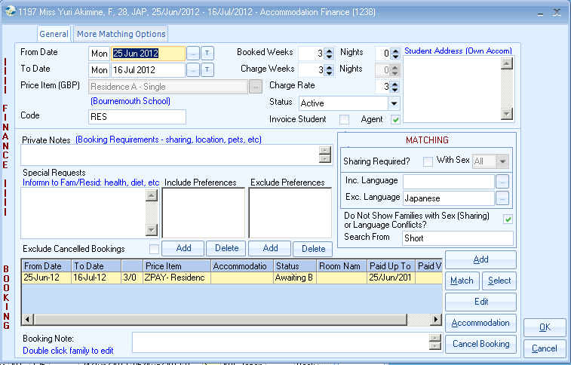

ACCOMM Header 1 | FINANCE (Price Item) | EXTERNAL Documents  Used for Confirmations
Name 1 | AccommodationHeader\Accommodation-Header | [Accommodation-Header.txtPriceItemName/1] | This refers to the “Top” part of the Accommodation screen, ie the FINANCE item. This used in documents to Agent/Student
Code 1 |  | [Accommodation-Header.txtCode/1]
Start Date 1 |  | [Accommodation-Header.dteFromDate/1]
End Date 1 |  | [Accommodation-Header.dteToDate/1]
Special Request |  | [Accommodation-Header.txtSpecialRequestNote/1]
Status |  | [Accommodation-Header.txtStatusName/1] | Quick Reports – Select only “active”
ACCOMM Booking 1 | AccommodationBooking\Accommodation-Booking | EXTERNAL (for HF details)  EXTERNAL (for HF Confirmations) | This refers to the “Bottom” part of the Accommodation screen, ie the Booking item. Used in documents to Family.
Name 1 |  | [Accommodation-Booking.txtPriceItemName/1] | Accommodation 2 is achieved by copying Accomm 1 and changing  the numbers highlighted
Start Date 1 |  | [Accommodation-Booking.dteFromDate/1]
End Date 1 |  | [Accommodation-Booking.dteToDate/1]
Status |  | [Accommodation-Booking.txtStatusName/1]
Week 1 payment Val |  | [Accommodation-Booking.curWeeklyPaymentValue/1] | Week 1 payment value (often used to show weekly value)
Total payment Due to HF |  | [Accommodation-Booking.curTotalHostPayment/1]
Host Title | Accommodation Booking\Accommodation-Booking-Host | [Accommodation-Booking-Host.txtTitle/1]
Host First Name |  | [Accommodation-Booking-Host.txtForename/1]
Host Surname |  | [Accommodation-Booking-Host.txtSurname/1]
Host Addressee |  | [Accommodation-Booking-Host.txtAddressee/1]
Host Address line 1 |  | [Accommodation-Booking-Host.txtAddress1/1]
Host Address line 2 |  | [Accommodation-Booking-Host.txtAddress2/1]
Host Address line 3 |  | [Accommodation-Booking-Host.txtTown/1]
Host Address line 4 |  | [Accommodation-Booking-Host.txtRegion/1]
Host Address line 5 |  | [Accommodation-Booking-Host.txtCountry/1]
Host Address line PTC/Zip |  | [Accommodation-Booking-Host.txtPostalCode/1]
Host Tel |  | [Accommodation-Booking-Host.txtTelephone/1]
Host Mobile |  | [Accommodation-Booking-Host.txtMobileNumber/1]

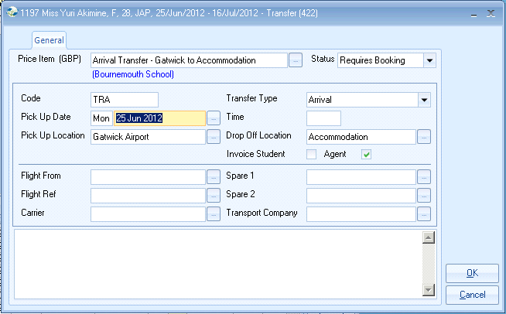

TRANSFER
Name 1 | Transfer\Transfer | [Transfer.txtPriceItemName/1] | Transfer 2 is achieved by copying Transfer 1 and changing the numbers highlighted
Code 1 |  | [Transfer.txtPriceItemCode/1]
Date 1 |  | [Transfer.dtePickUpDate/1]
Time 1 |  | [Transfer.dtePickUpTime/1]
Pick up Name 1 |  | [Transfer.txtPickUpName/1]
Drop off Name 1 |  | [Transfer.txtDropOffName/1]
Flight Origin |  | [Transfer.txtAnalysis1/1]
Flight Ref |  | [Transfer.txtAnalysis2/1]
Status 1 |  | [Transfer.txtStatusName/1]
Note 1 |  | [Transfer.txtNote/1]

OPERATOR
DETAILS
Todays date | Special Fields | [Special Fields.Todays Date (Short)]
Todays date |  | [Special Fields.Todays Date (Long)]
User Name |  | [Special Fields.User Name]
User Title |  | [Special Fields.User Title]
Users Email |  | [Special Fields.User E-Mail]

