Class – Help Document


DATE FORMATS for Excel, Class and Word

Excel Problem

When merging reports to Excel/Word the dates are appearing incorrectly e.g. 12.25.16 when it should be 25.12.16

Solution

From the desktop select:

- My Computer

- Control Panel

- Regional Settings - Check this is set to English (British)

- Select the Date tab.
Amend the Short Date Style to – dd/MMM/yy (25/Dec/16)
Amend the Long Date Style to – dd MMMM yyyy (25 December 2016)

- Select Apply
- Select OK

Problem
The date format is incorrectly showing as the US format, i.e. 12.25.16 in merged.

Solution
Amend the merge field

Setting Word Label Merge Fields Date Format

It appears that some Windows versions cause dates to be formatted in US date style (mm/dd/yyyy) where merging to labels from Excel/Word within Class SQL.

The way to get around this is to format the desired fields within the label template document to the desired format.

- Open the Quick Report that you want merged with labels and click ‘Search’ to get the results.
- Click ‘Send As Labels’ to get the following screen.

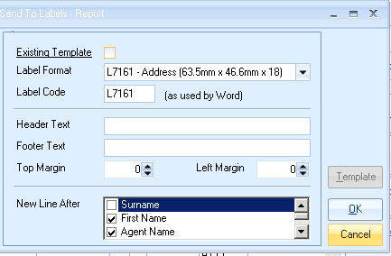

- Click on ‘Existing Template’ to open the label template document in Word

- Position the mouse over the first date field to be amended.
Click on the RIGHT mouse button.
Select ‘Toggle Field Codes’ from the popup menu that appears
The field will look similar to the example below showing {MERGEFIELD followed by the merge field name}:

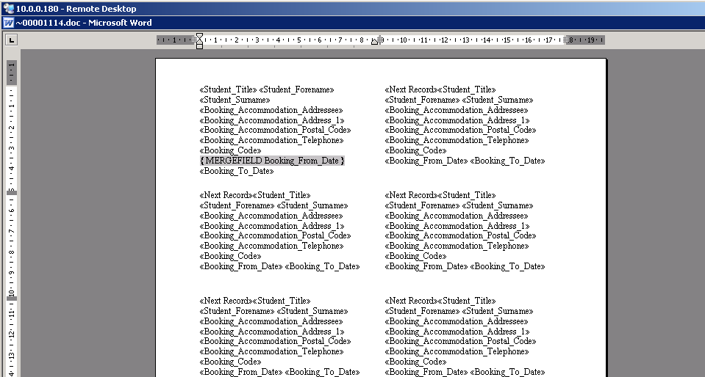

- Position your cursor after the name of the merge field-
Type a SPACE followed by a BACKSLASH (‘\’) then an (‘@’) symbol and then the date format required (this is customisable but we suggest dd/MM/yy) and insure the formatting is NOT outside the ‘}’ of the field.
Example: {MERGEFIELD Booking_From_Date \@dd/MM/yy}
(ensure there is a space between Date and \)
See example below:
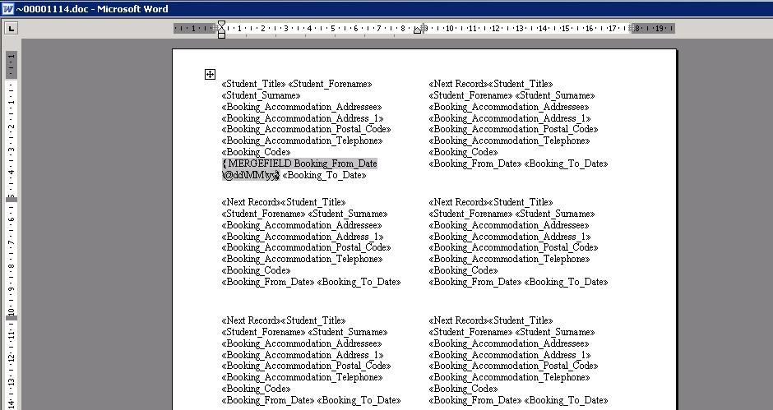
Or to see the dates merged as 25/Dec/2016 enter the code as:
{MERGEFIELD Booking_From_Date \@dd/MMM/yyyy}

- Do the same for any other date fields within the first label.
- Now you need to set up the other labels on this form with the toggled fields. You can do one at a time or copy and paste the information from label one in to all the other labels on the page.
- Save the document and close it down

When you next merge this document to labels the date should display in the format specified on the template.

