Class – Help Document


Popular Excel Formulas

Question 1
I have produced a list of Agents with their total Enrolments for the year but now need to:
- Sort by number of Enrolments
- Add percentage of Total Enrolments

Answer 1
First of all export your report to Excel. “This is only an example”

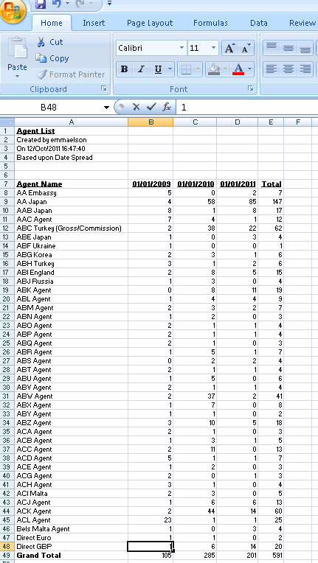

Sort the rows so that they are ascending order of the “Total” column.

As the “Total” column is a formula one method would be to:
- Highlight the “Total” column
- Right-click and then “copy”

Click on the next available free column
- Right-click and then “paste special”
- Click on “values”
- Click on “OK”

This will then move all the figures to the new column but without the formula

- Now highlight and delete the original column – in this example it would be column E.

Sort the rows in ascending order by “Total”
- Highlight all the data that you want sorted
- Click on “Data”
- Click on “Sort”

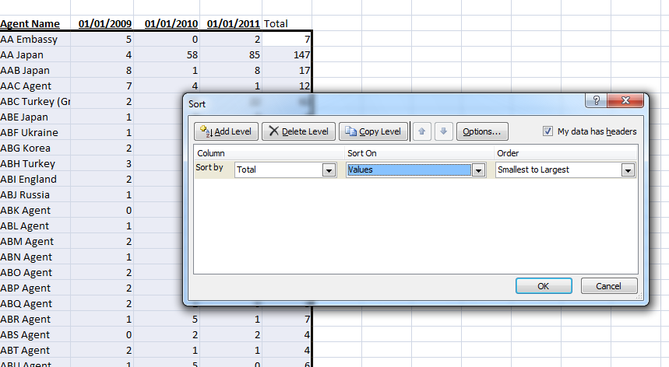

Click on “OK”
The rows will now be resorted.

To add the percentage of the Total for each row.
(once again using the above example)

- Put your cursor into column F2
- In the formula field input =E2/$E$19
- Click out of this field

To format how the percentage is displayed
- Click on cell F2
- Right click
- Select “Format Cells”
- Select “Category” of “percentage” and also how many decimal points you want to use
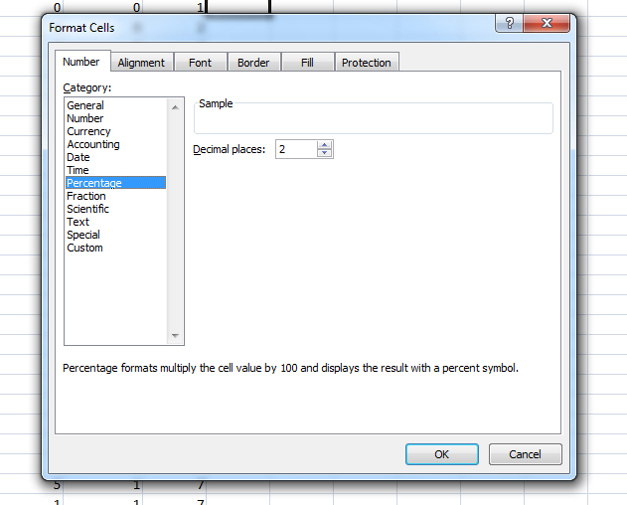

Click on “OK”

Now you need to copy this to the other cells you want this formula to be used in.

- Click on cell F2
- Right click and select “Copy”
- Highlight cells F3 to F18
- Right click and select “Paste Special”
- Select “Formula and number format”
- Click on “OK”

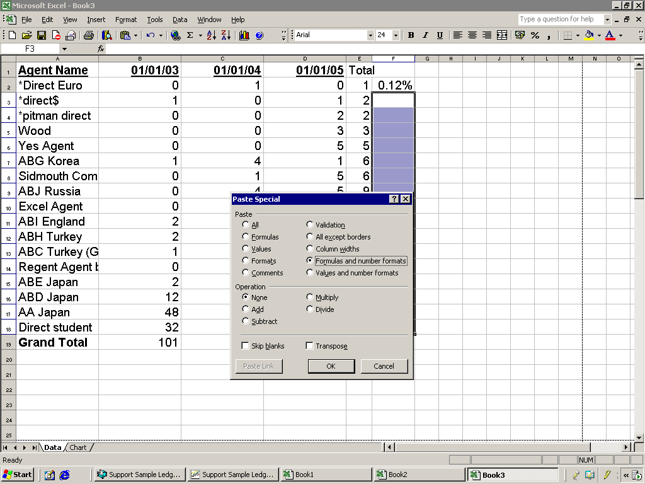

The column will now be filled with the percentages of the “Total”

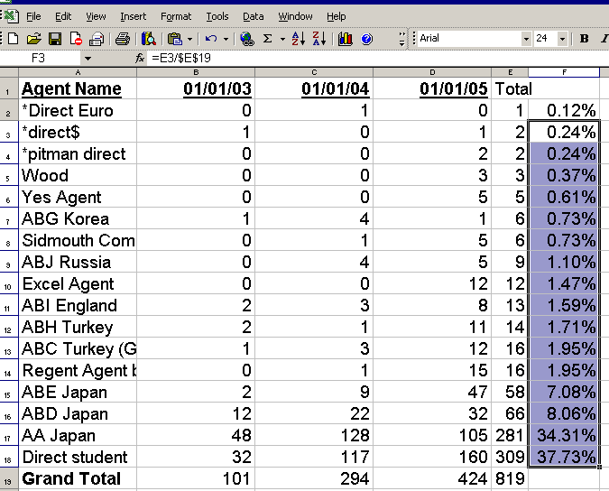

Question 2
I have produced a list of student weeks by course for the year but now need to:
- See the student numbers (not weeks)

Answer 2

First of all export your report to Excel. “This is only an example”
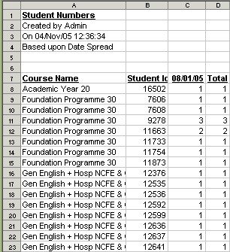

Highlight the top columns and delete them so that the column headings are displayed in row 1.
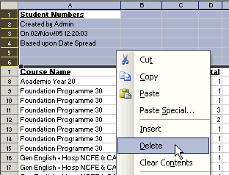

Highlight the Course Name column by clicking on ‘A’
Select ‘Data’ from the menu toolbar and choose ‘Subtotals’ from the list.
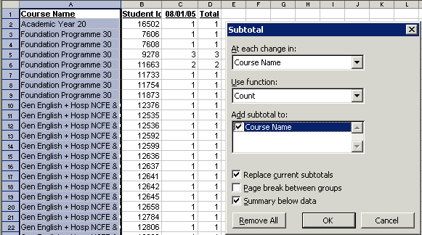
Click on “OK”

The report will now sub total on change of course but the students will still be listed.

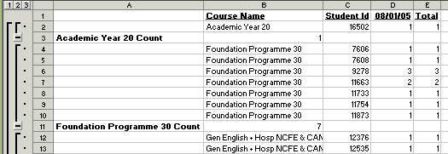

Click on the number 2 in the margin.

This will collapse all the columns to leave just the course names together with the total student numbers (count) for the year.

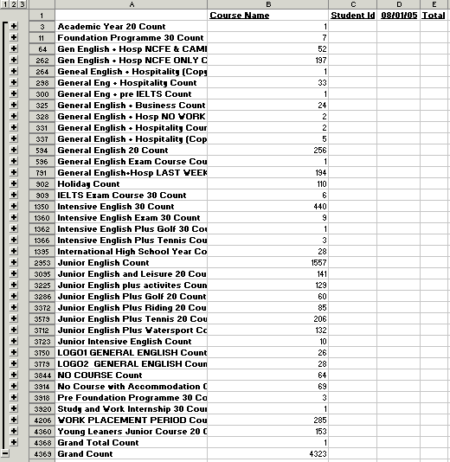

You can tidy up the Excel spreadsheet by re-arranging and deleting unwanted headings:
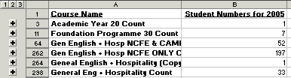

Question 3
I have produced a list of all Agents that have sent us students from 2001 – 2005 with their contact details (address, phone, fax, email etc.) problem is it displays the Agent name for all students, need to see the Agent name once.

Answer 3

First of all export your report to Excel. “This is only an example”

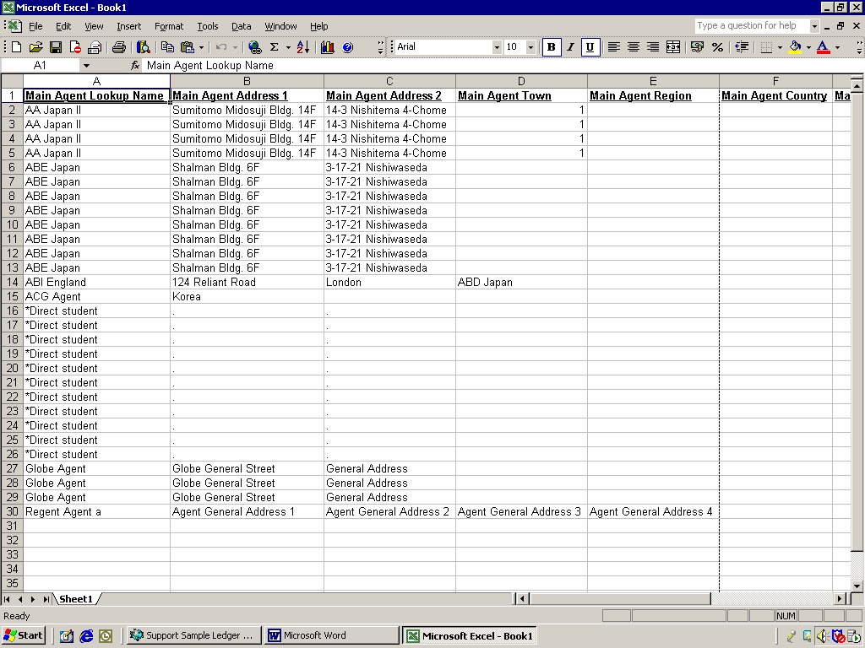

Highlight all the columns

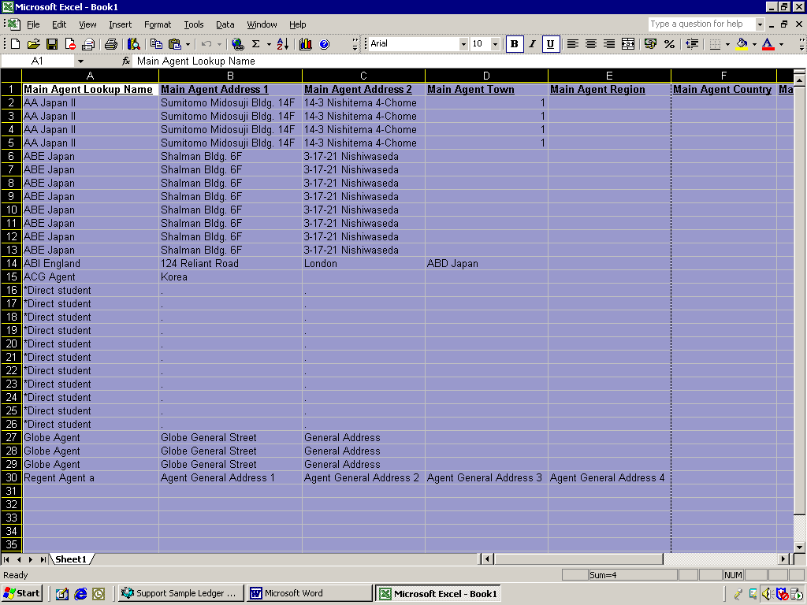
Click on Data/Filter/Advanced Filter

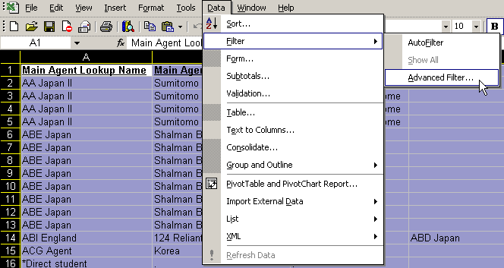

Tick Unique records only
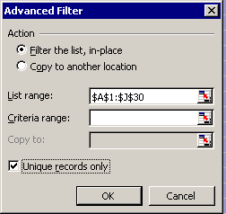
OK

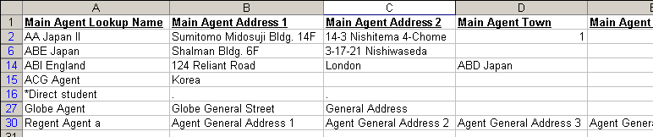

The other Agent names have been hidden.

Q4 – I have exported a report to Excel detailing Host Family name, address and payments but would like a summary report that gives the family name, address and total of all payments.

Export list from Class to Excel without subtotals
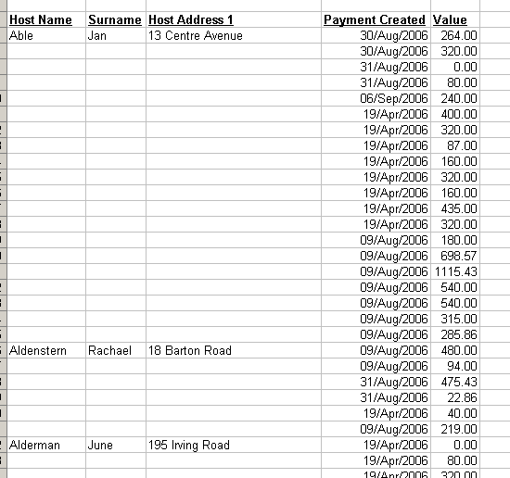

Insert a blank column A

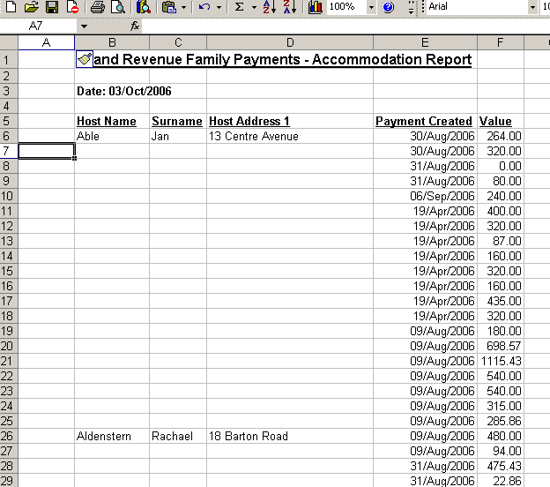

Put your cursor in column A for the first family click on:

Fx

concatenate putting column B, C AND D into the three Text Fields.
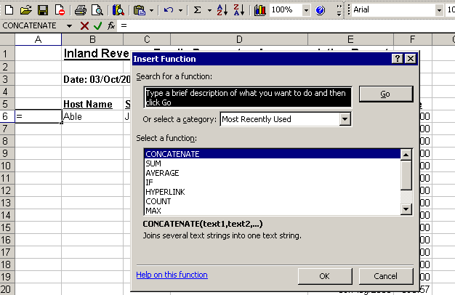

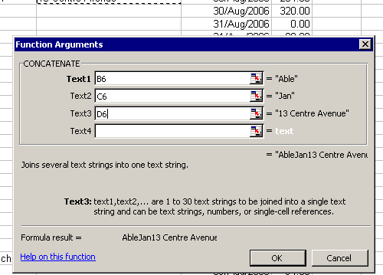

This puts the family name and address into column A

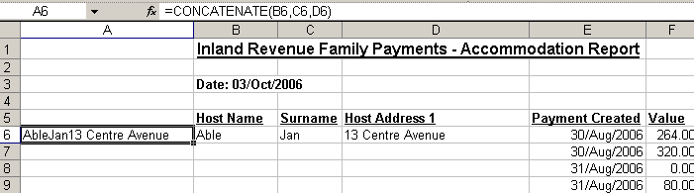

copy the cell just created

paste into rest of column A by using Paste Special, Formula - this will copy the command to all the families

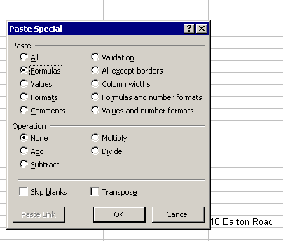

Use the sub-total command to total on change of family

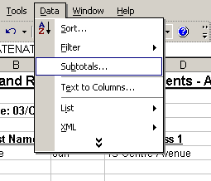

Now you can close down subtotal 3 to get just a list of family name, address and total.

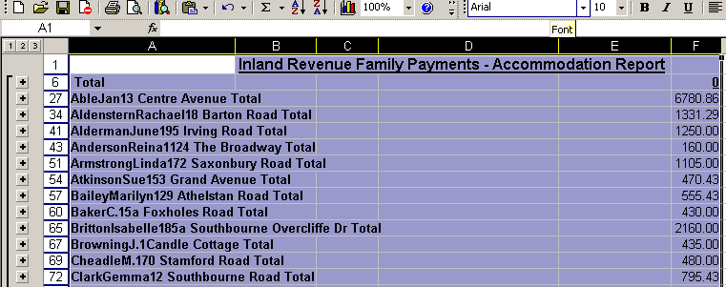
Q5 How to get Excel to total the number of entries but to exclude blank columns.

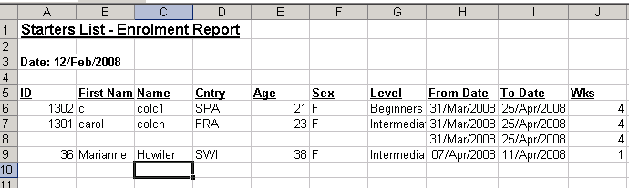

The total number of students is 3 but the total number of lines is 4. To get the total number of students use the following command:

=COUNTA(A6:A9)

