Advanced Accommodation Chart

Purpose
To provide, at a glance details of when, rooms are occupied/free, at a specific (or all) accommodation(s), on a weekly basis.

Features:
- Visual details of the Student’s Name, Sex, Age, and Language.
- Colours - used to distinguish sexes and other booking states. (e.g. part week bookings, over bookings)
- Room changes can be made directly from the chart.
- Note facility
- Weeks can start any day of the week e.g. Sat, Sun, Thurs.
- Output – Excel
- Chart expands/contracts according to screen definition size.
- Occupancy statistics.

Age parameter allows a colour highlight to indicate students below a specific age at start of accommodation e.g. under 16

The chart enables schools to maximise occupation of accommodation, particularly to those with a large number of rooms, such as residences. It can also be used to show the level of occupancy over any period of time for all or any specific type of accommodation e.g. Host Stay single – Week Commencing 1/7/04 300/400 (75% occupancy)

It can also highlight the following possible problems:
Rooms overbooked (although the system warns when making the booking).
Booking students into a room that is “Not Available”
(e.g. it is being redecorated).
Booking mixed sexes students, into the same room.
Selection screen:
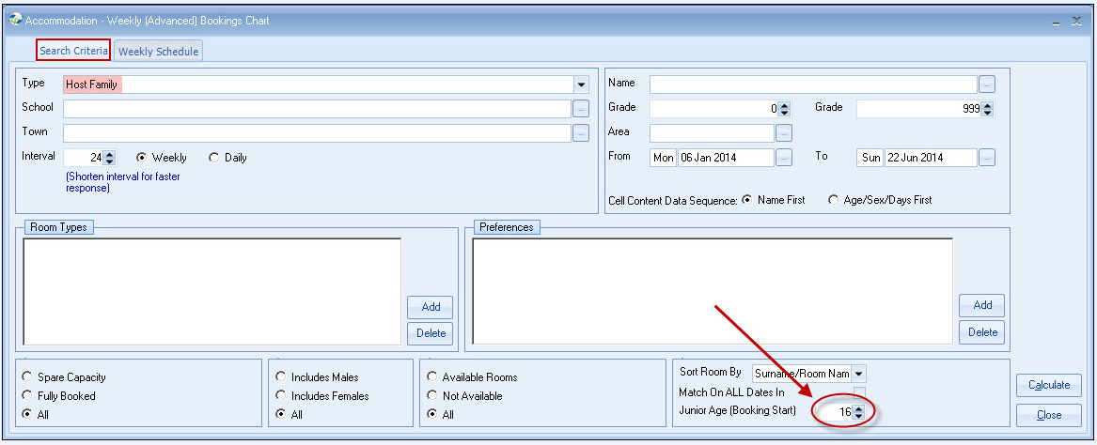
Note: The chart will automatically resize to your screen resolution, if your screen display is only set to 800 x 600 only 9 weeks are displayed, more information can be seen by changing to a higher resolution e.g.1024 x 768 (12 weeks displayed)

Results
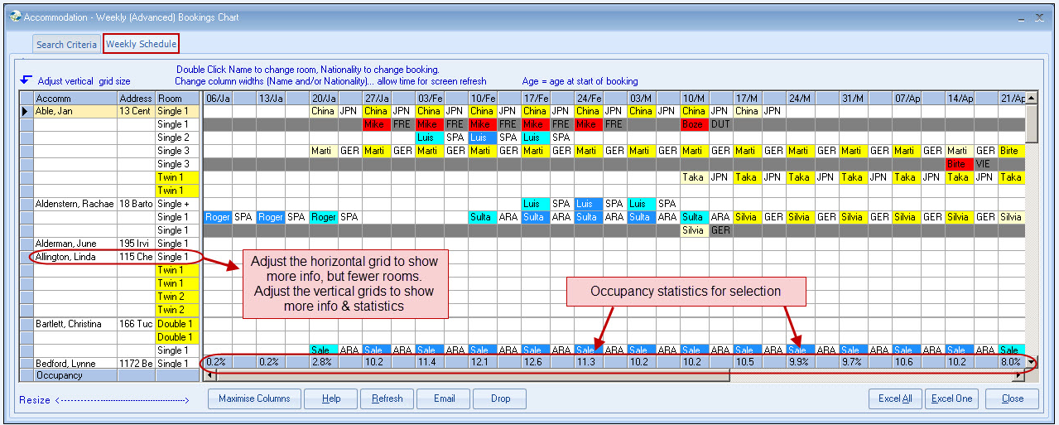

Adjust the horizontal grid to show more information (but fewer rooms).
Adjust vertical grids grid to display more information. (Also shows more statistics)

- Hover/single click the student to display more information.

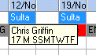

- Double click the student to display the booking details (which may be updated e.g room change.) The change will only show if the display is Refreshed)

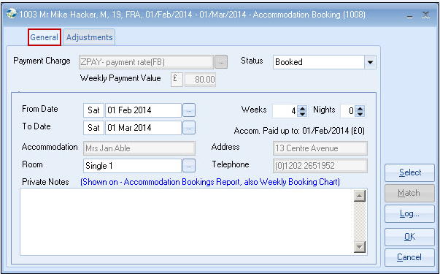

- Double click Nationality to display complete booking (which may be updated).

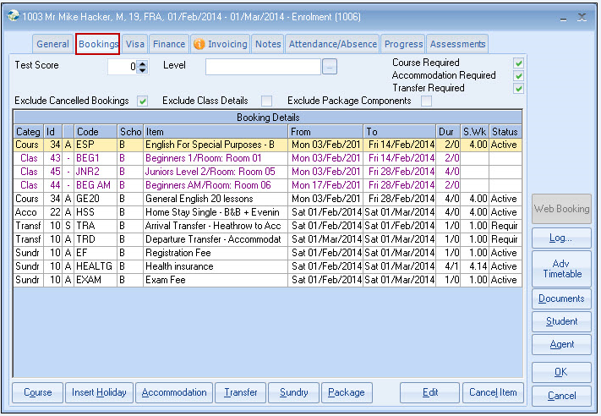

- Double click “Family” to show details

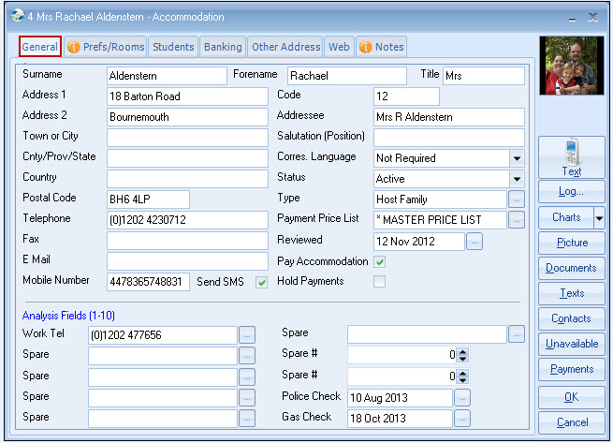

Help
A Key to the colours is displayed.

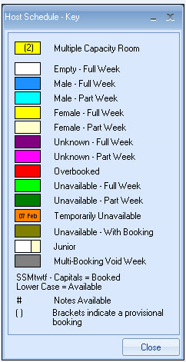

Maximise columns
Shows columns at full width

Refresh
Rechecks the booking details & redisplays the grid.
This allows the selection to remain on screen (say for several hours) while bookings are processed. Perform a Refresh periodically, but not after every change as this is likely to affect machine performance if done too regularly.

Excel
This sends the details to Excel to allow data manipulation & printing.

