Class – Help Document


Problem:
I need a list of all agents that have sent us students in a particular date range with their contact details.

Solution:
Create an Enrolment report

- Click on Reporting (top of the screen)
- Quick Reports
- Report type – set to Enrolment General
- Click on Add

Set the Date Filter to Present and enter your date range, i.e. 08 Mar 2013 to 08 Mar 2013

Add the required fields similar to the example below:
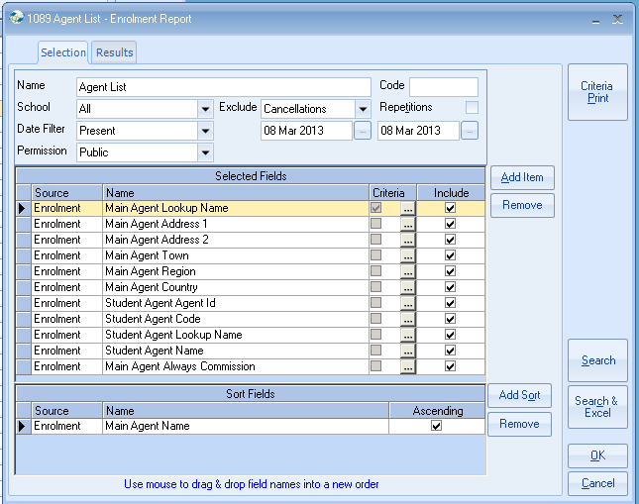
If you do not wish to include the *Direct Students in this report, add the following criteria to the Agent Name or Agent Lookup Name field.
Comparison = Not Equal To
Select your *Direct student (or multiple direct students if applicable)
Select SET

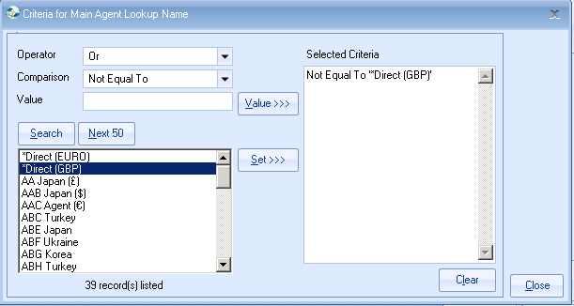

Select Close

Click on Search & Excel

This will open up an Excel spreadsheet as you will see the Agents name shows for each student they have sent.
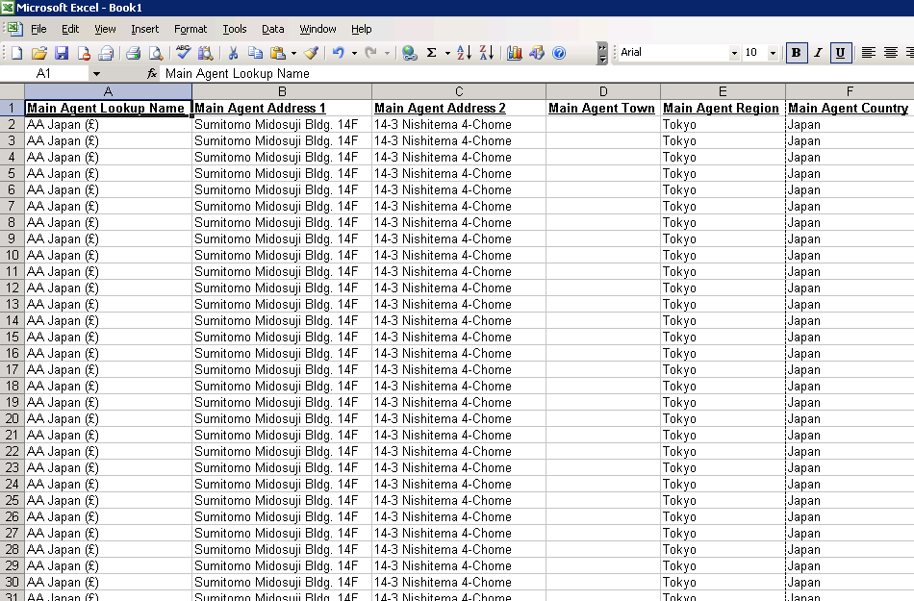
To list the Agent name once for each student do the following.

Highlight all the columns
To do this place your cursor in the corner square next to Column A and Row 1 and click.
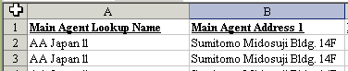

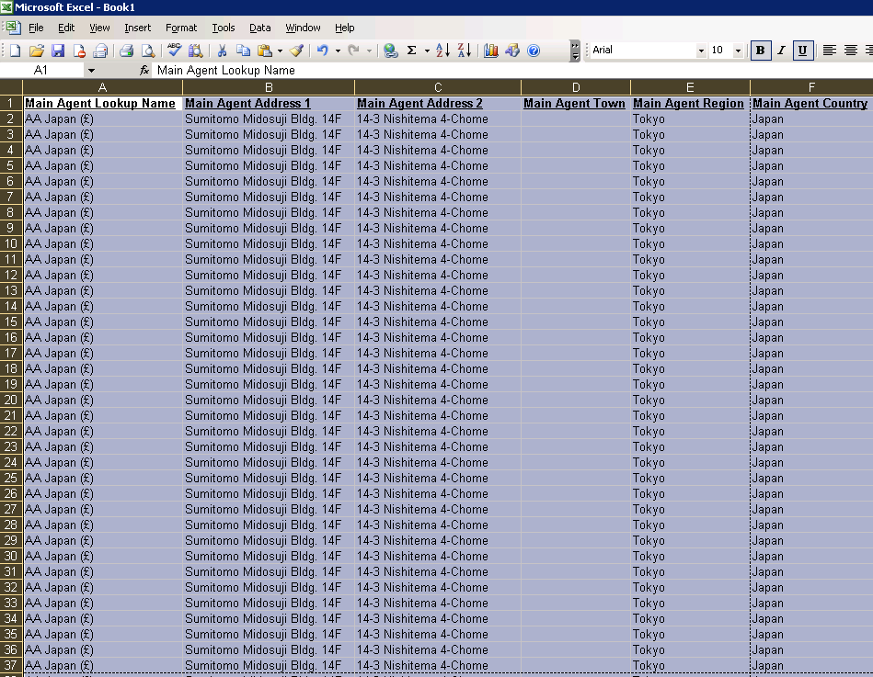

Click on Data/Filter/Advanced Filter
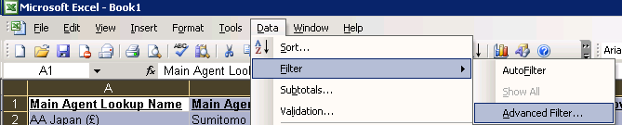

Tick Unique records only
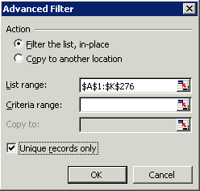

Select OK

The duplicate Agent names have been hidden and now each agent is displayed only once.

