Class – Help Document


Statistics

General:
Statistics in Class are either based on “Booking” values (i.e. the date bookings are entered into the system, not when the student attends) or “Production” (date spread) values (i.e. based on when the student attends.)

Marketing are often interested in Booking values as these reflect the current level of booking activity. Class can compare the current period with the same period last year.
So for example the first 8 weeks of 2011 can be compared with the same 8 weeks the previous year.

Finance is generally more concerned with Production values reflecting the figures appearing in the P&L account.

Payment: Payment for a booking has no relationship to Booking or Production values.
Of course receipt of funds is very important but is not relevant in looking at the key Booking and Production statistics.

Example Booking:

Booking date | Attending | Net Value
1 Jan 11 | 1 Jul 11 – 30 Jun 12 (1 year) | £12000

Period | Booking  Value | Production value
1 Jan 11 - 30 Jun 11 | £12000 | Nil
1 Jul 11 - 31 Jul 11 | Nil | £1000
1 Aug 11 - 31 Dec 11 | Nil | £5000

At the end of the year (31 Dec 11) there is £6000 of (Production) income to be deferred until 2012.

Each of the Class Statistics will require you to enter “Booking” or “Production.”

Using Class Statistics:
Start at the top level (All School Statistics Summary) and then analyse further using the Booking and Production Statistics.
All statistics default to extracting “tuition” income/weeks, but other income can also be included.

All School Statistics Summary - Top level

Designed to address the questions:
- Current state of the Bookings so far this year (+ compare with last year).
- Or, what (Production – P&L) income has been earned so far this year (+ compare with last year).

Booking based:
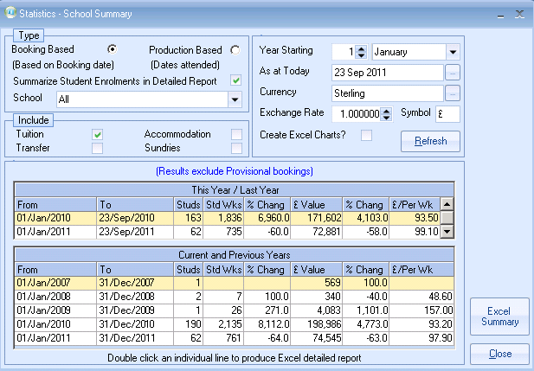
Booking based
1 Jan – 31 May
Students Up
Wks Up
Net Value Up
However, net income per week is down considerably!

Production based:
Production based
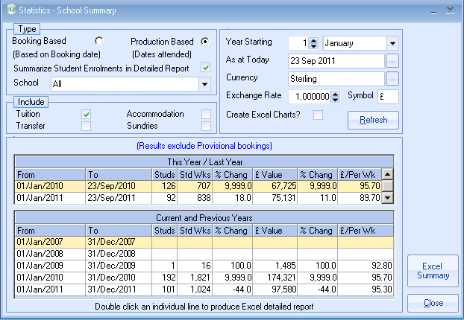

1 Jan – 31 May
Students Up
Wks Up
Net Value Up

However, net income per week is only a fraction down! These are only sample figures, and numbers are very low, but would clearly illustrate that current bookings are producing low incomes per week. Each School can be analysed separately.

Where do I find the All School Statistics Summary?

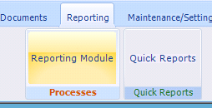

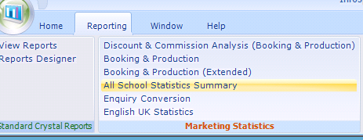

How do I analyse further?

Booking and Production Statistics: (Detailed)

Having looked at the top level statistics much can be gained by looking at the next level down where the concentration is on Countries, Agents and Products and comparing weeks, months and cumulative with the previous year.

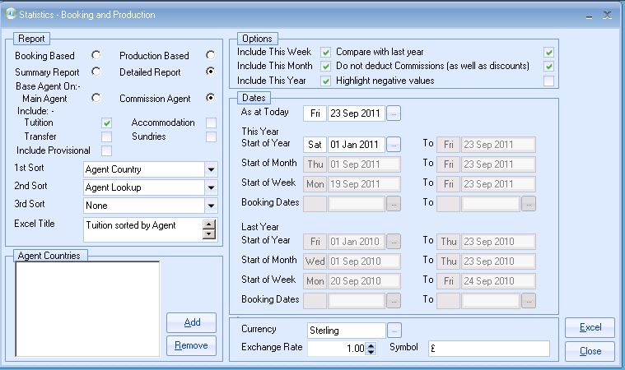

You can see from the results below that the total values are the same as the All Schools Statistics. It is important when comparing figures between different statistics that the same parameters are used.
The results below provide totals by Country by Agent, but the parameters allow a far greater range of options e.g. by product and by Week/Month etc

These below figures are cumulative for the year.
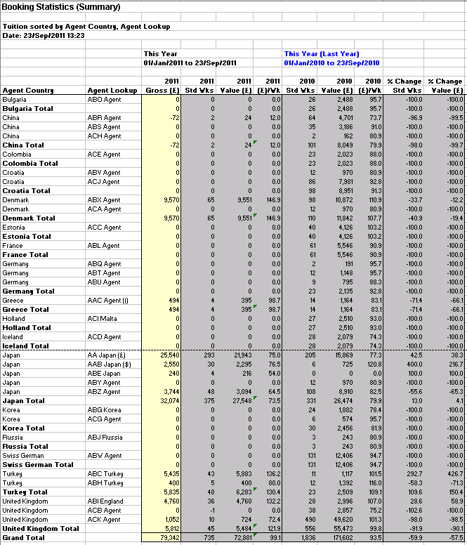

Production Statistics will produce the same set of comparatives.

Where do I find the Booking and Production Statistics?

Reporting (top of the screen)
Reporting module
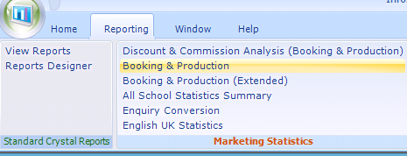

What if I want to go further?

There are the Booking and Production (Extended) Statistics allowing up to 5 years of comparatives to be made, and there is the Statistics Generator which allows you to compile a whole range of other useful statistical data.

Finance users will need to use the Statistics generator (Invoice Statistics) to get Class to calculate the deferred income at the end of each Accounting period. This is covered in a separate Help Sheet.

