Class – Help Document


How to print a list of students within a Group

2 Examples:

1) There is a standard report that can be used:

- Go to: Reporting
- Reporting Module
- Select: Reports (first icon on left)

- Group Reports - Summary

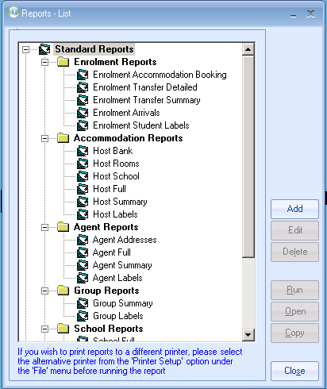
If this is not in the format required then you will need to create a “Quick Report” similar to the following:

2) Create an ‘Enrolment-General’ Quick Report

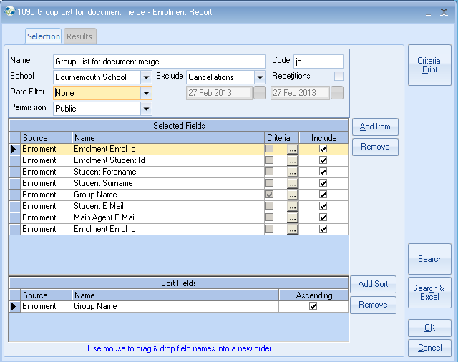

Add Criteria to the Group Name - Equal To
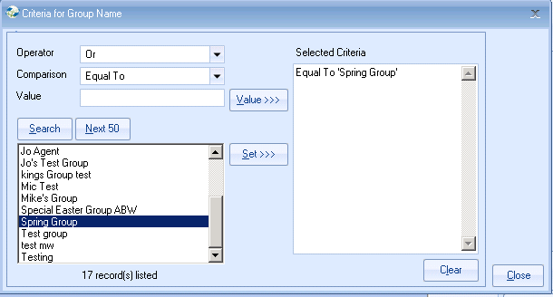
Click on “Close”
Click on “Search”

You can, of course, add whatever additional information regarding the students/courses/accommodation as required as the above is just an example.

