Class – Help Document


Problem – When sending out emails from Class you get the following screens displayed for each email.

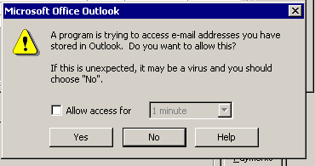

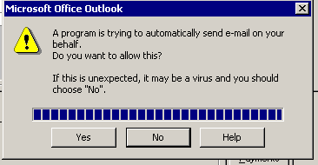

Solution

We would recommend that:

the following be carried out by a technician
- you check the Microsoft webpage for any updates

Please Note: Infospeed cannot be held responsible for any issues that may arise from carrying out the following procedure.

Deploying Outlook Security Administrator

THIS WILL ONLY WORK IF:

- You are using server-based mailboxes (not local .PST files)
- The latest service packs are loaded

- DOWNLOADING THE UPDATES

Download the ADMPACK.EXE file from the following link…

http://www.microsoft.com/office/ork/xp/appndx/appa11.htm

EXCHANGE SERVER SETTINGS

This is where the Outlook settings are kept.

a. Start System Manager
b. Create a new folder called “Outlook Security Settings” within “Public Folders”
c. Grant permission for all users to have full access to new folder

ADMIN PC SETTINGS

This PC is used to create and administrate the Outlook settings.

a. Install the ADMPACK.EXE files to the local PC (C:\ADMPACK)
b. Copy HASHCTL.DLL to C:\WINDOWS\SYSTM32
c. Use REGSVR32 to register HASHCTL.DLL
d. Run the “OutlookSecurity.oft” Template
e. Select the “Outlook Security Settings” within “Public Folders”

d. You may now set the required security settings as follows…

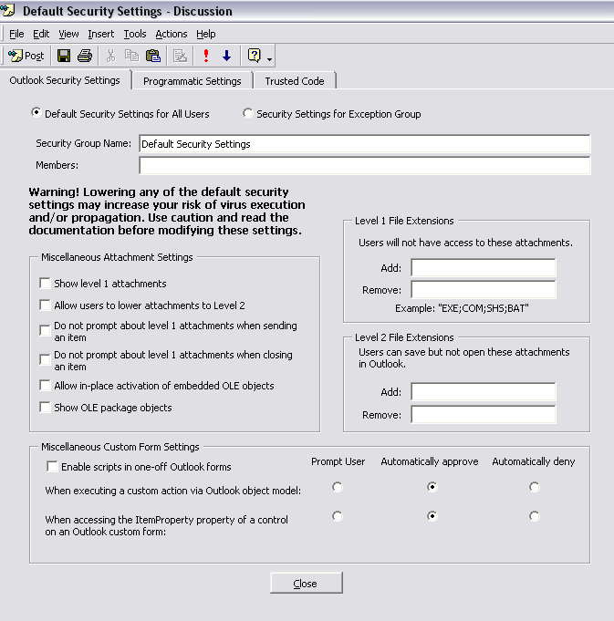
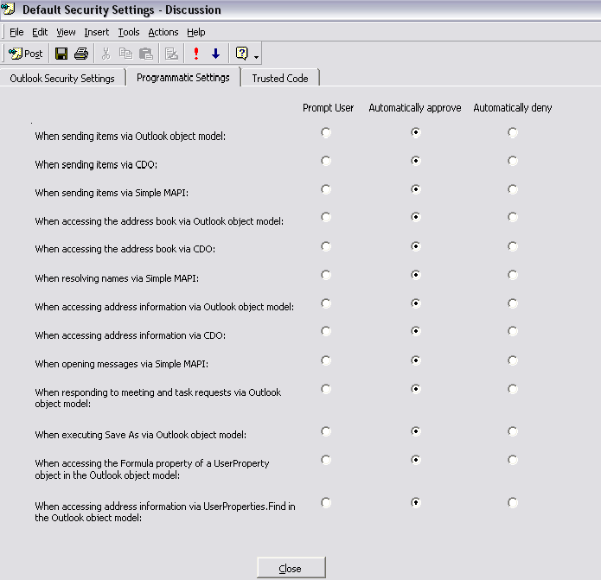

e. Click “Tools”, “Forms”, “Publish Form” and then select the “Outlook Security Settings” folder
f. Name the file “Outlook Security Form”

This only has to be run once; i.e. not from all workstations.

USER PC SETTINGS

This is the end-user’s PC. The following needs to be applied for all users…

a. Start REGEDIT
b. Add a key value HKEY_CURRENT_USER\Software\Policies\Microsoft\Security
c. Add a value to the above key called “CheckAdminSettings”
d. Set the value for the new item to “1”

