Class – Help Document


Period End Accounting

Provision for Unpaid Agents Commissions

General:
At the end of an accounting period there may be Commissions due but not paid. E.g. Gross Agents (Agents who pay 100% and receive back the commission later) or Net Agents who are due commissions on extensions. For accounting purposes it is necessary to make a provision for these costs.
- 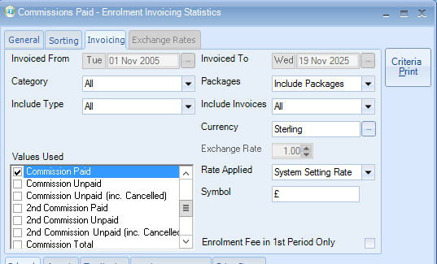Reporting
- Reporting Module.
- Select Reporting
- Statistics Generator
- Invoicing

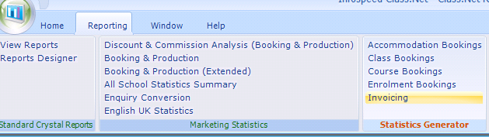

ADD a new report – Commissions unpaid

General screen:

- Basis – Date Spread
- From Date – enter the date the report is to start from
- Period Type – choose Weeks or Months
- Periods – enter the number of weeks or months you wish to report on.

If you wish to filter this report, select the relevant tab at the bottom of the screen. The example is for a particular agent.
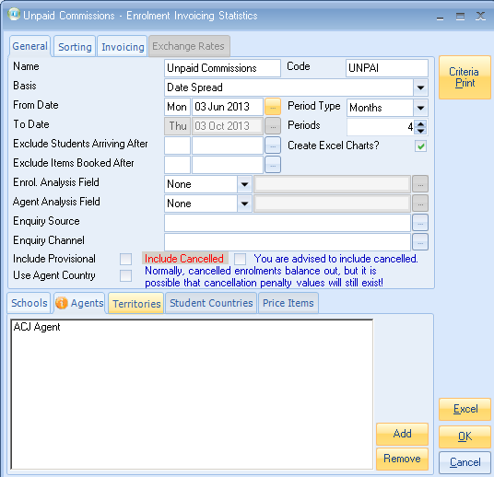

Sorting screen:

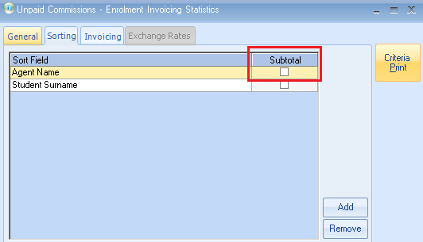

If you wish your report to show sub-totals after each agent tick this box.
Invoicing screen:

- Include Invoices: Invoiced
- Value Used: Commission Unpaid

Note: you can select “Commission Paid” to produce a report to show what commission has been paid during a certain period.

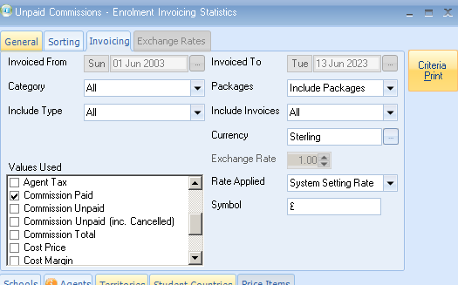

- Select Excel

Example output:

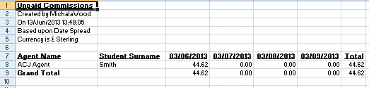

- Remember the parameters above have been set to only include invoiced items.
- Total the values up to the relevant accounting period end and use this as the provision for the period. The journal must be reversed out at the start of the next accounting period and recalculated again at the next period end.

