Class – Help Document


How do I set up a new School?

Go to Maintenance/Settings > Schools
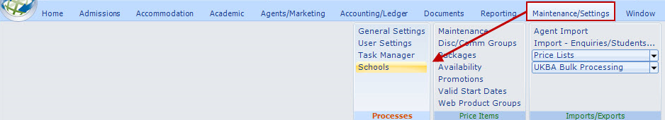

Select ADD

General screen

Enter the school details.
Amend the Currency if required
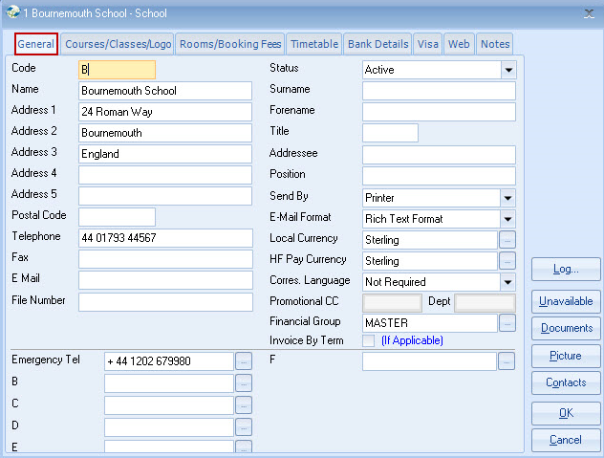

Courses/Classes/Logos

The Courses and Classes will automatically be added to the school when you set up the courses within the price list and classes.

If you wish to have a different logo you will need to add the path, see above.

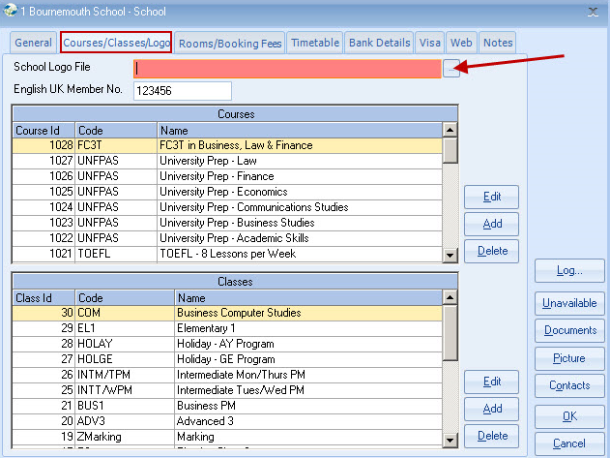

Class Rooms/Booking Fees

If you want to charge a booking fee every time the school is entered then you will need to add it here.

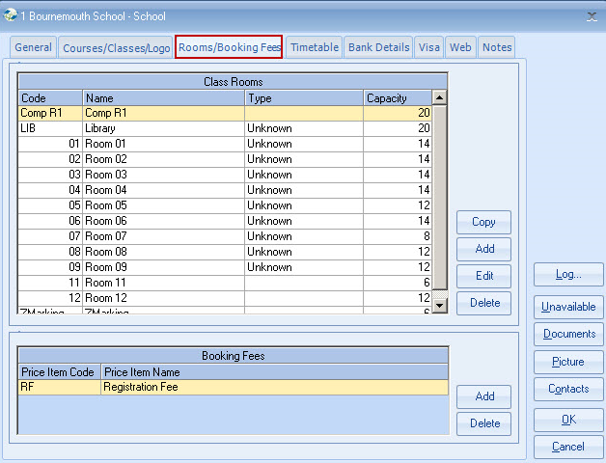

Timetable screen:
(Only applicable if the timetabling module is in use)

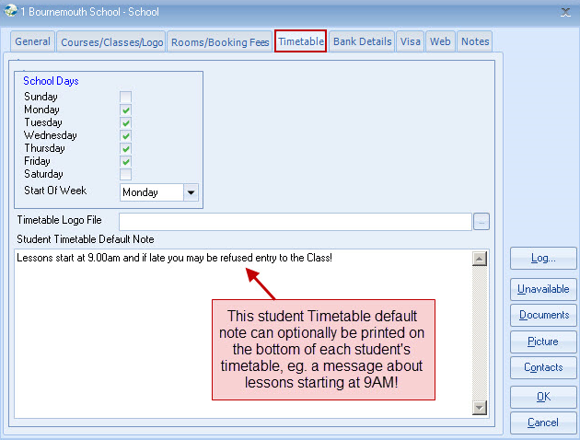

Visa screen:
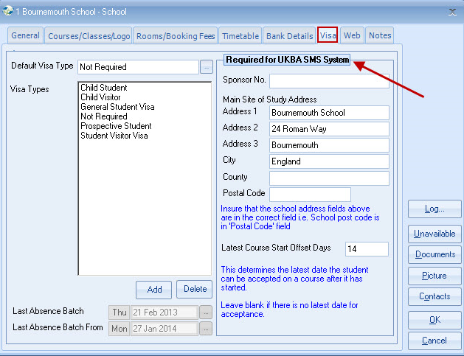

Web screen:
(Only applicable if the Class Online Toolkit module is in use)

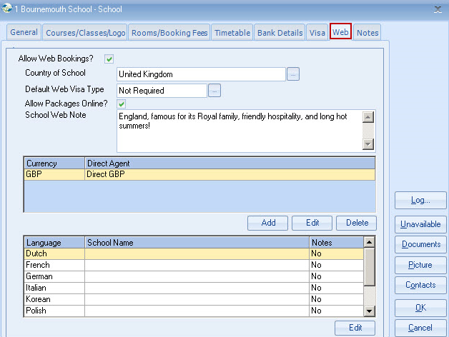

Notes tab:
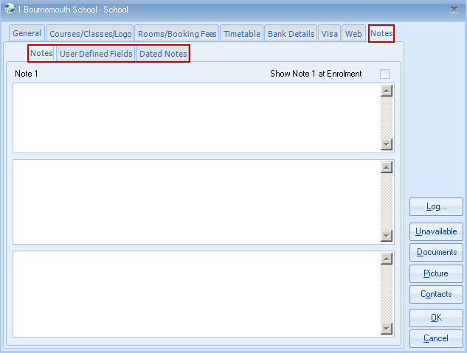

Once the new school is entered you will need to set up the price list.
Maintenance/Settings > Maintenance

