

Class – Help Document

PROBLEM
How do I deal with price increases in Class?

SOLUTION
Amend the Price Lists.
Do this by selecting: Maintenance/Settings > Maintenance.

The default screen will display the Price Items attached to the Master Price List for All Schools.
Select a specific school from the list if the prices are to be changed for only one school.

All active Price Items will be displayed.
Prices normally exist under each of the tabs: Tuition, Accommodation, Transfer & Sundry.
So ensure prices are increased in all areas if necessary.

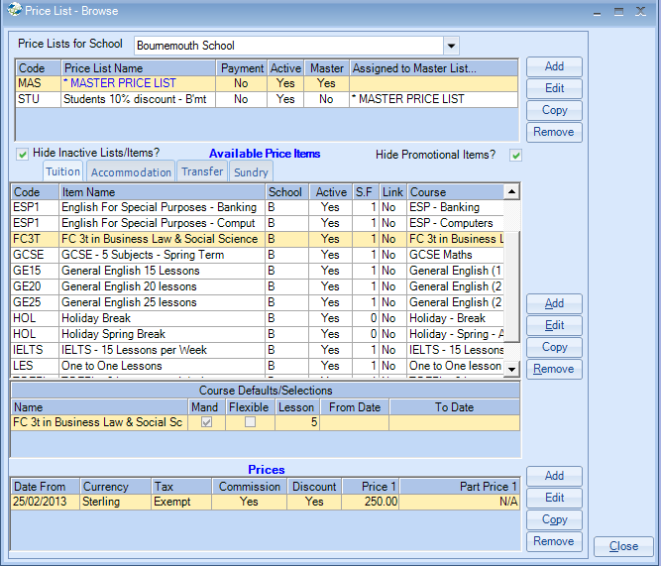

- Highlight the first price item to be amended.
- At the bottom of the screen you will see a list of price breaks attached to this price.

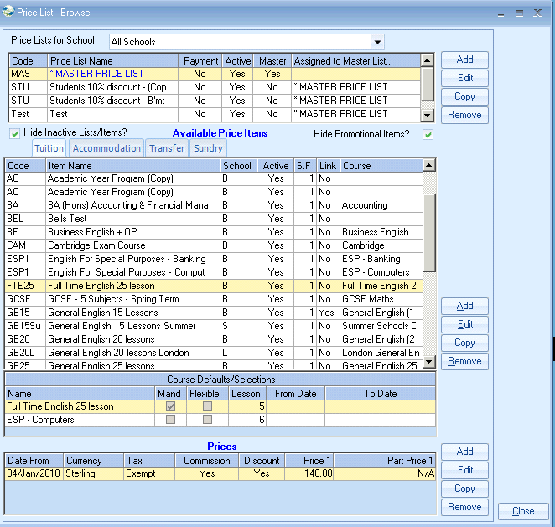

To create a new price for the same currency, highlight the latest price and select COPY (bottom of screen).

Note: If multiple currencies are in use, ensure the correct currency is highlighted before selecting Copy.

Note: If a price break is to be created for a new currency, select ADD (bottom of screen).

A copy of the existing price will be displayed:

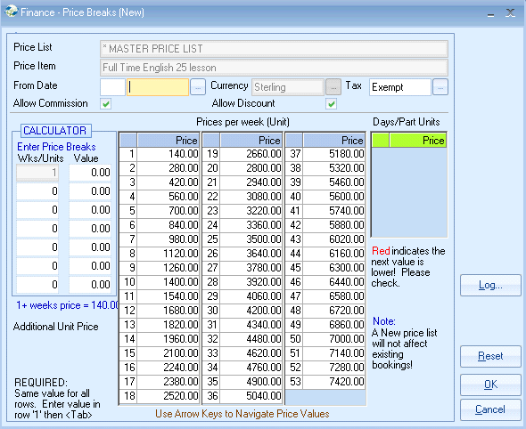

Click on the Reset button to change all Unit Prices back to 0.00.

From Date: Input the date for which the price increase is to start from.
Note: ensure the date represents a normal starting day for the item, .e.g. courses normally run from Monday. Having prices starting mid-week may create undesirable finance calculations.

Enter the new weekly price into the Wks/Units 1 Value of the Calculator

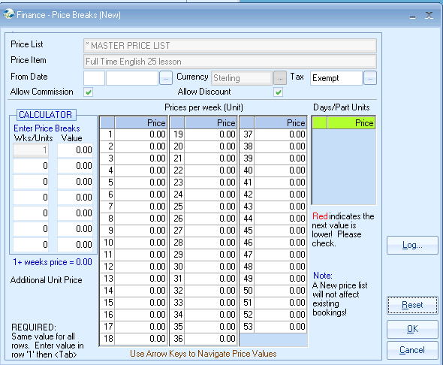

Now tab out of the field.
Your new prices are entered into each week.
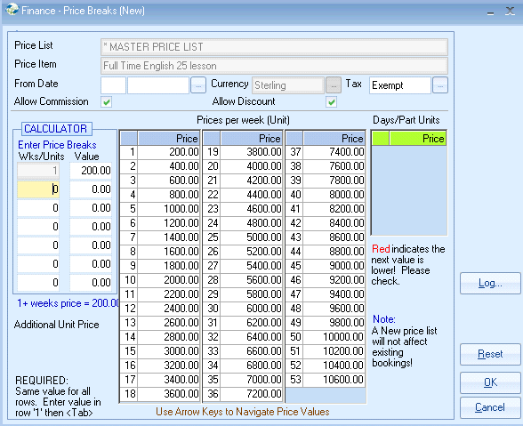

Click OK

The new price break will be listed.

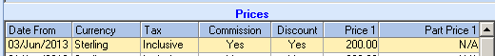

Where prices increase during summer months the same rules apply.

Accommodation Example:

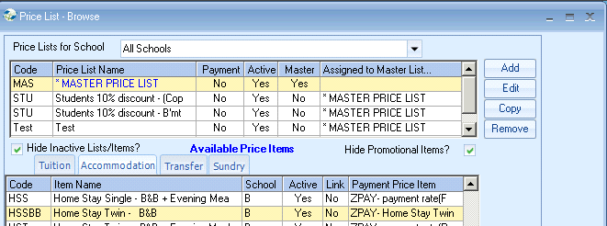

For accommodation price increases remember to change the invoice price item (student/agent charge rate) and the payment price item (payment to be paid to host family. Important if the Class Homestay Payment Run is in use)

For Transfers and Sundry items use the same method as above.
Highlight the price item to be increased and use the Copy option.

INFORMATION:

Don’t forget about the following option:

Once next year’s prices have been entered in Class, when adding an Enrolment on the General tab you can select whether you want the prices to the student/agent to be based on:

- Enrolment Date (when the student starts his course/accommodation etc.)
- Booking Date (date Enrolment input into Class but there is a facility to manually amend the date)

