Class – Help Document


Problem
How can I show the receipt value on a proforma/temporary or final invoice?

Solution
First the merge code needs to be added to the master financial document to pick up the receipt value.

To do this select:
- Documents
- Finance Documents.
- Select the type of financial document to be amended.

There are several layouts per document type.
- Highlight the document to be amended
- Select Word. Or double click on the document name.

Example Master Invoice:

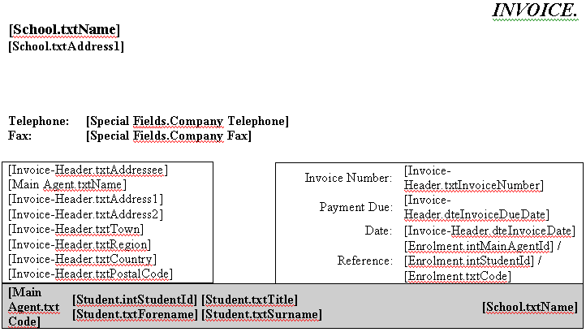
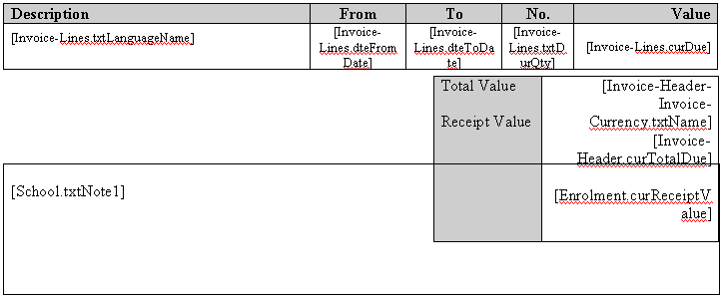

Add the merge code in to the document as shown above -
[Enrolment.curReceiptValue]
To add this field from the Word Edit box, select Enrolment Fields / Enrolment.

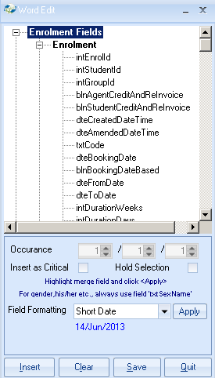

Scroll down the list and highlight curReceiptValue

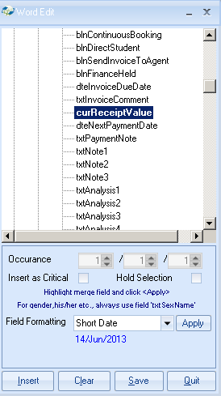

- Place the cursor within the document at the point where the field is to be inserted.
- Highlight the merge code and select ‘Insert’.

You can also add some text.
For example: Receipt Value or Deposit Received.

Note: Class does not deduct the receipt value from the invoice total.

When you are happy with the amendments, save the document using the SAVE button within the Word Edit box.
To record the receipt value for the student:

- Go to the students’ enrolment and in to the Finance tab.
- Insert the receive value (deposit) in the ‘Receipt Value’ box (top right of screen)

- An “Invoice Comment” can also be added to the proforma / invoice.
- The Invoice Comment is added from the students finance tab.
- Select ADD

- A comment line allows 30 characters so several lines may need to be added as in the example below:

As the comment line is part of the ‘Invoice Lines’ no additional merge code is needed within the master document.

Example of merged invoice showing both the receipt value and comment lines.

