Class – Help Document


Classing

Add the teachers details.

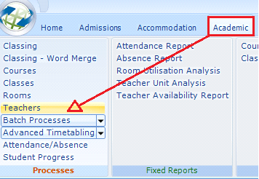

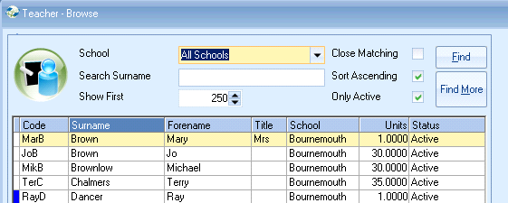

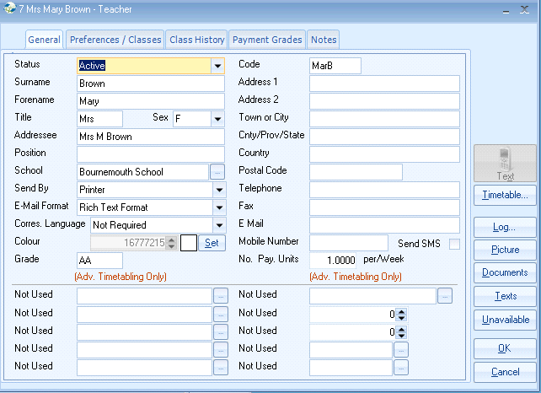

Spare fields that can be re-labelled.

Rooms

To add class rooms

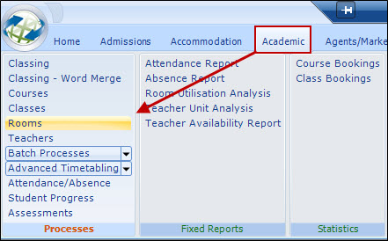

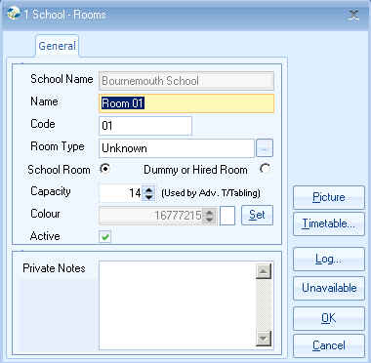

Room Name appears in Class Reports.
Room Type provision for the future.
Capacity used by Advanced Timetabling.

To add classes

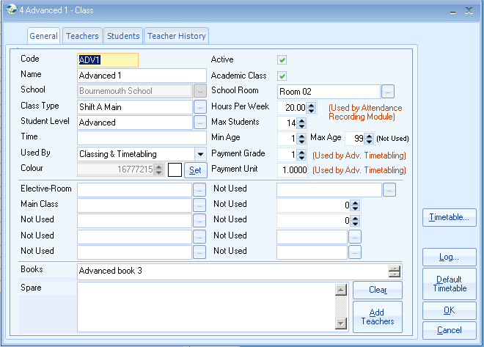

Code 10 character mandatory
Name 30 characters can be the “level” of just a name.
Active deselect if Class is no longer to be used. Inactive Classes do not appear within Automatic Classing.
Hours per week used by Attendance Recording Module – an ddditional Module – covered in more detail later.
Class Type The system makes use of this field in Class timetables. Every Class can have assigned to it a Class Type. This Class Type can be printed on the timetable together with the room.
Student Level Level of the class i.e. advanced, intermediate, beginners
Time Time that the class is actually running i.e. 9am-9.45am. Useful if Advanced Timetabling is not in use.

User Defined Fields Set in the system settings
can be made mandatory - will then appear in RED
can be forced to select from a list - will then appear in BLUE.

Note 1: We recommend that this field is used for books or any other type of teaching media that is used for this class. The heading can be changed within the system settings.

The note appears on the standard register created by Crystal.

Note 2: Can be used for adding the times and days of a particular class.
Also the teachers can be added.

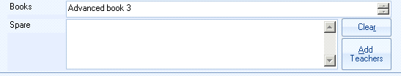

Teachers Tab

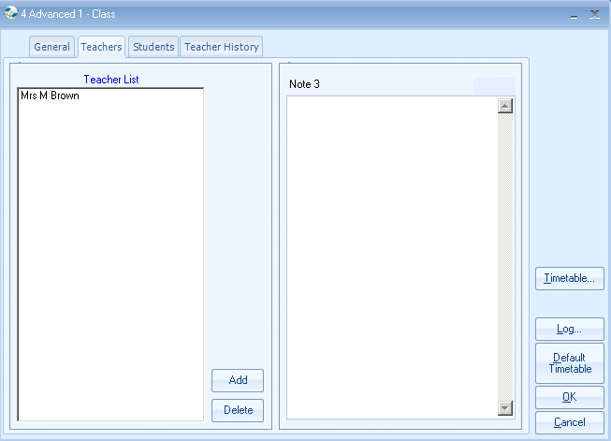

If Advanced Timetabling not in use.
Click on Add to add Teachers to the Class.
Once you have done this you can go back into the General tab of the class and click on “Add Teachers”.
Automatic Classing

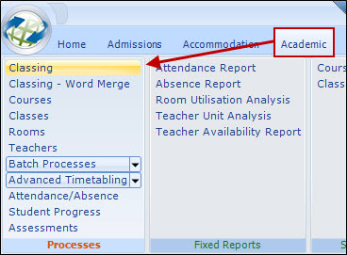

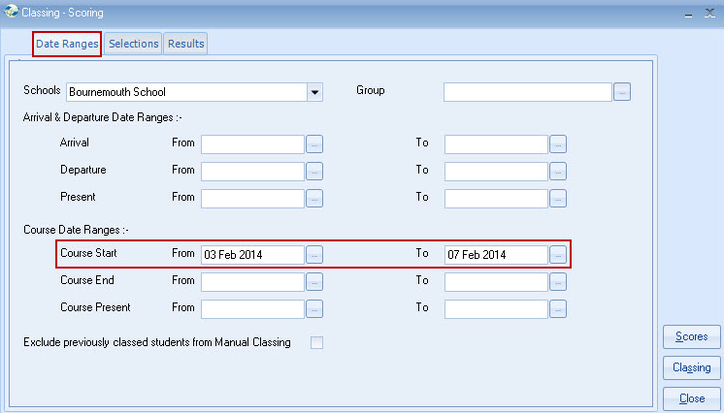

Dates Ranges
“Course start date” range is normally all that is required, but other dates can be added if required, e.g. Arrival Start (selecting only new arrivals).

Selection (Tab)
Courses and/or Classes can be restricted. For example only students on the Exam Course may be selected by picking the appropriate courses.

Scores

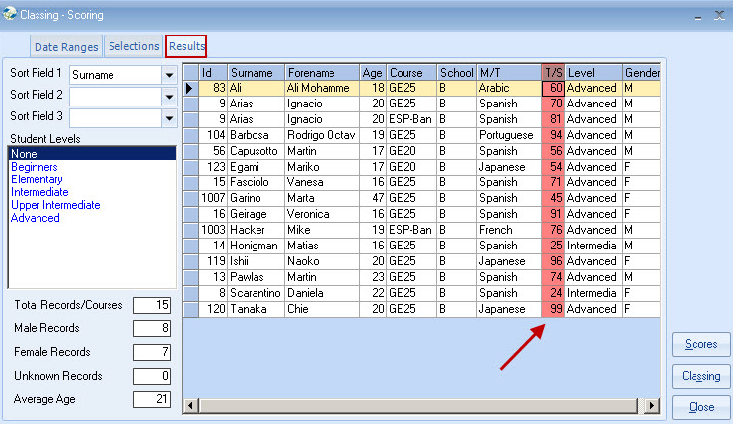

Enter the Test Score then use the down arrow key to move to the next student. Entering the score will display the Level name (as defined in the Settings/Students).

The level can be overridden by placing the cursor in the level column against the student, then double clicking on the required Level (left hand box).

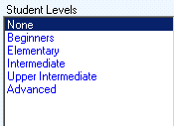

Classing

Select Classing and the following screen is displayed.

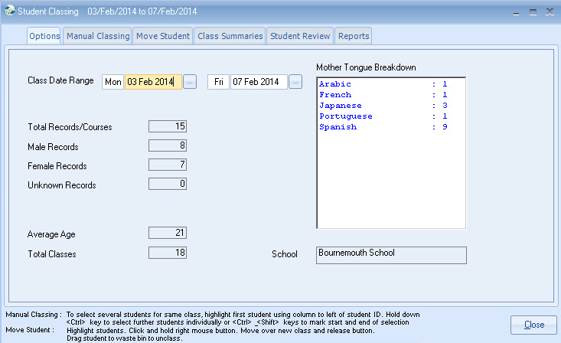

Note: This is a date range normally covering Monday to Friday.
A summary by language is shown, for the new enrolments.

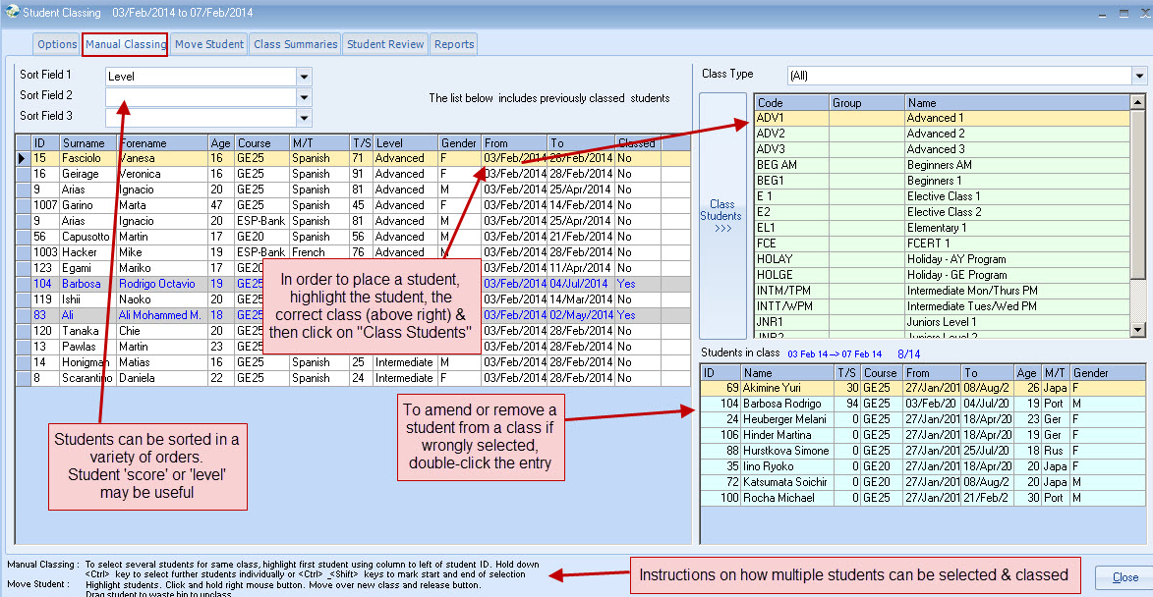

To class a student – Highlight a class
Then double click on the student or click on “Class Students” in the middle of the screen.

To amend or remove a student from a class if wrongly selected, double click the class entry.

Note: The instructions at the bottom of the screen advise on how multiple students can be selected and classed.

Sorting – students can be sorted in a variety of orders. Student score or level may be useful.

Move Student
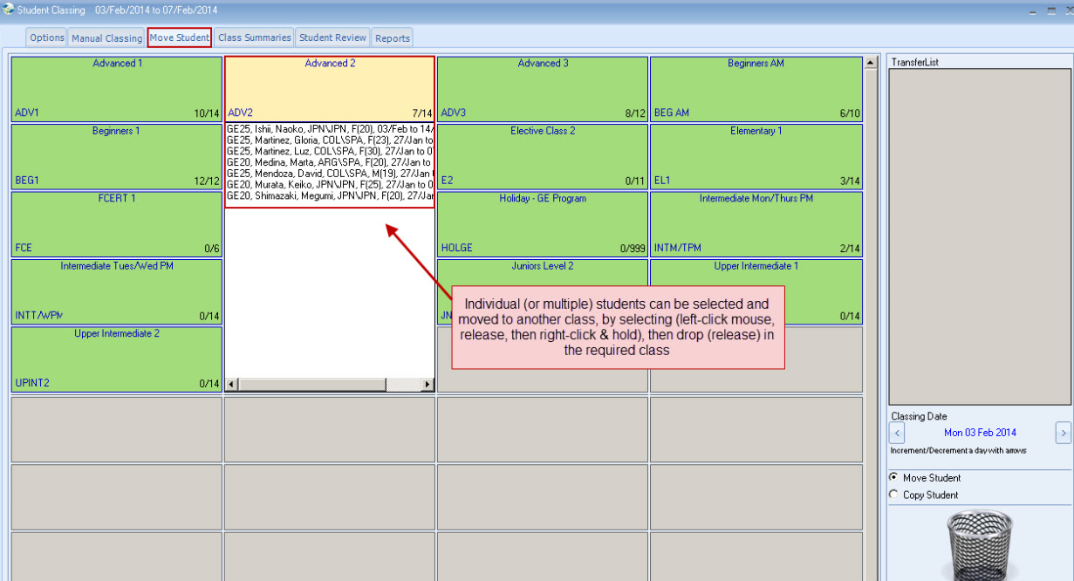

Individual (or multiple) students can be selected and moved to another class, by selecting with the left side mouse, then dropping in the required class.

Class Summaries

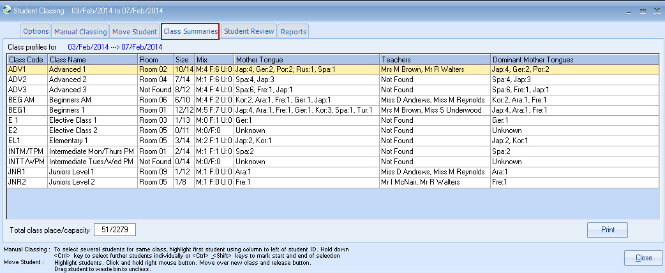

Student Preview
A students historical classes can be reviewed.

Reports
Select required reports & options
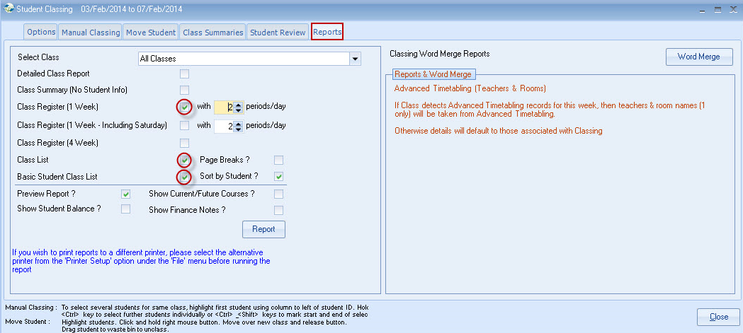

User Defined Class Lists/Registers
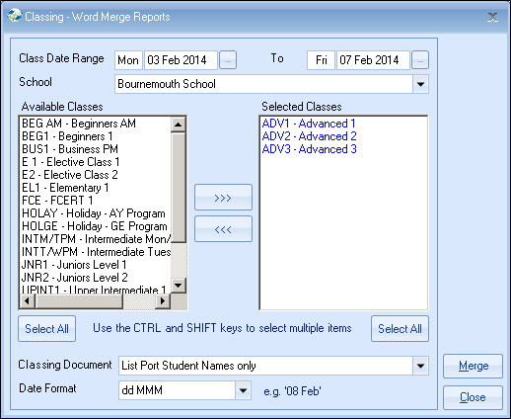

Document for merging

Class registers/Lists can now be user defined but the existing reports (Crystal reports) remain. A new filter option allows Classes to be selected, for merging with a Classing document.

Direct Access to Classing – Word Merge

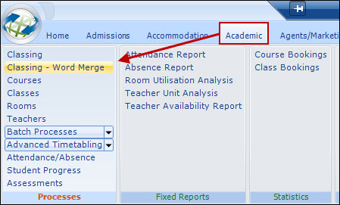

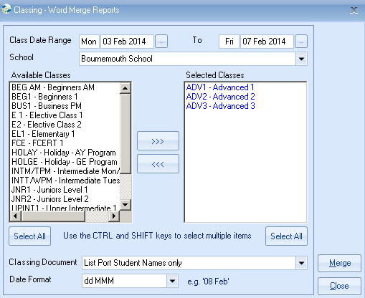

There are a number of sample documents available please contact the Support Desk if you do not already have these.

To create a Classing document is the same process as creating an “Enrolment” document.

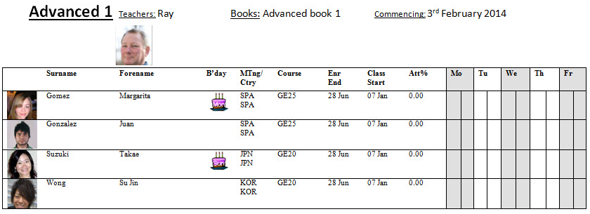

Creating Master Classing Documents:

