Class – Help Document


Problem: How to obtain a list of commission spread over the duration of a students stay.

Solution:

Click on Reports

Click on “Invoicing Statistics”

Complete the screens similar to the following:

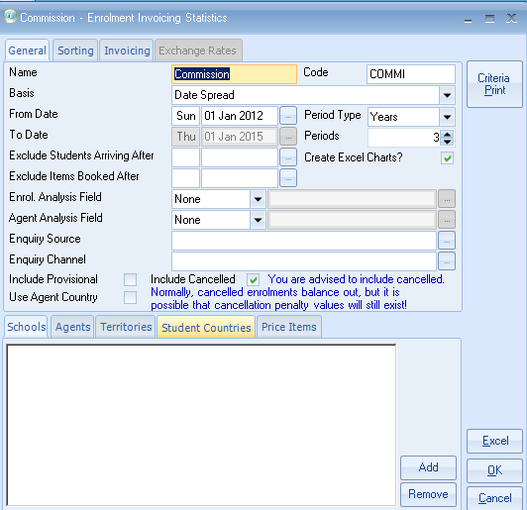

The date would need to be changed each month e.g.
- If you were running this report 31.1.12 then the From Date would be 1.2.12
- If you were running this report 28.2.12 then the From Date would be 1.3.12

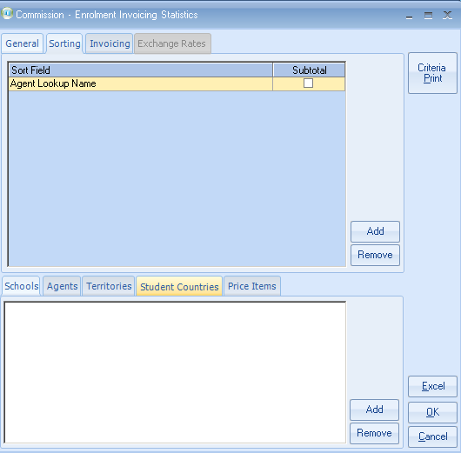

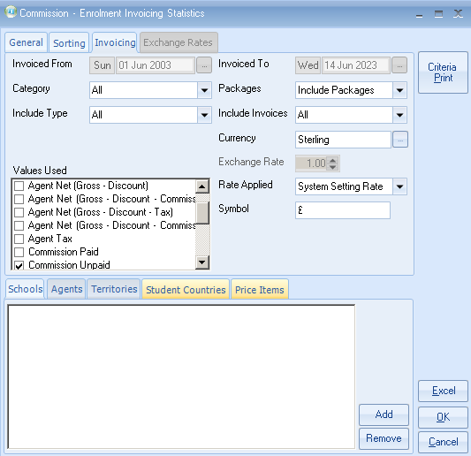

- Click on the “Excel” button.

Result

