Class – Help Document


Create an Arrivals List with No accommodation.

Any student’s who have not booked accommodation or has cancelled accommodation, within the date selected, will appear on this list.

Create an Enrolment Transfer Report similar to below:

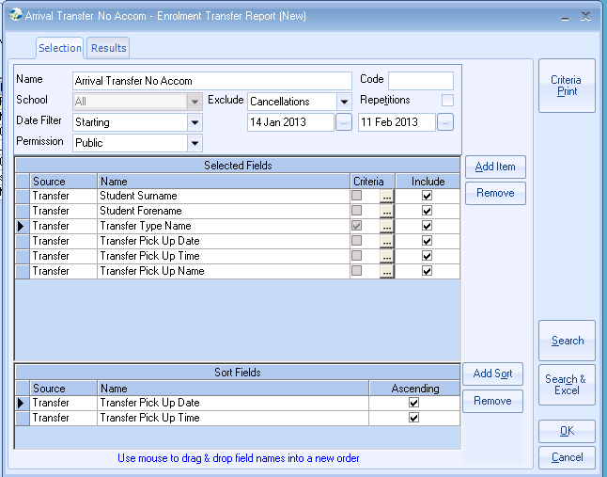

To select the Transfer Type go into Criteria and select Arrival.

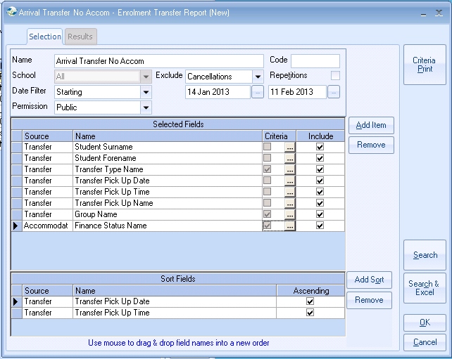

The Group name could be added if you wanted to see arrivals for certain groups.
If you did not want to see students from within a group on your list, then add a criteria of ‘Is NULL’.

Add a Criteria to the Accommodation finance Status Name of ‘Not Equal to ‘Active’ or ‘Is NULL’.

Departures
You can create a departure report by changing the Date Filter to finishing and changing the Transfer Type criteria to equal to ‘Departure’.

/tmp/in/input.doc

