Class – Help Document


Create a Transfer Arrivals Report with Accommodation

Any Student who has booked a transfer and also Accommodation, within the selected dates, will appear on this list.

Create an Enrolment Accommodation Booking report similar to below:

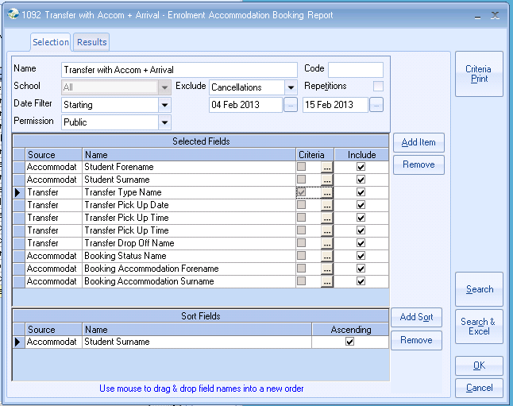

Add criteria to the Transfer Type Name of equal to Arrival.

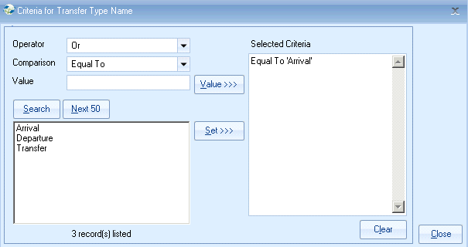

Add the criteria to the Transfer Pick Up Date.

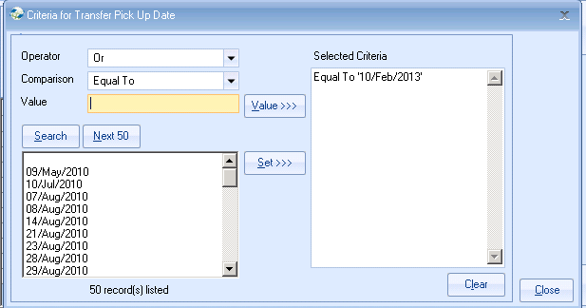

This needs to be entered for the transfer date you want the list for.

Results

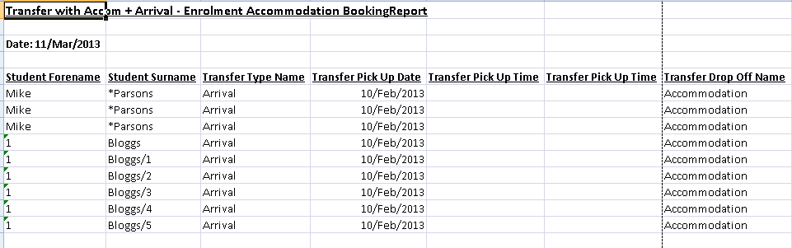

Departures
You can also create a Departures report by using the Date Filter of Finishing and changing the Transfer Type criteria to equal to Departure.

