

Class – Help Document

Attendance and Progress
If you require information for Absence Processing please see help sheet SQL175

Attendance:
- To allow entry of attended hours (typically or daily weekly) quickly and efficiently.
- To show attended hours by student on the enrolment screen.
- Provide reports to show students failing to reach attendance percentages (e.g. less than 80%) for any given period.
- Allow resulting percentages to be included in documents e.g. certificates.

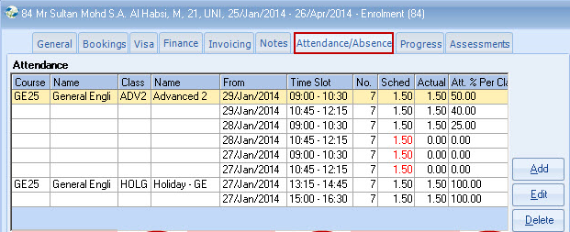

Progress:
- To enable the academic progress of a student’s enrolment to be recorded and monitored by traditional “levels” and/or by user defined categories e.g. speaking, listening, reading, writing, etc.
- To produce documents which can either show the numerical results or by providing a standard paragraph for each score under each category produce a comprehensive report/certificate.
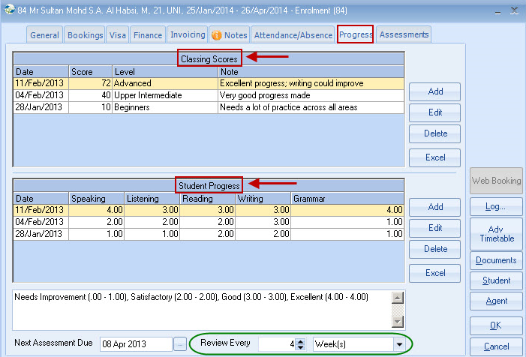

ATTENDANCE MODULE

Enrolment screen:

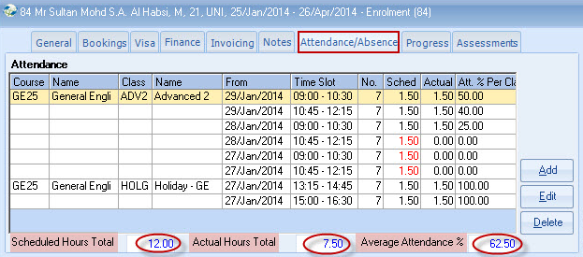

Batch Entry Process:

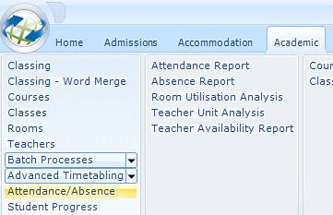

- This process is normally performed daily or weekly.
- It is recommended to batch update one course or class at a time.

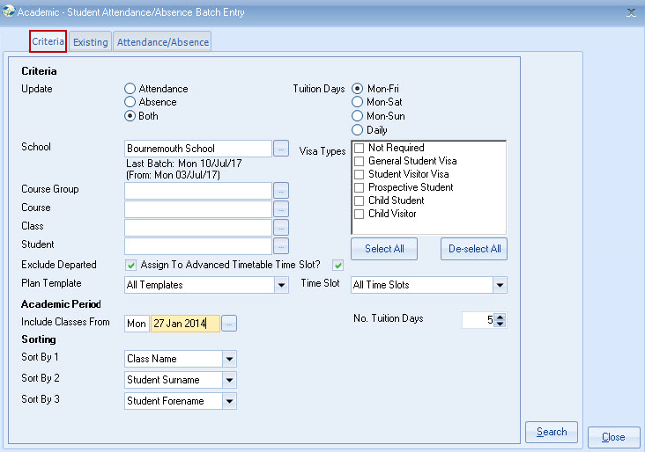

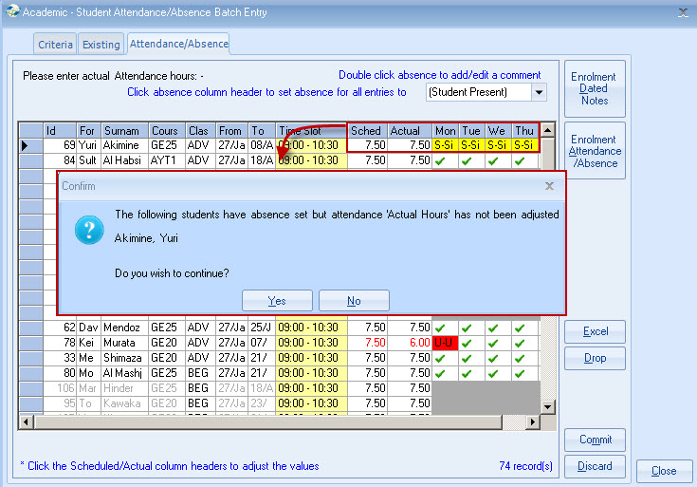

- Results are displayed and if required can be sent to Excel.
- Hours are calculated, by looking at the hours per week on the Class record, or the Timetable and assume the student attends 100%.
- Only those students not attending 100% need to be modified.

Class record
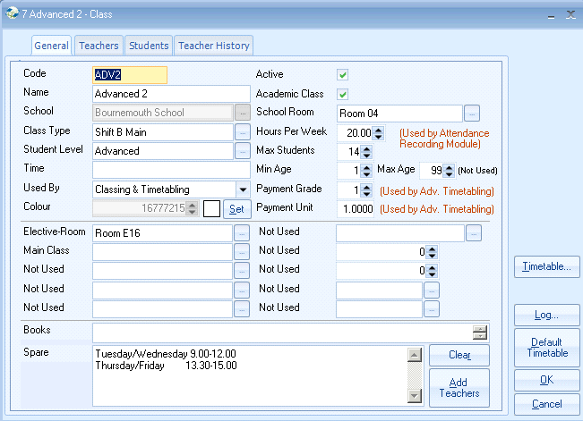

Reporting
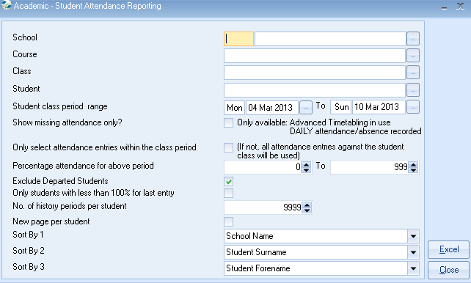

A wide range of selection criteria is available, enabling Schools to simply focus on the students not within certain parameters, over a period of time.

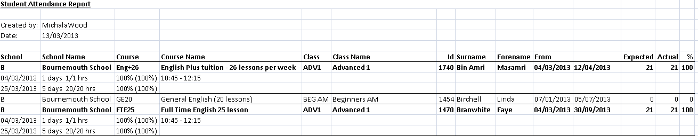

Student Enrolment Record
The Attendance is shown as a tab on the Enrolment record, together with relevant attendance figures. Individual lines may be amended from this screen.

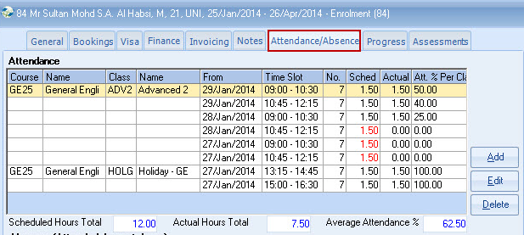

Document Merge
The followings fields are available for merging e.g. for certificates/letters:

- Enrolment total scheduled hours
- Enrolment total actual hours
- Enrolment % attained

STUDENT PROGRESS MODULE

The categories and levels can be added within the system settings:
Maintenance/Settings > General Settings > Admissions >
Progress Categories & Progress Levels.
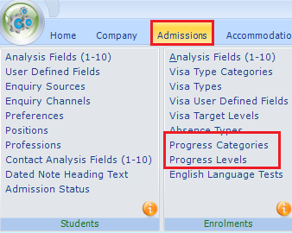

Categories: ADD the heading names here.

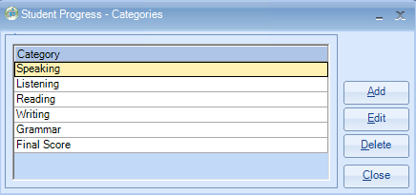

Levels: ADD the level names and grades from/to here

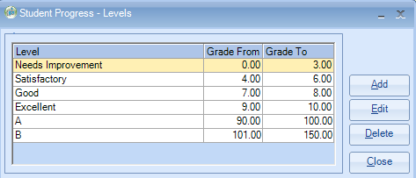
General
Example of a student’s progress record

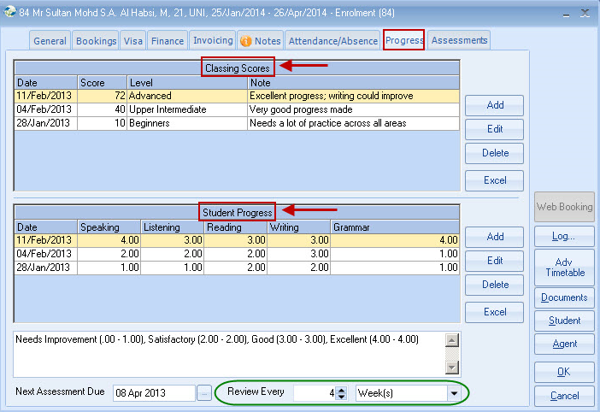

There are two main sections to the screen shown above and either or both may be set up and used.

The top half of the screen is being used to show a history of score/level results. The numbers are equated to a table in system settings and levels displayed.
(Settings / Academic /Academic levels).

The bottom half of the screen is being used to show a more analysed history of a student’s progress. The headings, called “progress categories” and shown as speaking, listening etc are defined in the system settings.

There is no limit to the number of categories, but screen size will limit to approx 9.

The assessment interval shown at the bottom of the screen can be altered manually, but there is a system setting to determine the normal default within Maintenance/Settings > General Settings > Company > Company – Academic:
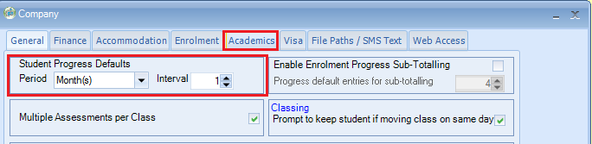

Reporting/use of information
Various reporting options exist – for example:

Word merge – Example 1
Progress profile (showing last 3 results)

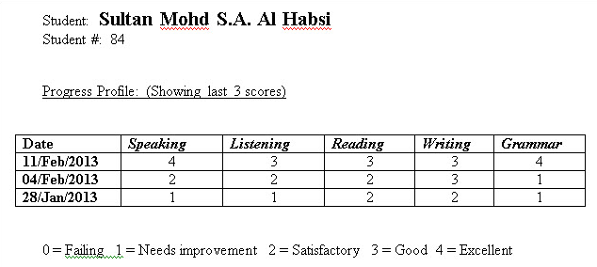

Word merge – Example 2
Progress profile (showing score text)

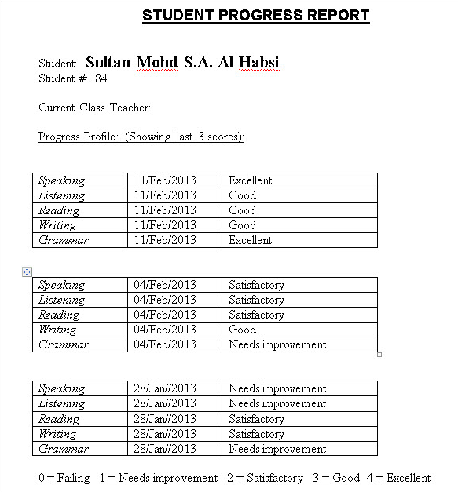

Word merge – Example 3
Progress profile (descriptions)

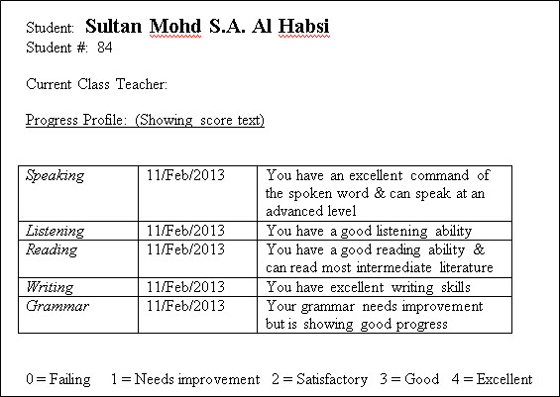

Quick Reports:
The following fields are available through Quick Reports (enrolment types).

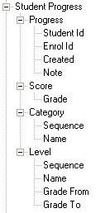

Progress Batch Entry
Academic / Student Progress
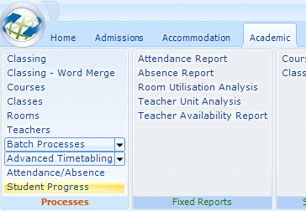

Selection
Most of the criteria is self apparent, but if Course Groups are not currently used it may be useful to create Groups to represent the courses where students are to be assessed. Alternatively, use may be made of “Class Types” to assist in this process.

Note: Red box – If you are dealing with current students these dates can often be left as the default.

Classed From + Classed To: Students who have been in classes between these dates
Departing From + Departing To: Students leaving the school between these dates. The Departure date on the General Tab is used.
Example for use: Adding a final mark for all students leaving the school that week.

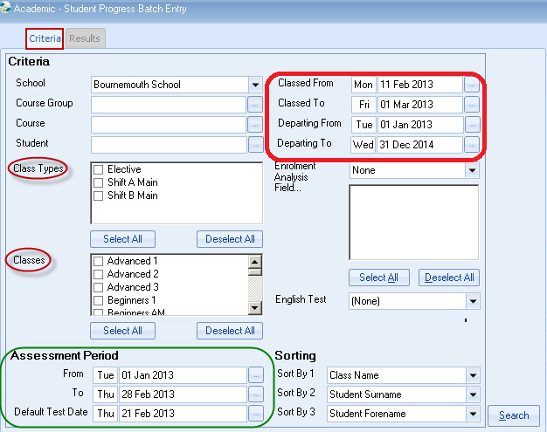

Default Test Date: This date will be used when each of the student’s Progress records is updated (see below).
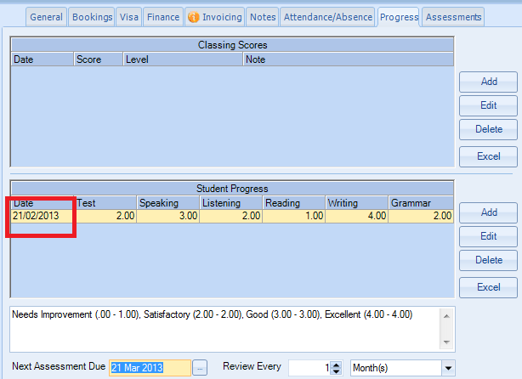

Assessment Period: The system will check the Assessment Due Date on each enrolment. Those within the range are selected.

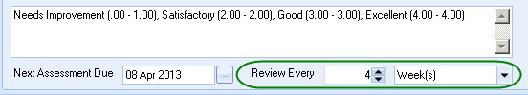

The date for new enrolments is automatically set as the Monday following the date of arrival. This date is maintained if the arrival date is changed

Results:
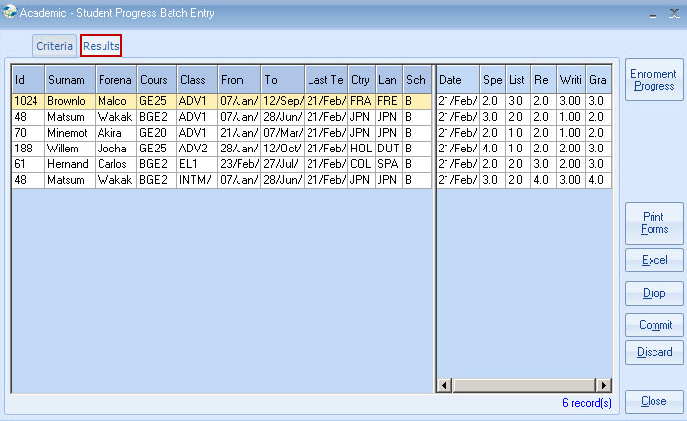

Note: Students in multiple classes appear multiple times.
The use of Class types or Classes themselves, used selectively in the selection criteria, may be used to remove duplicates.

Print Forms:
A single form for each student is printed (no display option).

Excel:

