Class – Help Document


How do I add a holiday Break for a Student?

Holiday Break

There is a function within the Enrolment ‘Bookings’ screen which allows Course holiday breaks to be inserted into an existing course booking. This effectively causes the course booking to be split into two bookings, unless the holiday break starts or finishes on the course booking start or finish date.

No change to the total financial value of the Course is made.

Before the Holiday Function can be used ensure you have a holiday price items set up as follows:

1. Maintenance/Settings > Maintenance
Add a PRICE ITEM (Tuition) called “Holiday” (or amend an existing record)
- Tick the “Holiday Break Item” box
- There is no need to add “Prices”
- Select “Create New Course” and create a “Holiday” Course

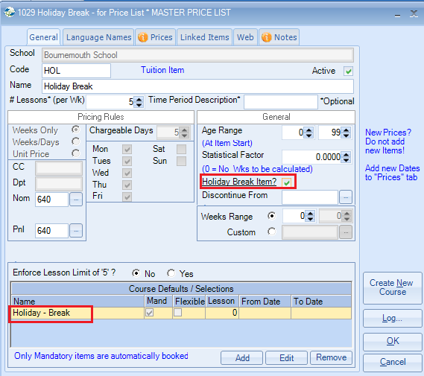
2. Academic > Classes
Create a CLASS called “Holiday” (Max students = 999)
3. Academic > Courses
Open up the Holiday COURSE add the Holiday CLASS (above) as the
Default Class. This final step allows the student to be automatically
classed when the holiday break is entered.

The Holiday Break is actioned as follows

- Finance - split pro rata (based on tuition days)
- Booking - Course(s) are split either side of the Holiday Break
- Classes are split either side of the Holiday Break
- If set, the student is automatically added to the “Holiday Break” Class.
Booking - before inserting a Holiday Break

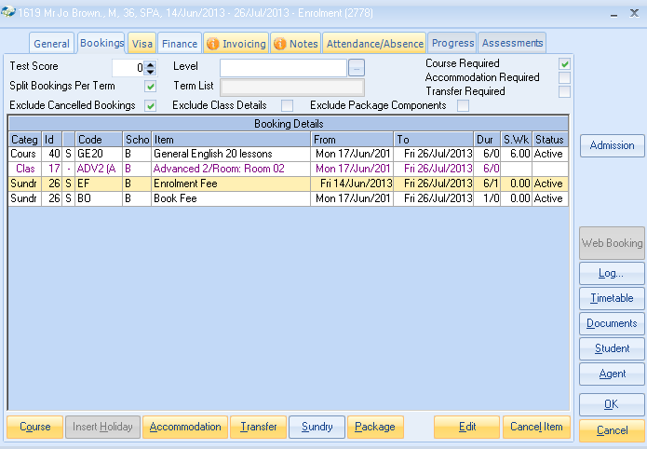

Finance - before inserting a Holiday Break

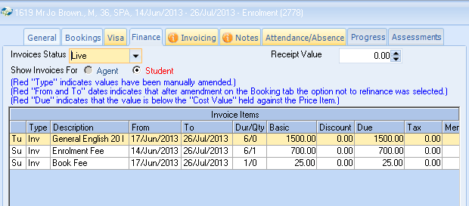

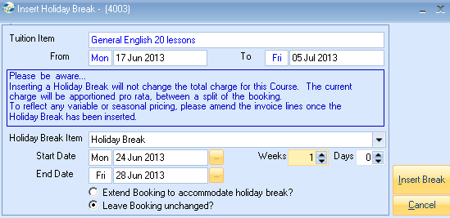

The booking may be extended, or left unchanged (student loses the time).
There is no change to the value of the Course Finance.

Two parts of the Course Booking – either side of the Holiday Break – See also Holiday Class, automatically inserted!

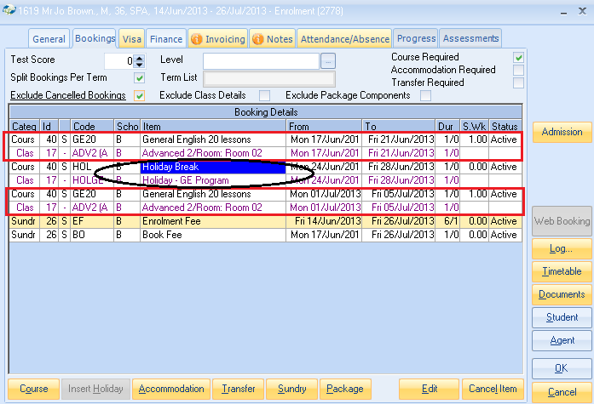

Finance - after inserting a Holiday Break

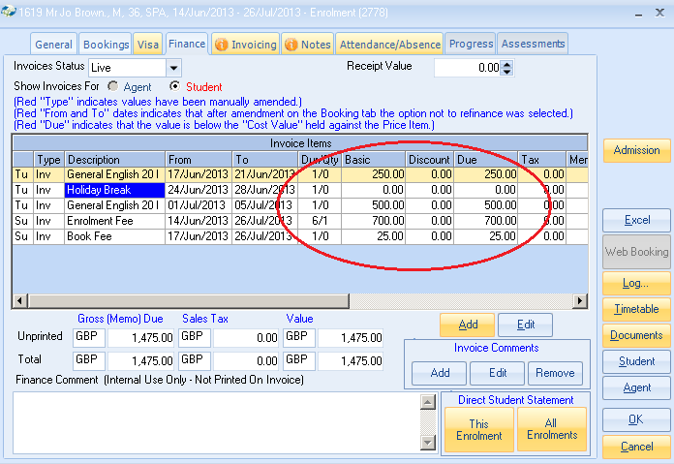
If invoices have already been printed, then a new credit note and invoice will automatically be created behind the scenes, to stop the unprinted finance from being picked up and actioned elsewhere in the system.

This is based on the company setting as shown below:

