Class – Help Document


Dated Notes / Internal Messaging

Overview of Class Internal Messaging

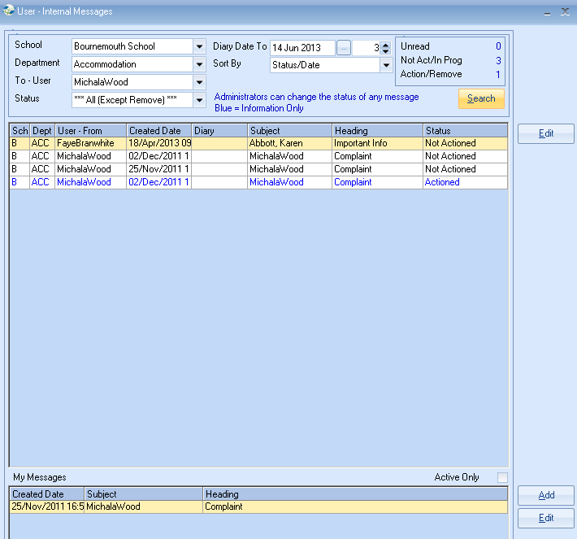

What is it and how does it work?

Internal messaging is a Class only system, unlike Outlook which is dealing with external as well as internal communication i.e. whole world! There is, therefore, no spam and with an array of cross referencing (links) enabling a single message to be seen within various parts of Class and by a variety of users, there is a much higher level of connectivity and relevance…!

When messages are received a simple link will take you directly to the relevant Student, Agent, Family or Teacher. Users can be either tasked to “action” the note, or sent it for “information” only (coloured in blue), making life much easier for the recipient. Additions can be made to the single note and the complete story tracked and dated by each contributor.

This is best explained with a simple example:
A student complains that the Host Family accommodation is not up to the standard suggested by his agent.

A “dated note” is added to the student’s record, and cross referenced (linked) both to the family and the Agent. The note (and any update to it) can then be seen when viewing the Student, Agent, or the Family. In addition individual Class users can be advised to act on the note (action by) or just kept in the loop (for information only). All updates to notes are user and time stamped so a clear history can be seen.

Dated Note:

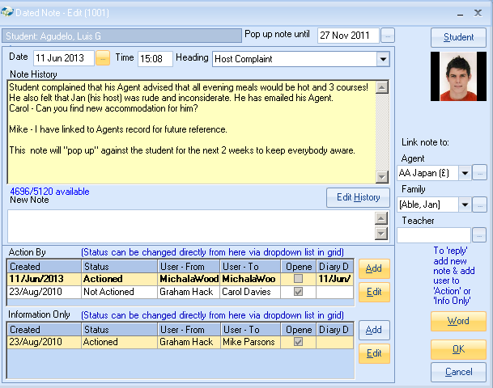

Student’s Dated Notes

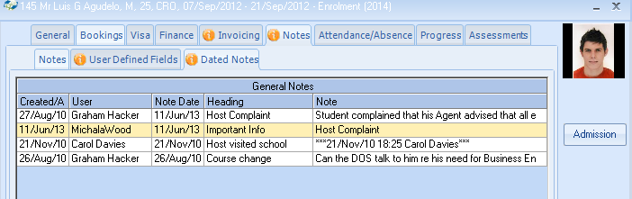

Host’s Dated Notes

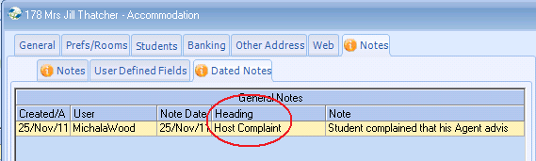

Agent’s Dated Notes

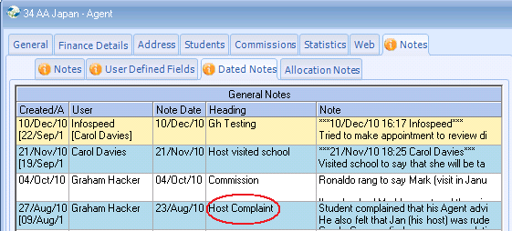

Student (and enrolment) record – Note “pop up”

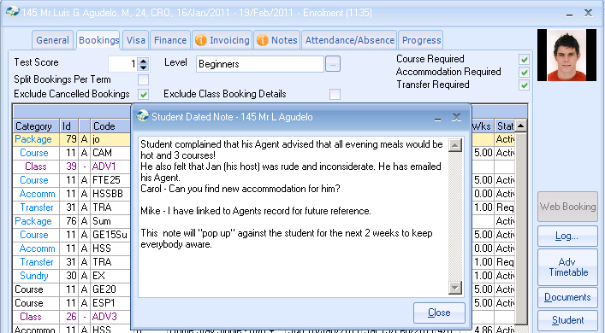

Carol’s “In box”
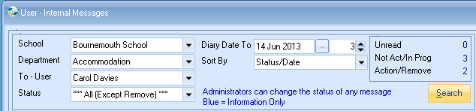
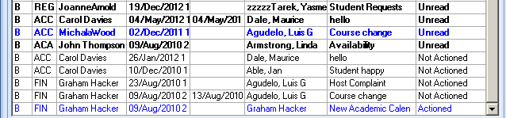

Blue coloured entries are “information only” messages.

Set up
The system will allow each user to send and read their own messages without need for further set up; however, it is worth taking the time to set up “message departments” and “permissions” to use the Internal Messaging to the full.

Internal Messaging in more detail

Set up
The system will allow each user to send and read their own messages without need for further set up; however, it is worth taking the time to set up “message departments” and “permissions” to use the Internal Messaging to the full.

Create or amend the list of Departments, this can be done as follows:
- Maintenance/Settings
- General Settings
- Company
- Messaging Departments

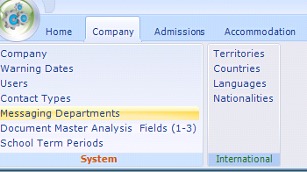

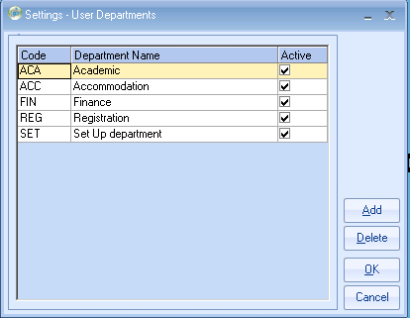

Set up the Departments used by all schools in the database. Then attach each user to the appropriate message department/school (see below)

User Message Settings:
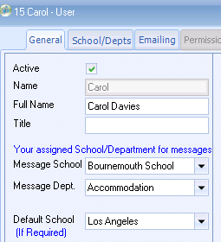

Schools/Departments

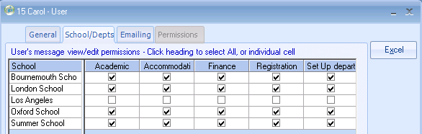

Internal Messaging is a corporate system, allowing other users to monitor messages for the whole department. Tick the appropriate boxes.

Message Options
Date of event
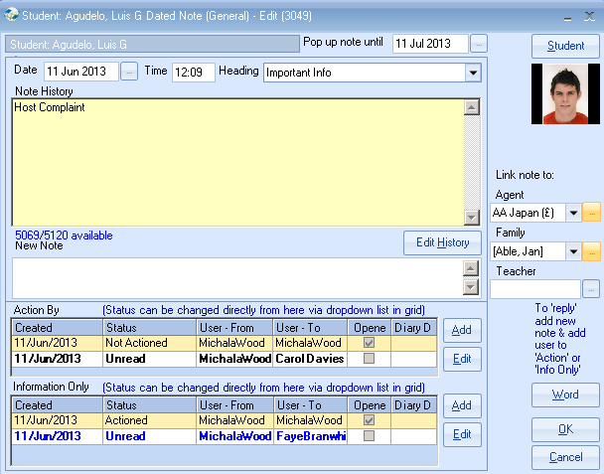
Pop up option

Add notes to:

A “Word” option allows note to be exported.

Recipient’s options:

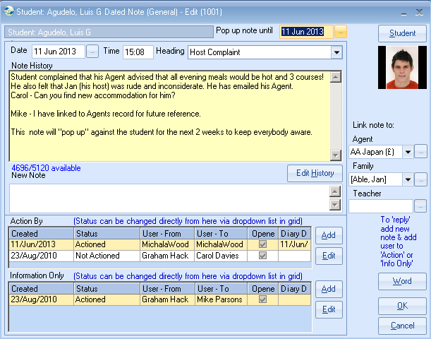

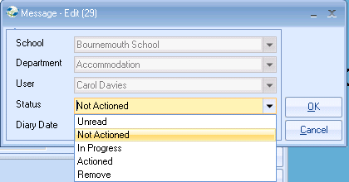

When a message is “opened” the message (for this recipient) is automatically marked “opened” and the status changed to “not actioned.” The user can change the status as appropriate. The importance of the status is that it can be seen by all users, allowing the originator in particular to be aware that it has been, read, actioned etc. A recipient can only change the status of his/her own messages. The “Remove” status will “hide” the message from most screens, but can still be seen by a specific selection.

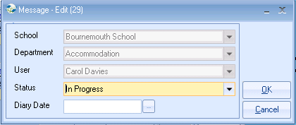

A dairy date can be added allowing the message to redisplay in the future.

User’s summary screen

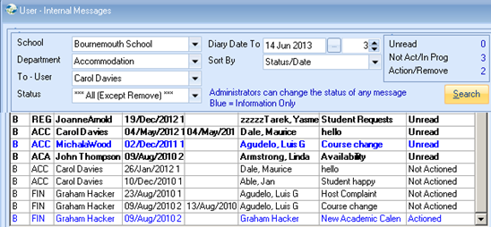

Incoming messages are shown at the top with “sent” messages at the bottom.
Dairy date items default to showing 3 days before the date set. (This can be changed).

A message unrelated to a Student, Agent, Family or Teacher can be Added.

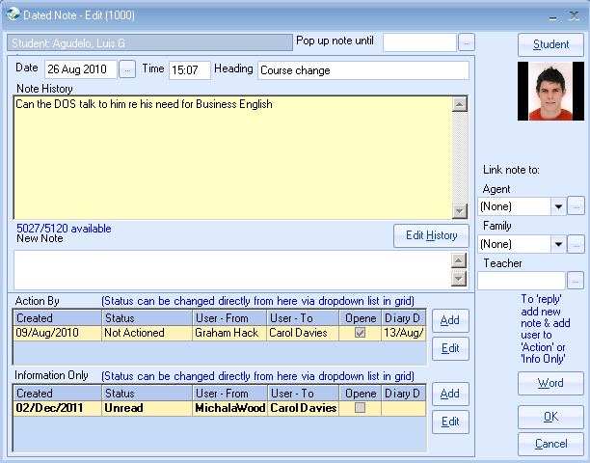

Note this message has no “action.”
Later you could check to see if all users have opened the message!

Messages awaiting

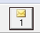

Class checks for incoming messages automatically on entry to Class and also when Class “refreshes” on screen displays. For an active Class user this occurs regularly. If the Class user is not “working” with Class the message symbol will not be updated.

