Class – Help Document


Question: You need to be able to produce a list of Accommodation Bookings to send to Host Families.

Solution: Create a Quick Report.

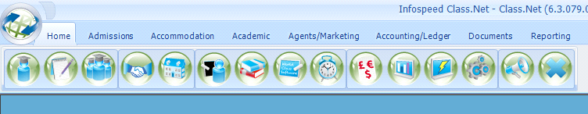

Select the Report Type as “Accommodation Booking”
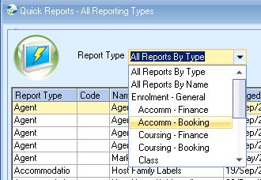

Select “Add”

Complete the selection screen similar to the following and then click on “Search & Excel”:
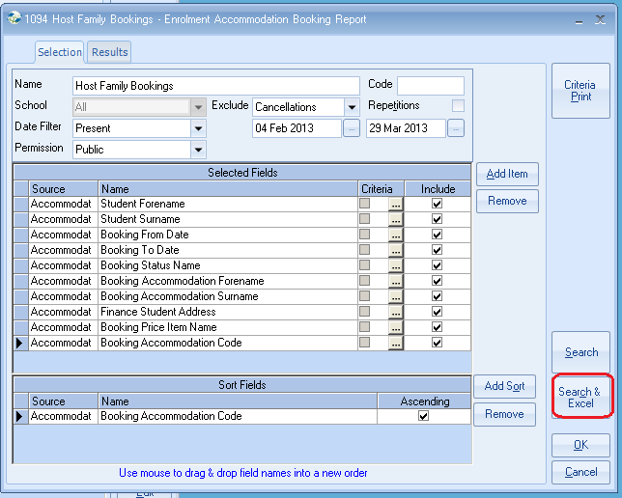
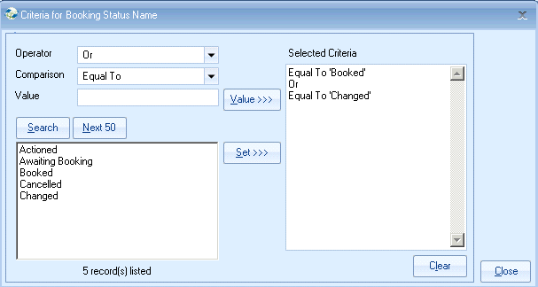

Within Excel

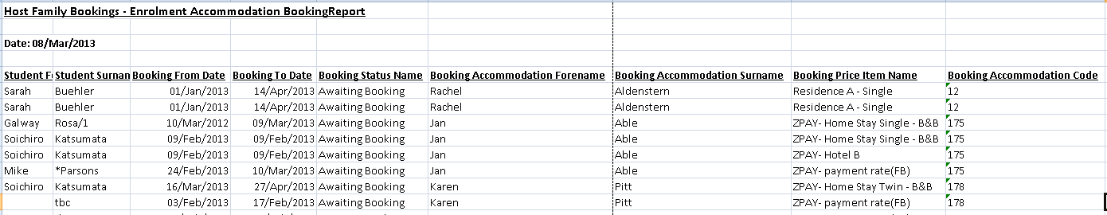

Click on Data, Subtotals

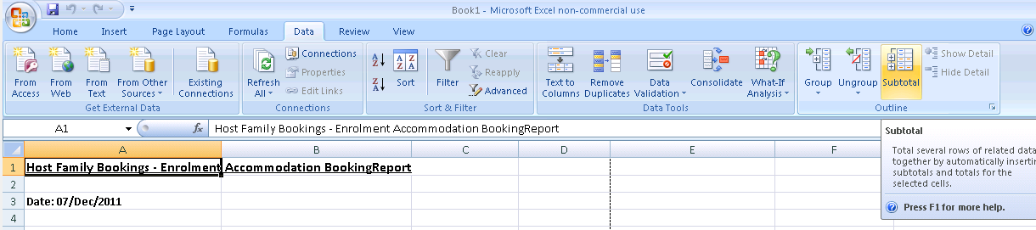

Complete the selection similar to the following:
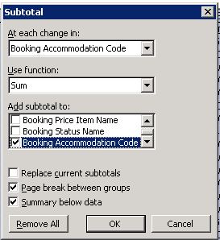

Page breaks will now be automatically input after each family.

