Class – Help Document


Import - Students/Enquiries

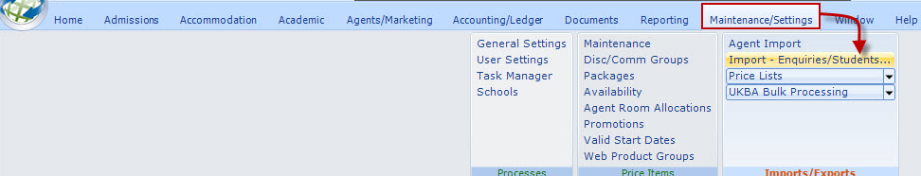

Overview
The import function allows a file of Enquiries or Students to be imported into Class.
The file must be in ‘csv’ format (an Excel file can be saved in csv format). Typical uses would be a file of enquiries downloaded from a web page or a file of students needing to be added to Class (no bookings).

The file to be imported must conform to the format given in the “Create CSV Template.”

Import File Format

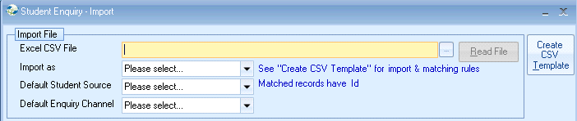

Select the ‘Create CSV Template,’ to see details of the layout and the rules that are applied.

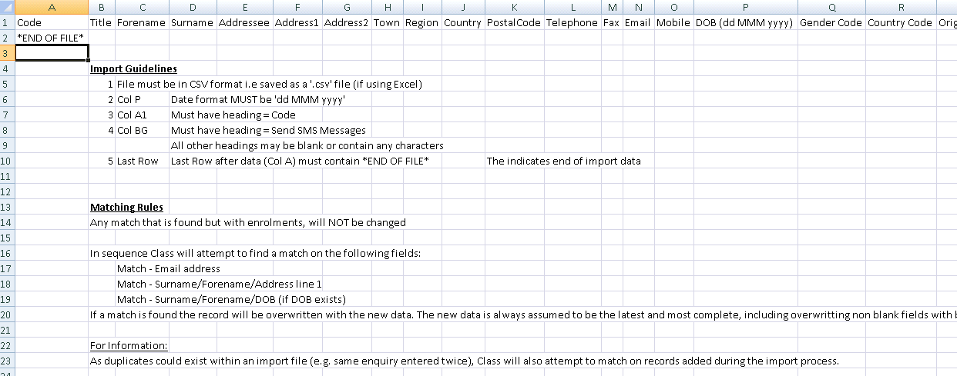

Additional Information
- As Class requires an entry in address line 1, blank address line 1’s will automatically be entered as “*IMPORTED*”
- If a student is matched with an existing record, the Student “type” (Enquiry or Student) is overwritten to = the value as defined by the import (Enquiry or Student).

A file not conforming to the above will not be recognised and therefore not imported.
There is no danger if a file is “imported” multiple times as matching records will be overwritten with the same information.

Import Process

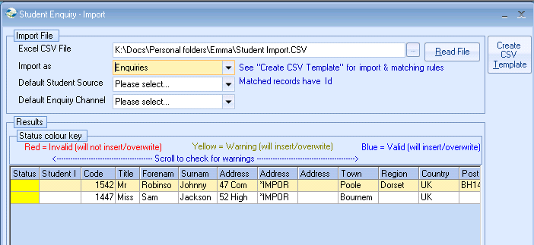

- Enter file name, or use the browse button to search for the import file.
- Select from the other options as required (“Import as” is mandatory).
- Select “Read File,” to initiate the checking process.
- A count will appear in the top righthand corner.

- On completion the screen will indicate which records will be imported or rejected.

