Class – Help Document


Notes – User Defined Fields

Any number of user defined fields and sections can be added to the student record (they are displayed both in the student and the enrolment screens). Fields can be grouped into Sections for ease of use, as can be seen in the below example, Exam, University Placement, Work Experience

To set up fields and sections go to:
Maintenance/Settings > General Settings
Admissions > User Defined Fields

Then click ADD and input the section name.

Select ADD to build the list of user defined names.

Using this user defined field with the student’s enrolment

Go to the student enrolment and to the notes tab. Click on the user defined field tab and select the section (i.e Exams). The list of user defined fields attached to the highlighted section are listed.

Highlight the relevant field and click on Edit

Input the required information and Select Ok

Enter details in the other user defined field if required, as shown in the example below.

Each User Defined field is given a unique Merge number and this can be used to report on within the Quick Reports and also enter details within Documents.

Quick Report - fields are found under Enrolment / Student:

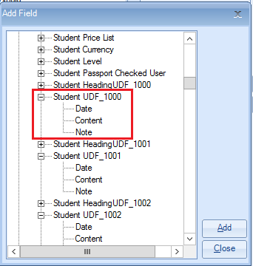

Document – fields are found under Enrolment Fields / Student

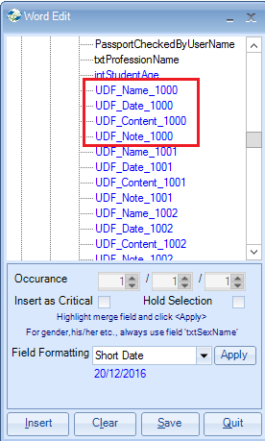

For information

User defined fields are also available for agents, host families, teachers, groups and courses.

