Class – Help Document


Absence Processing
If you require information for Attendance & Progress please see help sheet SQL141

General
Absence processing has been added to Class to assist with various Border Agency requirements. The regulations vary from country to country and so the parameters have been designed to be flexible. Users may also consider using absence recording for welfare tracking purposes (e.g. students over 3 days absent needing to be contacted).

Users wishing to make use of absence recording will need the Attendance module, as this is an extension to this module.

Absence is recorded by “class” and schools not using the classing function and wishing to enter absence data will need to create a single class to which all students can be automatically allocated. This is done by allocating the single class to all Course Master records – if help is required please contact the Support Desk.

Before entering data please read the following notes to ensure settings (rules) are established first.

Settings:

Absence types:
- Maintenance & Settings
- General Settings
- Admissions
- Enrolment
- Absence types

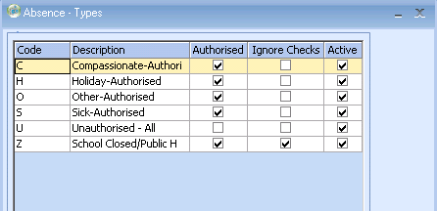

The above list is automatically set but should be updated to reflect the schools requirements/rules. For example, it may be decided that a breakdown of unauthorised absence is also required.

Single codes have been used to make batch entry easier/quicker. The list is in “code” sequence enabling users to manipulate the code to achieve the best sort order.

The “school closed” record has “ignore checks” set and this will ensure such absence is ignored from unauthorised absence calculations; also the visual presentation is different.

Permissions

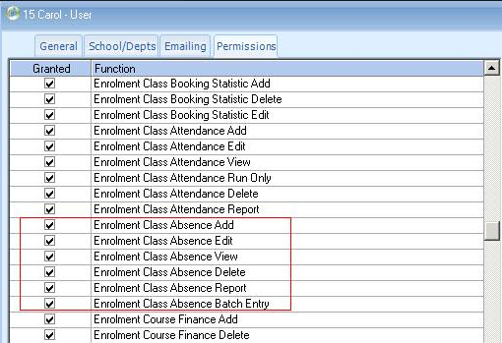

Absence recording and reporting is controlled by user permissions and these need to be set for users needing access, unless a user is set as an “administrator” (access automatically granted).

Enrolment Data:

Absence – Manual entry
Data may be added manually or via a batch process (see later)

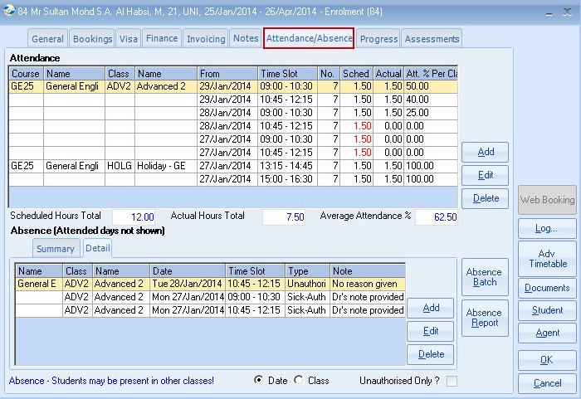

Detail: Add an entry

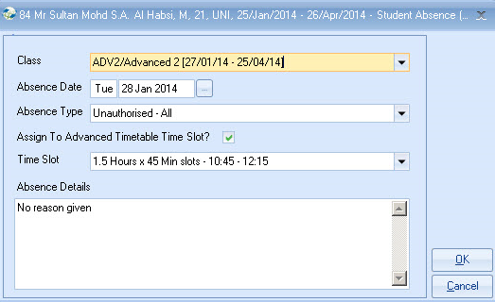

This is suitable for single entries, but if for example 2 weeks authorised holiday is to be entered, rather than making numerous individual entries at this screen the user may find it quicker to use the “batch” button.

Future entries can be made.

Display Summary

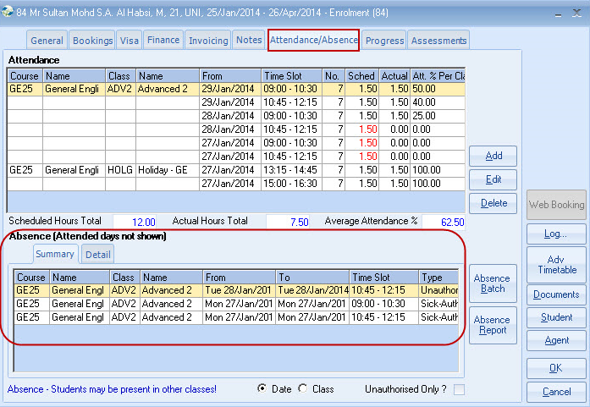

Note: A student may have other enrolments and/or may have moved from another school. Only by producing an absence report will you know for certain whether a student has had continuous absence over time, as the system will check across all activity (course/enrolments/schools). Just checking an individual enrolment may not give a complete picture!

“Class” Sequence

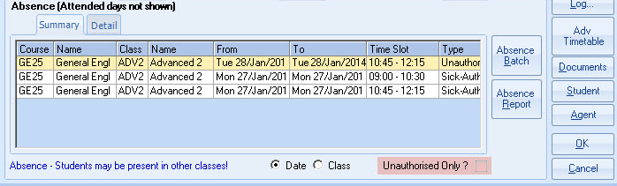

Summary – Unauthorised Only filter

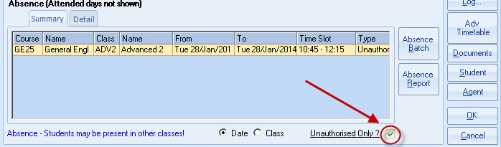

Absence – Batch entry

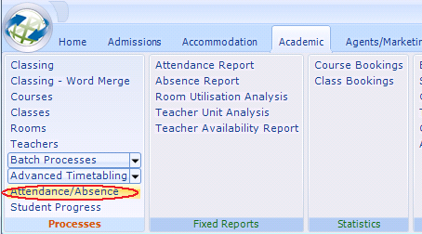

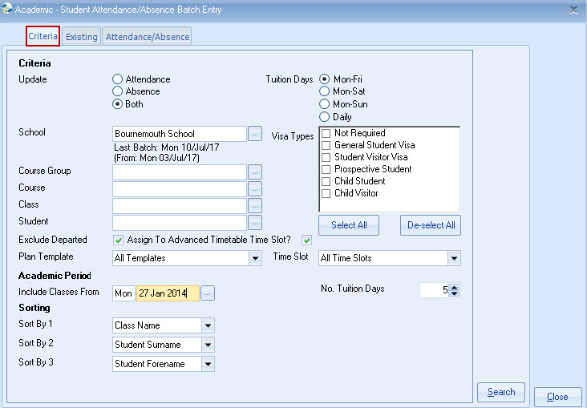

This is the same screen (enhanced) as used for batch attendance entry. Absence can either be entered separately or at the same time as attendance.

There are several ways a school could consider operating “absence,” and two examples are given below:

Updating absence and attendance together - weekly.

This has the advantage of being a weekly process, entering both attendance and absence at the same time, but could not be used for welfare purposes in identifying students who had for example only been absent for 3 days.

Update setting = “Both”

Updating absence independently of attendance – daily or weekly.

If entered daily, absence could be used for welfare purposes. A school has to provide details of 10 days continuous absence within 10 days of the event occurring.

Update setting = “Absence”

Absence recording is best suited to schools that use teachers/registers to record absence/attendance. The process may not be totally suitable for schools wishing to enter “attendance” by checking off students as they enter the school!

Attendance and Absence update – Both together

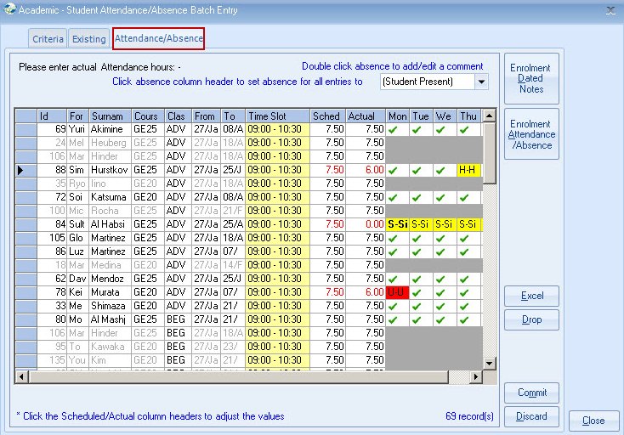

Note – Students where the enrolment is set as not requiring absence recording will have the absence area greyed out, to stop entry.

There is no automatic link (i.e. the recording of the absence) to the “Insert holiday” function within a booking.

Entries already made manually will display, and can be changed.

Use the arrow keys to move around the screen and use single codes to enter values............it’s quicker!

Click the heading if the column requires defaulting to a single value e.g. school closed. (See Friday column)

If mistakes are made values can be changed.

Data is not saved until “Commit” is selected.

Update attendance as normal

Reporting:

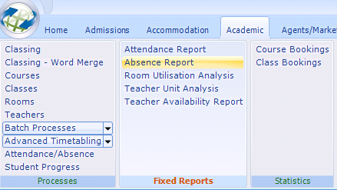

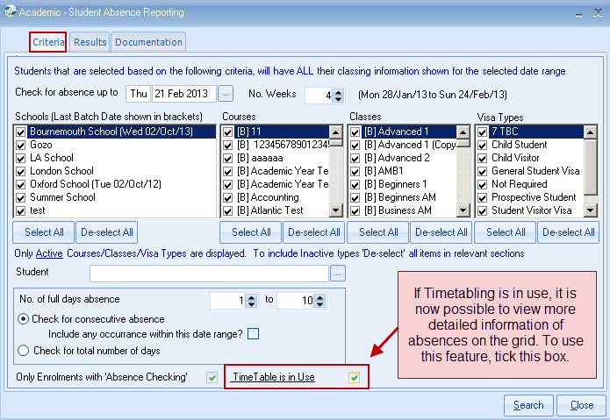

The absence report will check across classes/courses/enrolments/schools for continuous absence.

Enter the date up to which absence has been entered, also the number of weeks Class is to check back for continuous absence. Additional filters can be added, although if a single school is selected Class will still check across all other schools for any additional absence/attendance.

It is important to note: If a student is attending multiple classes, continuous absence only exists if the student is absent in ALL classes.
The first line for each student shows consecutive absence for ALL classes.

Results

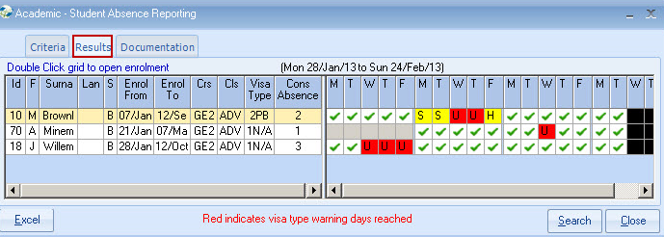
For easy reference reports will always display up to the end of each week (Friday Saturday or Sunday).

Black - Days beyond the dates selected
Dark Grey - Non school days (school closed)
Light Grey - No classes
Red - Unauthorised absence
Yellow - Authorised absence
- - Presence is assumed i.e. no absence entered.

Documentation

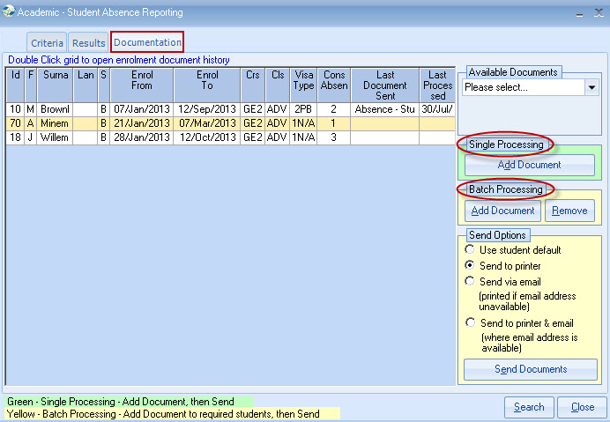

It is anticipated that letters/documents will need to be sent.

Each student can have documents selected and sent either individually, or in a batch (i.e. selecting documents for each student first, and then sending all in a batch all together).

The advantage of the individual process is that each student is treated separately and documents can be manually changed before sending. A variety of send methods are available e.g. an email to the student, a printed copy via the Host Family, and an email to the agent.

Batch Processing allows a single document (for each student) to be selected and sent, without the option to change.

Each student has the last absence document sent shown, giving guidance as to the next document in the process, although double clicking the row will bring up the enrolment documents folder, giving a complete history. The appropriate document is selected for either processing Individually or in Batch.

Merge Fields (for Documents)
The number of days is set in the absence document header.

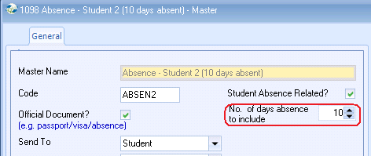

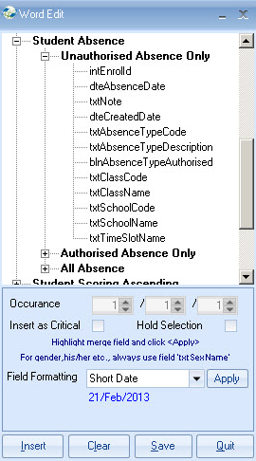

The document below is a sample showing how Class could produce a letter giving details of absence (unauthorised or both) covering a number of days.

Sample Absence letter:

-----------------------------------------------------------------------------------------
[Student.txtAddressee]
c/o [Accommodation-Booking-Host.txtAddressee/1]
[Accommodation-Booking-Host.txtAddress1/1]
[Accommodation-Booking-Host.txtAddress2/1]

28 July 2026

Dear [Student.txtForename]

Absence Letter

You have been absent from our school for 10 days without good reason, and it is part of your Visa obligation to attend regularly or to provide good reason to the school for continued absence. A letter was sent and emailed to you after 6 days absence warning of the consequences of non attendance, or alternatively the provision of a valid reason for your absence

We are legally required to advise the Border Agency of your absence, and this letter confirms that this has now taken place.

This may affect your ability to continue with your studies and the Border Agency may send you back home, as the terms of your Visa have been violated.

Details of your absence are below:

Absence Date | Class | Absence Type | Comment
[Unauthorised Absence Only.dteAbsenceDate/1] | [Unauthorised Absence Only.txtClassName/1] | [Unauthorised Absence Only.txtAbsenceTypeDescription/1] | [Unauthorised Absence Only.txtNote/1]
[Unauthorised Absence Only.dteAbsenceDate/2] | [Unauthorised Absence Only.txtClassName/2] | [Unauthorised Absence Only.txtAbsenceTypeDescription/2] | [Unauthorised Absence Only.txtNote/2]
[Unauthorised Absence Only.dteAbsenceDate/3] | [Unauthorised Absence Only.txtClassName/3] | [Unauthorised Absence Only.txtAbsenceTypeDescription/3] | [Unauthorised Absence Only.txtNote/3]
[Unauthorised Absence Only.dteAbsenceDate/4] | [Unauthorised Absence Only.txtClassName/4] | [Unauthorised Absence Only.txtAbsenceTypeDescription/4] | [Unauthorised Absence Only.txtNote/4]
[Unauthorised Absence Only.dteAbsenceDate/5] | [Unauthorised Absence Only.txtClassName/5] | [Unauthorised Absence Only.txtAbsenceTypeDescription/5] | [Unauthorised Absence Only.txtNote/5]
[Unauthorised Absence Only.dteAbsenceDate/6] | [Unauthorised Absence Only.txtClassName/6] | [Unauthorised Absence Only.txtAbsenceTypeDescription/6] | [Unauthorised Absence Only.txtNote/6]
[Unauthorised Absence Only.dteAbsenceDate/7] | [Unauthorised Absence Only.txtClassName/7] | [Unauthorised Absence Only.txtAbsenceTypeDescription/7] | [Unauthorised Absence Only.txtNote/7]
[Unauthorised Absence Only.dteAbsenceDate/8] | [Unauthorised Absence Only.txtClassName/8] | [Unauthorised Absence Only.txtAbsenceTypeDescription/8] | [Unauthorised Absence Only.txtNote/8]
[Unauthorised Absence Only.dteAbsenceDate/9] | [Unauthorised Absence Only.txtClassName/9] | [Unauthorised Absence Only.txtAbsenceTypeDescription/9] | [Unauthorised Absence Only.txtNote/9]
[Unauthorised Absence Only.dteAbsenceDate/10] | [Unauthorised Absence Only.txtClassName/10] | [Unauthorised Absence Only.txtAbsenceTypeDescription/10] | [Unauthorised Absence Only.txtNote/10]

---------------------------------------------------------------------------------

NOTE: Merge Fields (for Quick Reports)

Absence merge fields are available for use in Quick Reports, although it is expected that most reporting will be done via the report provided, as Quick Reports will not intelligently look across schools and enrolments for related absence.

