

Class.Net – Help Document

How to produce a report showing students in the school whose Visa is due to expire.

Don’t forget – there is a report already created that you may wish to try first which can be accessed via:
- Admissions
- Fixed Reports
- Visa/Passport & UK Sponsorhip

Create an Enrolment General Quick Report.

Enter to Date Filter as ‘Present’ with your required date range.

Add the fields as shown in the example below:

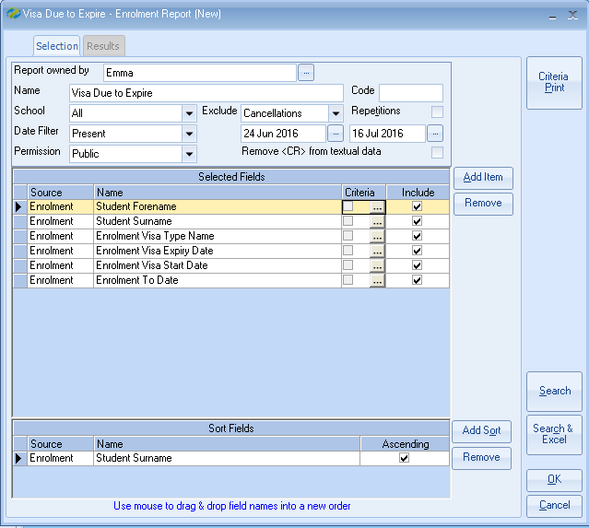
Criteria:

Enrolment Visa Type Name -

Set as: Not Equal To ‘Not Required’

This will exclude all students from the report who do not require a visa.

Enrolment Visa Expiry Date -

Is Null
Or
Less Or Equal To: enter the date you wish to search on.

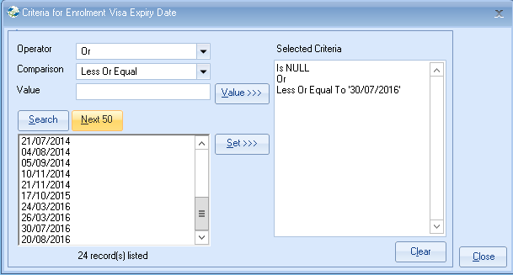

This report selection will find all present students who require a visa but their visa expiry date has either not been entered (Is Null) or is due to expire on or before the date that you have selected above. (Less Or Equal To).

