Class – Help Document


Agent Pricing - Setting up discounts and commissions

An agent can have different discount and commission rates set up.
These are entered within the Agents ‘Pricing’ screen.

Each Agent will have a ‘Default’ set up for Tuition, Accommodation, Transfer and Sundry. The Default is where you record the agent’s general discount and commission rates.

The example below shows how to set up different Discount and Commission percentages for Tuition.

Type: There are 3 types available:
- Default
- Group
- Item
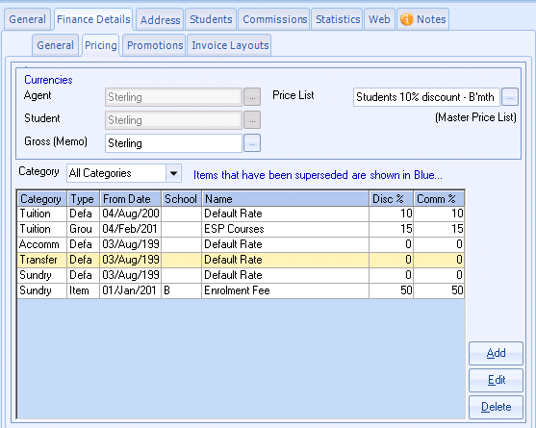

Select ADD to add a new disc/comm %age.

Default - This is the default rate that the agent will receive for all courses.

If the agent is also to receive further discounts on specific courses you can add an ‘Item’ or a ‘Group’

Item - use this if an agent is to receive a special discount/commission rate for a specific Course, i.e. their general discount rate is 10%, but they are to receive 22% for bookings for the Academic Year Program course.

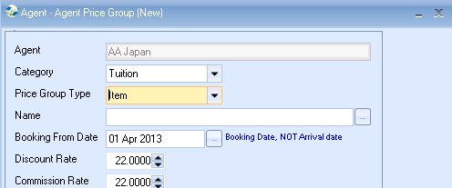

Group
If the agent is to get a different discount on a group of courses then you would set up a price group.

e.g. General English courses.
You could have courses for - GE 15 lessons per week, GE 20 lessons per week and GE 20 lessons per week.
You may want the agent to get a different discount if they book any of these ‘GE’ courses, so set up a ‘Group’.

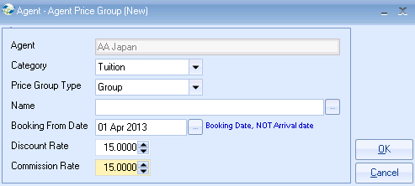

Before you can set the Group types within the agent records you will need to create the ‘Price Groups’ within Class.

Please refer to help sheet SQL.net 094 which explains how to set up Price Groups.

