Class – Help Document


HOW DO I FIND THE AVERAGE AGE OF STUDENTS ?

Create an Enrolment General Quick Report

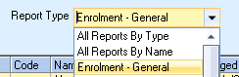

Select Add to create a new report.

Enter your required Date Filter and date range.
Add the required fields to your report ensuring you include ‘Student Age’

The ‘Sort’ must be by ‘Student Age’

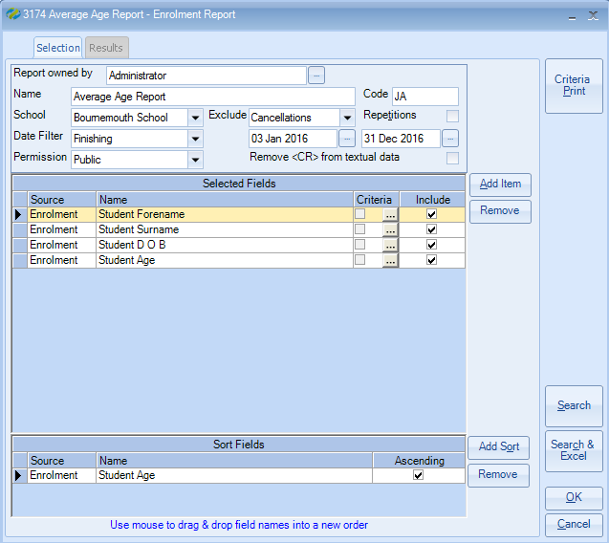

Select ‘Search & Excel’ to send results to an Excel spreadsheet.

To calculate the Average Age –

Highlight the whole AGE column

Select DATA
Select ’Text to Columns’

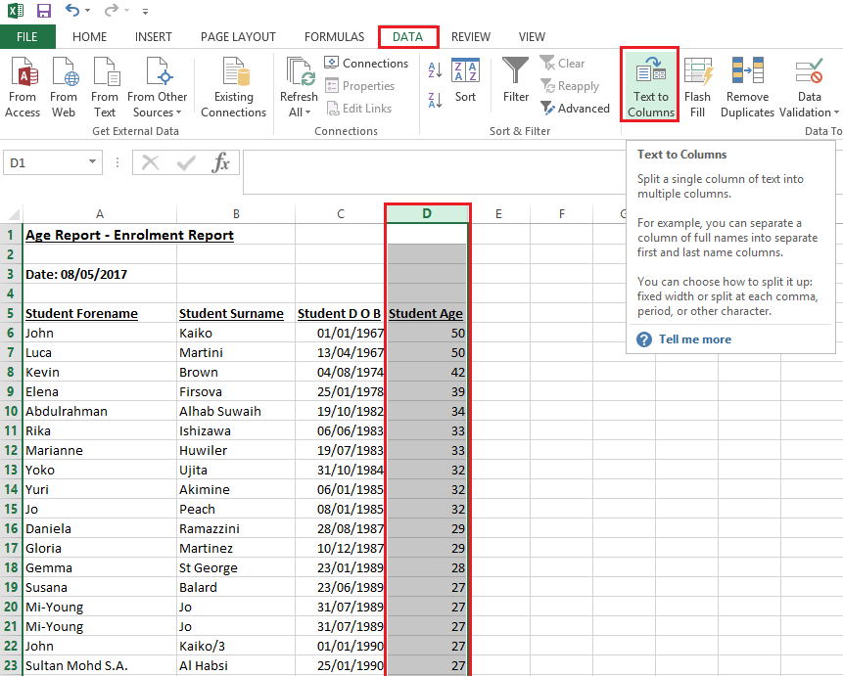

Click in to the empty Cell at the bottom of the Student Age column.

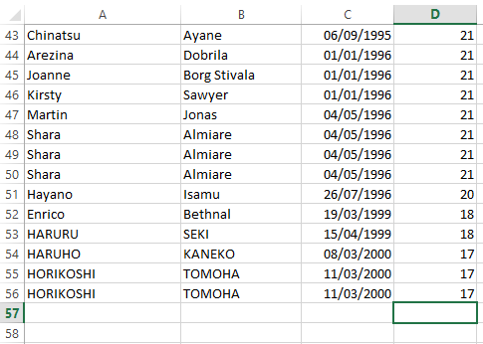

In the HOME menu click on arrow to the right of AutoSum on the menu bar:

Select ‘Average’ from the drop down list and select ENTER.

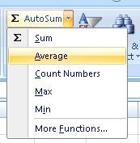

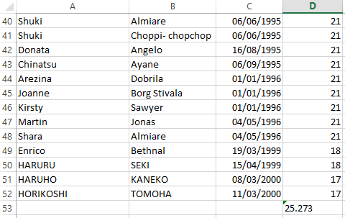

The Average Age will be calculated.

