Class – Help Document
Last Updated Feb 2013


Scanning Visa’s and Passport’s in to Class

Enrolments – Documents

Before Passport/Visas can be added (scanned or pasted) into Class, Master Official templates need to be created.

A single master document is required for the passport/visa, if the document is to be scanned/pasted. The scan/paste system “appends” to anything already existing in the document thus allowing a single document to include all necessary pages.

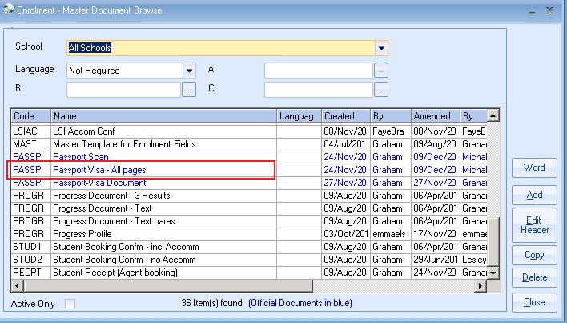

Select Edit Header to set a document as an Official Document.

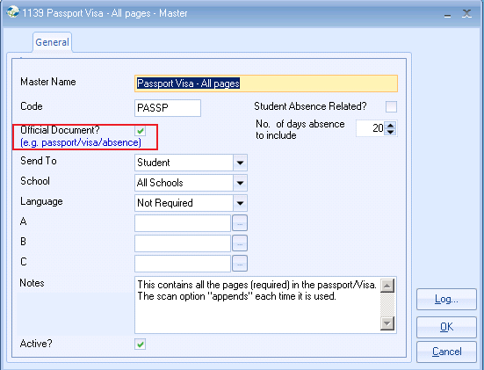
Adding a new “Official” document to an enrolment e.g. Passport
Go to the students enrolment and click on the Documents button
Select the Official documents tab.
Select Add to find the list of official documents and select the required document from the list.

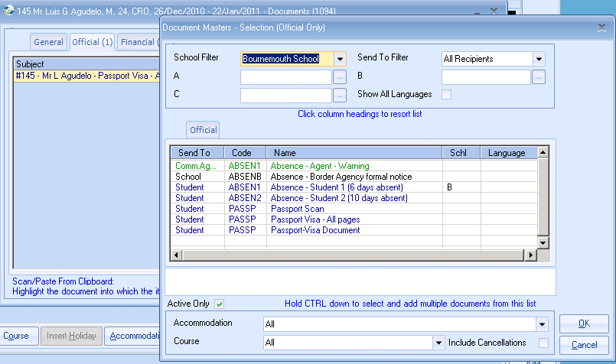

The document will now be listed.
Select Scan or Paste from Clipboard

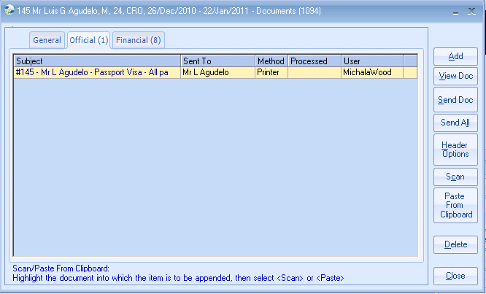

Highlight the document into which the passport is to be scanned and select “Scan.” Alternatively the passport can be “copied” and then pasted into Class.

Technical – Scanners and Cameras

Scanners/Cameras-General

Infospeed have adopted the use of the standard Windows WIA approach as this is how the Windows Operating System interfaces with such devices.

Scanners and Cameras that are WIA (Windows Image Acquisition) compliant should work, but we cannot guarantee this; especially where a user has a “combined” printer scanner.

An option to scan passports (or any other documents) for storing and saving within Class has been provided; plus options to take pictures with the use of Web Cams.

Due to the speed of scanning technology and the way in which this has to be automated, most users find it quicker to scan using the local scanner software or MS Paint and then copy/paste the required image area into a Class document. Unfortunately, Infospeed has no control over the speed of this process.

We will continue to re-evaluate the availability of better solutions in the market place until such time as a general solution presents itself that can be built into Class that will cover all our clients’ expectations in this area.

Terminal Server Users:

Unlike accessing a scanner or a web cam from your PC, trying to access these local devices from a terminal server environment can be problematic and when successful, the speed of automation has been found to be extremely restrictive. Again we would recommend that you scan locally from your PC and copy/paste into a Class document within your terminal server session.

Please note that the above information is provided in good faith and that Infospeed cannot be held responsible for any adverse effects on systems.

