Class – Help Document


UK Border Agency Report

This report gives a list of students who have received visa letters within a certain period.

Select Reporting/ Quick Reports

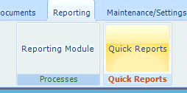

Create an ‘Enrolment-General’ type Quick Report

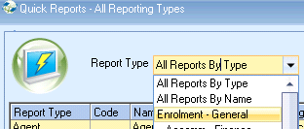

ADD a new report
School - if multiple schools in use and you wish to report on just one school, please select the required school.

Date Filter - select the required date filter and date range.

Selected Fields - Add fields to your report similar to the example below.

Sort - enter at least one sort field
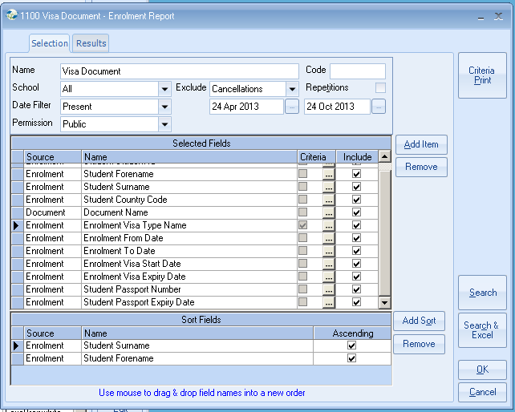

Criteria

Document - Document Name
If you want to find only students who have received a certain Visa document select the document from the list (select Next 50) if you can’t find the document.
Highlight the document
Select Set

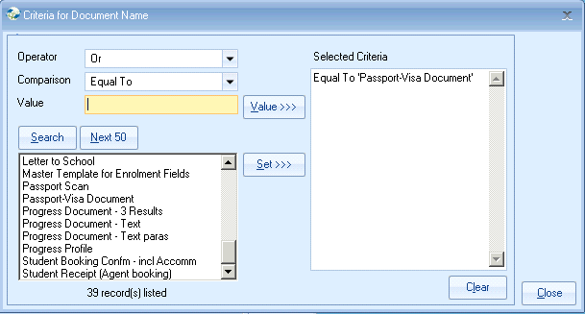

You can select multiple documents
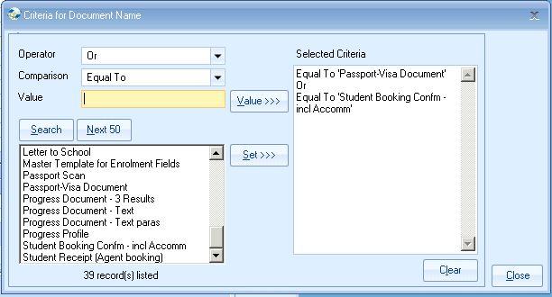

Enrolment - Visa Type Name

You may want to find students with a certain visa type.
Highlight the visa or visa’s and select Set.

Enrolment - Student Country Code

You may wish to select students from certain countries only.
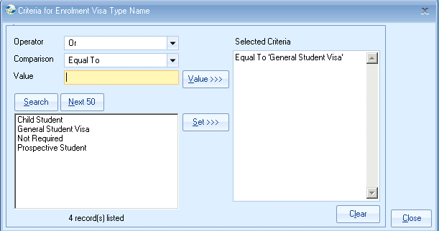

Select Close

If you select Search you will get the Results screen.
From here you can highlight each student and click on Edit, this will take you into the Enrolment screen for this student.
Click on Documents, highlight the Official document and select View Doc.
You can view the official document that has been sent to the student.

OR,
Select ‘Search & Excel’

Example report in Excel

